Global Shelter Cluster

Shelter Projects Working Group

Break-out Session at the GSC Meeting

5th October 2017

Overview
The break-out group was divided into two parts. The first focused on presentations of specific case studies, the project strengths and weaknesses and the lessons emerging from each. The second section was a group discussion around the following subjects:
- Longitudinal studies:
  - Need a different structure to prevent loss of importance and analyse key topics.
- The anonymity of contributing organisations:
  - Whether anonymity hinders the sharing of knowledge more freely.
- Where to take country level workshops:
  - Reaching a wider audience via Webex, but also through translation and inviting a wider range of participants such as members of municipal governments.
  - Subject areas could be more context specific and focus on the needs in the area – for instance, focusing on risk reduction and contingency planning as this could be the timeliest intervention.

Case study presentation: Nepal and Benin (Amelia Rule)
Amelia’s presentation explained the write up of case studies in Nepal and Benin in the 2015-16 edition. The focus was on the difference between the two, one being written retrospectively and the other from the field. Both had a focus on gender and GBV.
Discussion
- Amelia was asked what it was like to write up case studies. She focused on the differences between the type of case study (retrospective and while still in the field) as each provides its own challenges. The Benin case study (retrospective) was made more difficult as records and information were not fresh and were harder to track down from a distance. There was also a language barrier. The Nepal case study (from the field) was easier in these respects, but made more difficult due to time restrictions of day to day work.

Case study presentation: DR Congo (Sendralahatra Rakontondradalo)
This presentation focused on the case study on NFI Voucher Fairs held in DR Congo (2015-16 edition). These were held in parallel and in support of ongoing projects.
Discussion
- The flexibility of the case study template was raised, in terms of including other sectors through the chapter framework, as the voucher fairs could work for other sectors as well. It was noted that this case study did not follow the template too closely. There was uncertainty as to whether the template could work for a multisector project as this case study.
Case study presentation: Uganda, longitudinal study (Jamie Richardson)
Jamie ran through the longitudinal study in Uganda between 1986 and 2006 (developed by CRS and Interaction and not part of Shelter Projects), whereby there was no camp planning at the start of the crisis and very little space for it moving forwards. The study only highlights the main issues and doesn’t go into detail. There’s space for more work to be done. Mostly found new areas that could be researched.
ACTION: Look for new structure for longitudinal studies that would incorporate HLP, gender, social structures, recovery, dispute resolution, cash, environmental impact and livelihoods/livelihood recovery.
Discussion
- The case study template was discussed and found to cause issues for longitudinal studies. Details get lost if the project is too longitudinal and overarching. It would need a different template/framework.
- Suggestion to go back 10 years to case studies that were formerly part of Shelter Projects for earlier editions. The 10 year timeframe was used for the historical case studies in the early editions. Some of the original team members could be involved.
Plenary discussions
Identifying the organisations of the case studies
- This focused on the currently anonymous nature of the case studies. This has been to increase openness around what hasn’t worked and what could have been done better and to prevent naming and shaming.
- It was argued that users of Shelter Projects cannot easily contact the organization regarding a specific issue they might be facing.
- Another issue with providing the names of the organisations is that it could suggest the apparent domination of certain organisations and there was debate over whether this was a good enough reason for the information not to be shared.
ACTION: Further discussion needed on the issue of direct attribution of contributing organisations.
Country level workshops
This discussion focused on how we can best use the two upcoming country level workshops. What level should they be held at (local, national, regional) and what can we learn from disseminating the current version?
- Suggestion that the dissemination option should expand audience and looked at ways of increasing participation:
  - Webinars
  - At country level workshops, translations would be great – these could be one of the main languages to reach further as well (French, Spanish, Arabic as suggestions). Suggestions for a workshop in an Arabic speaking area, as well as Ukraine (where there are close ties in rebuilding to the Middle East).
  - What is the expected outcome – workshops could lead to forming community of practice
  - Could the workshops be used to analyse trends to support those in the field? The ‘trends’ section at the front of the book offers this opportunity
- Potential to focus on priority countries, which are disaster-prone or with protracted/recurring crises, and work on opening a dialogue with local (municipal) authorities. This might work as a form of soft advocacy as it could focus on context specific studies.
- When within a response this would be useful? It was suggested that it could be used within contingency planning and risk reduction.
- Workshops could feed into longitudinal studies as they offer opportunities to both gather information from stakeholders and even visit project locations.

Summary
The group would like to see a field workshop either in a country that is currently in the middle of a response, or a country that would benefit from DRR and contingency planning. The workshop should reach a wider audience through local government participation, involving those at a distance via Webex and having translated materials or running the workshop in the local language. The trends section at the start of the current edition could be used to focus on certain issues.
ACTION: Further discussion needed to define the format, audience and learning objectives of these workshops.

Annex 1.
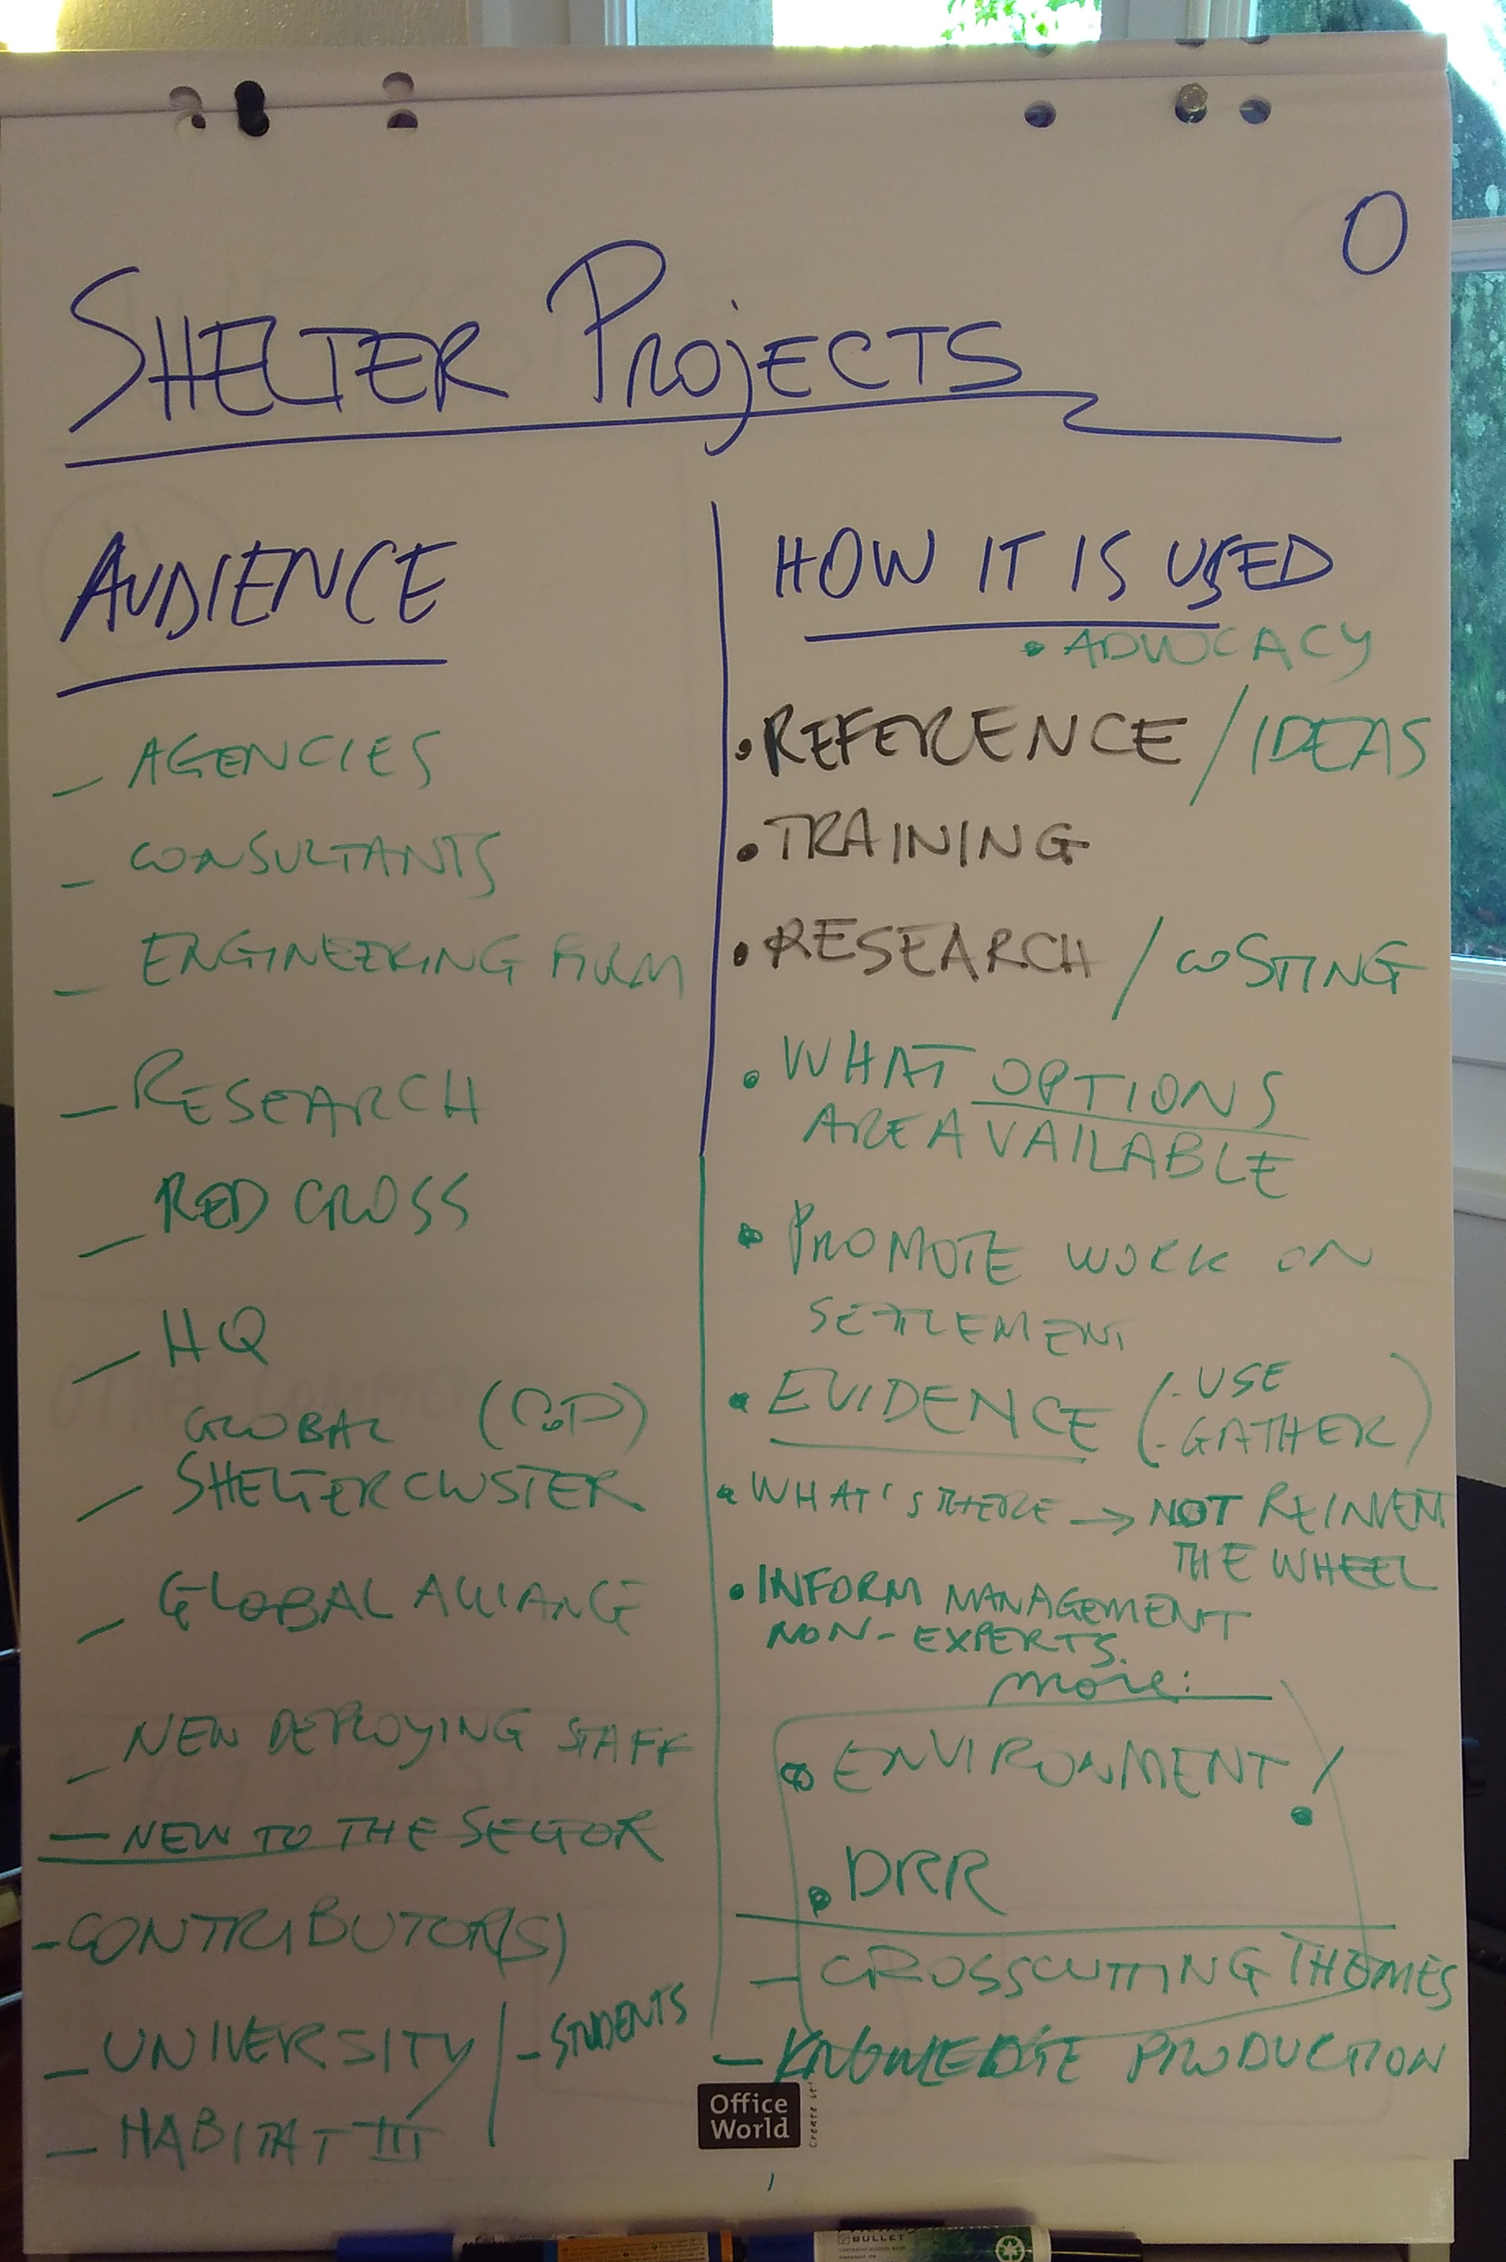
Fig. 1. Participants origins and uses of Shelter Projects

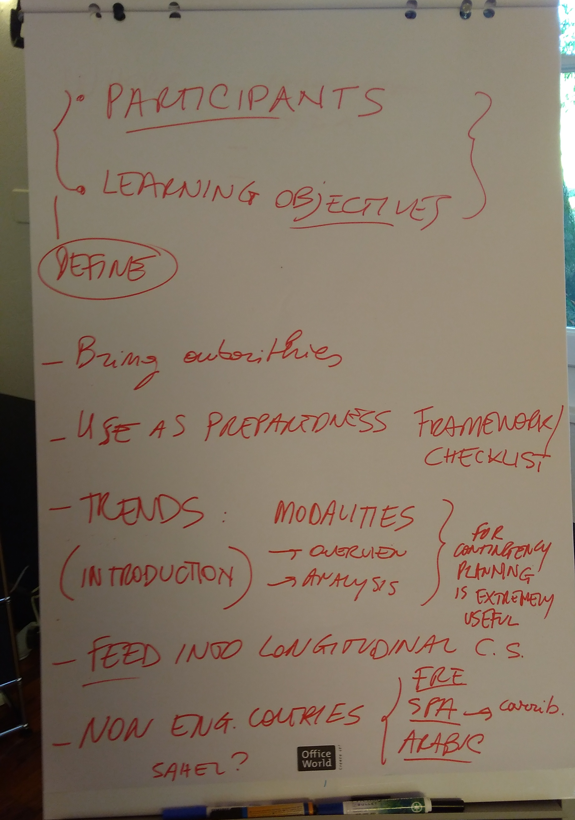
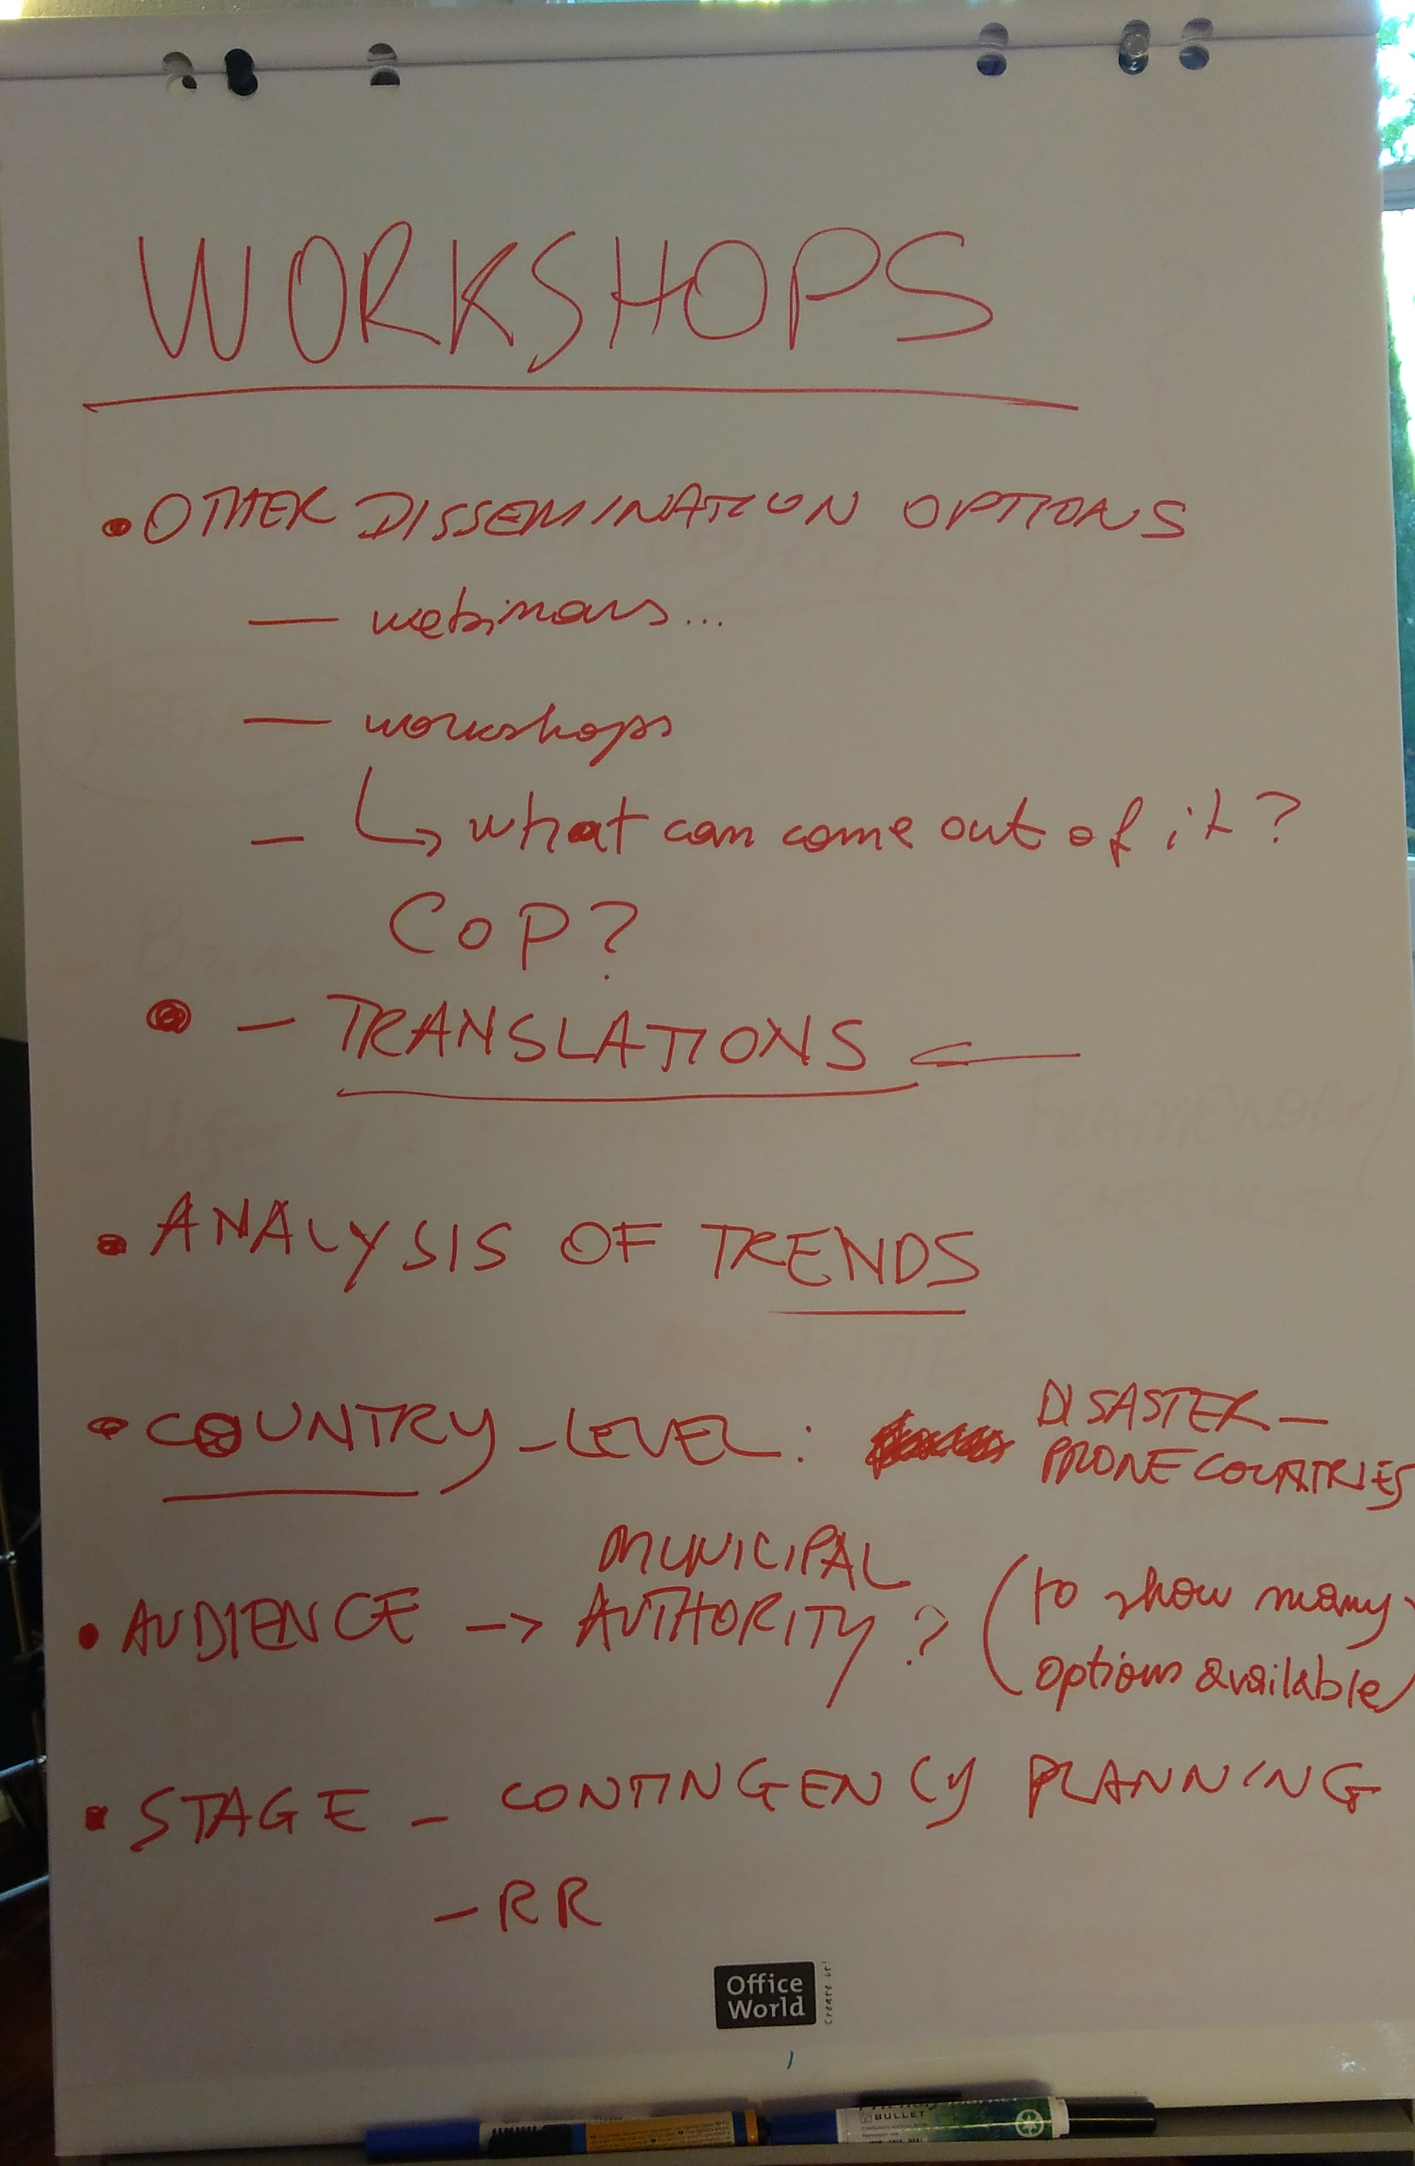
Fig. 2 and 3. Discussions relating to the upcoming workshops

