GSC Strategic Advisory Group (SAG) Meeting Notes – 29/07/2021
Date: 29th July 2021
Participants: Australian Red Cross (Leeanne Marshall), CARE International (Step Haiselden), Danish Refugee Council (Chiara Jasna Vaccaro), Habitat for Humanity International (Irantzu Serra-Lasa), IOM (Joseph Ashmore), UNHCR (Francesca Coloni), GSC (Brett Moore, Miguel Urquia, Pablo Medina, and Kimja Martha F. Vanderheyden)
Excused: ACTED/Impact Initiatives (Augusto Come), CRS (Seki Hirano), IFRC (Ela Serdaroglu), InterAction (Mohamed Hilmi), NRC (Miriam López)
Agenda:
Time | # | Agenda item
13:00 – 13:10 | 1 | Welcome, revision of action points from the last SAG meeting, and approval of the agenda.
13:10 – 13:25 | 2 | DCG Meeting: agenda for the next meeting.
13:25 – 13:35 | 3 | Communities of Practice
13:35 – 13:40 | 4 | ECHO project: brief update on the next steps.
13:40 – 13:50 | 5 | WHD, Environment and Localization
13:50 – 14:00 | 6 | AOB

Summary of action points:
Action Point | Who | Deadline
Finalize and share with the DCG the agenda with the meeting invitation. The message should include information on how to engage with different GSC Working Groups and Communities of Practice. | GSC coordinators | Next communication to DCG.
Working Groups that are considering evolving into CoPs to choose and set up their activities within one of the existing CoPs. The status of the WGs and CoPs needs to be kept up-to-date on the relevant pages of the website here. | WGs | Continuous activity as per decision of the WGs.
Share a Communication Plan on Environment. | GFP for Advocacy | As soon as ready
Statement on Environment published at the same time as the ECHO grant recipients. | GFP for Advocacy | 1 September
Statement on Localization shared. | GFP for Advocacy | As soon as ready

- Welcome, revision of action points from the last SAG meeting, and approval of the agenda
The agenda was approved with no additions.
The Chair went through the Action Points from the previous SAG meeting (can also be seen below), providing an update on progress made to date.
- Last inputs were received on the DCG ToR, they will be consolidated and shared with the donors along with a brief explanation on how to participate in the WGs and CoP when inviting them for the next DCG meeting.
- For the action point on capturing and compiling the main outputs from GSC Meeting 2021 in an interactive format and comparing attendance with the previous year, a ToR to hire a consultant is being prepared.

Action Point | Who | Deadline
Consolidate inputs to the DCG ToR and share them as final. | Support Team | completed
SAG members interested in participating in the ECHO selection committee can express their interest by emailing GSC/UNHCR (Brett and Miguel). | SAG members | completed
Disseminate to donors the different Working Groups and Communities of Practice, explaining how to engage with them in case they would like to participate. | GSC coordinators | To be included in the meeting invitation
The SAG will issue a GSC statement on the environment coinciding with the announcement of implementing partners selected for the ECHO grant (1st September). Prepare a draft for revision by SAG. | GFP Advocacy | Draft is ready and under review.
Capture the main outputs from the GSC meeting and compare attendance with the past year. | GSC Support Team | ToR for a consultant being prepared

- DCG meeting: agenda for the next meeting.
Topics that were submitted by the SAG members for the agenda of the next DCG meeting were presented. Some of the SAG members who proposed the topics explained further their suggestions, after which the topics were voted on using a jam board, with the following results:
- What are the 1-2 priority issues for funding a response, especially for under-funded emergencies – 6 votes
- Priorities of different donors – 5 votes
- Strategies for scaling up and advocating – 2 votes
- Greening the response: understanding the position of donors other than ECHO – 2 votes
- Scope of the SAG/DCG – 1 vote
The topics that did not receive many votes might still be relevant for future meetings. An additional topic of having donors discuss and find out each other’s positions specifically on shelter was suggested.
Priorities of different donors were already discussed during the first DCG meeting, but this topic can be discussed further with a focus on how the GSC SAG can help with the internal advocacy of donor agencies to prioritize shelter and settlements. The aim will be to get more insight from the donors on how we could position ourselves so that they can better advocate for the sector within their agencies.
One more advantage of discussing this topic for the donors will be becoming aware how their priorities range from emergency to development among themselves.
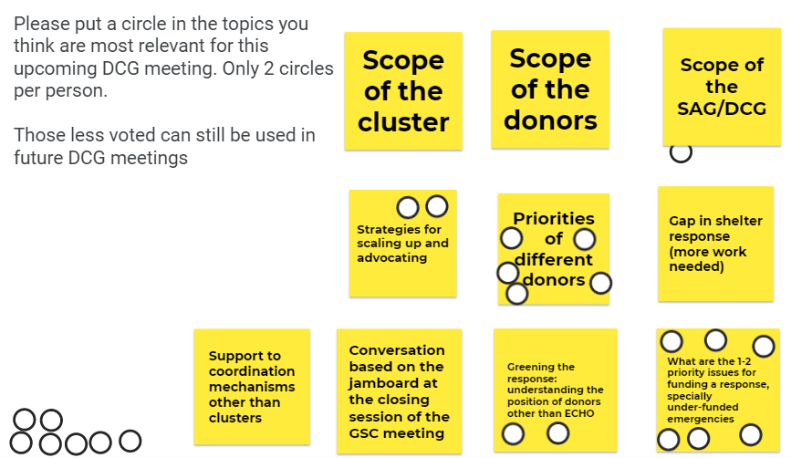
A doodle poll for the preferred dates for the next DCG meeting was already shared.
Action Point | Who | Deadline
Finalize and share with the DCG the agenda with the meeting invitation. The message should include information on how to engage with different GSC Working Groups and Communities of Practice. | GSC coordinators | Next communication to DCG.

- Communities of Practice
This agenda item comes from one of the discussions during the SAG Retreat in January where it was agreed that the WGs should start considering when and how to evolve to CoPs or to dissolve, as the tasks they were set out to do are completed. As a reminder, WGs are time-bound, output oriented and are there to address a specific gap. CoPs, on the other hand, are open ended and are there to ensure continuous engagement on the core functions of the cluster.
GSC has 7 CoPs at the moment:
- Coordination (dormant)
- Technical (dormant)
- Information Management (dormant)
- Environment
- Recovery (dormant)
- Gender and diversity (dormant)
- Shelter, Cash and Markets
The following GSC WGs have been active until now:
- Construction Standards Working Group (evolving into a CoP)
- Inclusion of Persons with Disabilities in Shelter Programming Working Group
- Working Group on NFI practices (evolving into a CoP)
- Self-recovery Working Group (former Promoting Safer Building Working Group)
- Settlements Approaches in Urban Areas Working Group
- Shelter Projects Working Group
- Working Group on Shelter Vulnerability Classification
- The State of Humanitarian Shelter and Settlements Working Group
- Working Group on Strengthening and Mainstreaming Diaspora Engagement in Shelter Responses
As more and more WGs are reaching the point at which they decide whether they will dissolve or evolve into a CoP, GSC might see a growing number of CoPs with a very narrow focus, low engagement, and activity. To avoid this, it is suggested that if a WG decides to evolve into a CoP, they should do so by creating a discussion thread within the most fitting and existing CoP. For example, the Construction Standards WG, instead of evolving into a new and separate CoP, could move its discussion into an existing Technical CoP.
Comments:
- Maintaining focal points for some of the closing WGs, in case there are questions on the activities these WGs carried out, or to provide expert knowledge on a topic is important.
- The WG pages on the website with the contact details will remain. The focal points on specific WG discussions within CoPs will have moderator rights and therefore will be clearly seen as the focal points for the topic.
Action Point | Who | Deadline
Working Groups that are considering evolving into CoPs to choose and set up their activities within one of the existing CoPs. The status of the WGs and CoPs needs to be kept up-to-date on the relevant pages of the website here. | WGs | Continuous activity as per decision of the WGs.

- ECHO Project: brief update
The deadline for Expressions of Interest is on 1st of August. The Selection Committee will meet on 4th of August to review the received proposals. The results of the review will be shared on 1st of September. Agreements are to be signed by mid-September 2021.
- WHD, Environment and Localization
This year the focus of the World Humanitarian Day, 19 of August, is climate action. The GSC will join the campaign by posting key messages on social media platforms.
A more elaborated statement will be developed, to be shared at the same time as the announcement of the ECHO grant recipients. The GFP on Advocacy will present a longer-term communication plan on environment that will include other dates and actions, also coordinated with Environment CoP leads.
A Shelter Cluster Strava team will be created and shared with partners for whoever would like to register their sport activities, as part of an awareness raising campaign for the World Humanitarian Day.
A second statement on encouraging the application of the IASC guidance on strengthening participation, representation, and leadership of local and national actors in IASC humanitarian coordination mechanism is prepared and under review at the moment. The guidance has indicators and recommendations for the clusters both at the global and country levels. When sharing this message, the country coordinators will also be requested to provide information on the level of participation of local actors.
Action Point | Who | Deadline
Share the communication plan on Environment. | GFP for Advocacy | As soon as ready
Statement on Environment published at the same time as the ECHO grant recipients. | GFP for Advocacy | 1 September
Statement on Localization shared. | GFP for Advocacy | As soon as ready

- AOB
- Miguel will be relocating to Peru at the beginning of August, and he shared his good wishes with the GSC SAG.

The next SAG meeting will be on 26 August 2021
at 13:00 Geneva time, 12:00 London time, 07:00 Washington, 21:00 Melbourne

