GSC Strategic Advisory Group (SAG) Meeting Notes – 24/06/2021
Date: 24th June 2021
Participants: Australian Red Cross (Leeanne Marshall), CARE International (Step Haiselden), CRS (Seki Hirano), Danish Refugee Council (Chiara Jasna Vaccaro), Habitat for Humanity International (Irantzu Serra-Lasa), IFRC (Ela Serdaroglu), InterAction (Mohamed Hilmi), IOM (Joseph Ashmore), NRC (Miriam López), UNHCR (Francesca Coloni), GSC (Brett Moore, Miguel Urquia, Pablo Medina)
Excused: ACTED/Impact Initiatives (Augusto Come),
Agenda:
Time | # | Agenda item
13:00 – 13:10 | 1 | Welcome, revision of action points from the last SAG meeting, and approval of the agenda.
13:10 – 13:25 | 2 | GSC meeting: reactions on how the meeting went.
13:25 – 13:40 | 3 | Advocacy: introduction of the new GFP for Advocacy, Kimja Vanderheyden and discussion on next steps.
13:40 – 13:50 | 4 | DCG meeting: upcoming on July 8, discussion on agenda points.
13:50 – 14:00 | 5 | AOB

Summary of action points:
Action Point | Who | Deadline
Consolidate the inputs to the DCG ToR and share them as final. |  | Support Team | 8 July
SAG members interested in participating in the ECHO selection committee can express their interest to do so by emailing GSC/UNHCR (Brett and Miguel). |  | SAG members | 1 August
Disseminate to donors the different Working Groups and Communities of Practice explaining how to engage with them in case they would like to participate. |  | GSC coordinators | Next communication to DCG
The SAG will issue a GSC statement on the environment coinciding with the announcement of implementing partners selected for the ECHO grant (1st September). Prepare a draft for revision by SAG. |  | GFP Advocacy | July SAG meeting
Capture the main outputs from the GSC meeting and compare attendance with past year. |  | GSC Support Team | 1 September
Organize bilateral meetings with SAG members in the coming weeks to understand their perspectives on advocacy. |  | GFP Advocacy | 1 August
SAG members to provide any additional ideas for the DCG meeting. |  | SAG members | Mid-day Monday 28 June
Prepare a draft agenda for the DCG meeting to be shared with SAG members |  | SAG chairs | COB Monday 28 June

- Welcome, revision of action points from the last SAG meeting, and approval of the agenda
The Chair went through the Action Points from the previous SAG meeting providing an update on progress made to date. The agenda was approved with one additional AOB item: an update on the ECHO grant by GSC/UNHCR.
Last inputs were received on the DCG ToR, they will be consolidated and shared with the donors along with a brief explanation on how to participate in the WGs and CoP when inviting them for the next DCG meeting.
Here is the presentation that was used during the meeting to explain the different points.

Action Point | Who | Deadline
Consolidate the inputs to the DCG ToR and share them as final. | Support Team | 8 July
SAG members interested in participating in the ECHO selection committee can express their interest to do so by emailing GSC/UNHCR (Brett and Miguel). | SAG members | 1 August
Disseminate to donors the different Working Groups and Communities of Practice explaining how to engage with them in case they would like to participate. | GSC coordinators | Next communication to DCG
The SAG will issue a GSC statement on the environment coinciding with the announcement of implementing partners selected for the ECHO grant (1st September). Prepare a draft for revision by SAG. | GFP Advocacy | July SAG meeting

- GSC meeting: reactions on how the meeting went.
The Chair presented the highlights of the GSC meeting: a total of 26 sessions were facilitated by more than 70 resource people. The opening session was the most attended one followed by the thematic sessions, the networking sessions, and the Open Space Sessions. A total of 403 unique participants attended the sessions and 553 people registered from over 100 agencies. The initial feedback received from the evaluation by the first 20 respondents was shared. A more detailed one will be provided once more people provide inputs. In general terms the comments were positive, respondents were very satisfied or satisfied with the meeting which they had found useful. The main complaints were related with problems with the Teams chat and the fact that chats are not captured in Youtube videos. The fact that the meeting was online helped broader participation which was appreciated.
SAG members agreed with the comments shared. There was a question on when the next meeting will happen. In principle this will be in June 2022, but this can be discussed in the coming months, particularly at the SAG retreat. It will also be good to consider whether a mid-year teleconference is still needed. It will be interesting to compare participation with last year’s data and to measure how many people watch the recorded session. It would be good in the future to explain better why registration is important, this will encourage people to register. SAG members found the single link for all sessions a very useful feature. They also appreciated the fact that the sessions were recorded and available in the website. A SAG member felt that there might have been less participation from the field than last year and particularly less from Government representatives. It would be good to check the data and confirm whether this is correct. If so, this could be due to having separated the country update sessions from the core sessions of the meeting. The technical problems with the chat may have been due to sessions being too close together, perhaps this could be addressed in the future by leaving more time between sessions. Some of the questions asked by participants during the meetings, in the chat or other places, were not addressed due to lack of time, it would be good to find ways to answer them. The use of interactive tools such as Menti, Jamboard, EasyRetro, and others was appreciated.
It was noted that SAG members were very active in preparing and facilitating the meeting. This has been very appreciated and SAG members were thanked for this.
Action Point | Who | Deadline
Capture the main outputs from the GSC meeting and compare attendance with past year. | GSC Support Team | 1 September

- Advocacy: Introduction of the GSC GFP for Advocacy.
The new Global Focal Point (GFP) for Advocacy, Kimja Vanderheyden, introduced herself and presented some initial ideas after having participated in the GSC meeting and having interviewed most of the GSC Support Team members. The initial ideas for a strategic action plan have been informed by the previous Advocacy and Communications Strategy, the GSC meeting and conversations with GSC Support Team members. It looks at three different areas: increase the visibility and engagement of the GSC and shelter and settlements sector, technical support to country-level coordinators and partners, and research-based advocacy for longer-term influencing. She proposed progressive actions, reactive and proactive, inclusive and positive communications, and recognized the importance of collective advocacy to achieve more impact. She is in contact with the GFP for Research and other GSC Support Team members. The Advocacy GFP will continue discussing these ideas and receiving more perspectives bilaterally with SAG members and country-level cluster coordinators.
SAG members welcomed the GFP to the team and highlighted the importance of this topic.
Action Point | Who | Deadline
Organize bilateral meetings with SAG members in the coming weeks to understand their perspectives on advocacy. | GFP Advocacy | 1 August

- Preparation of the upcoming DCG meeting
The next Donor Consultation Group (DCG) meeting will take place on July 8 at 14h00 Geneva time. The chair presented the agenda and action points of the last DCG meeting, and priority issues identified during that DCG meeting.
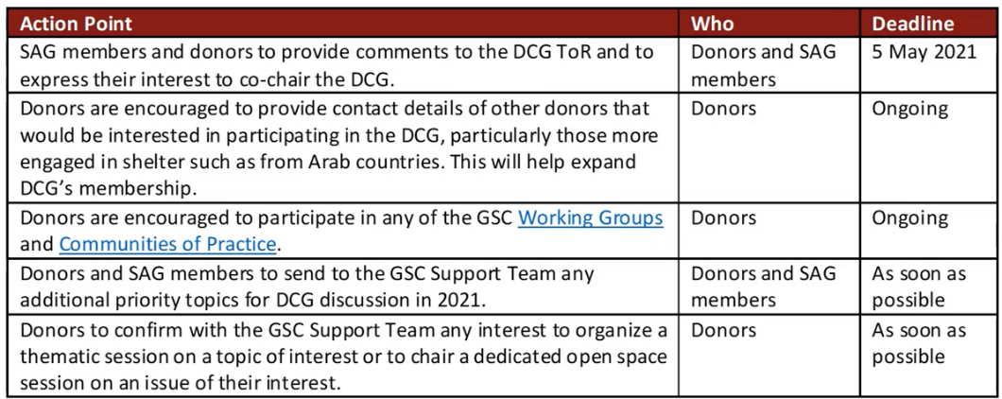

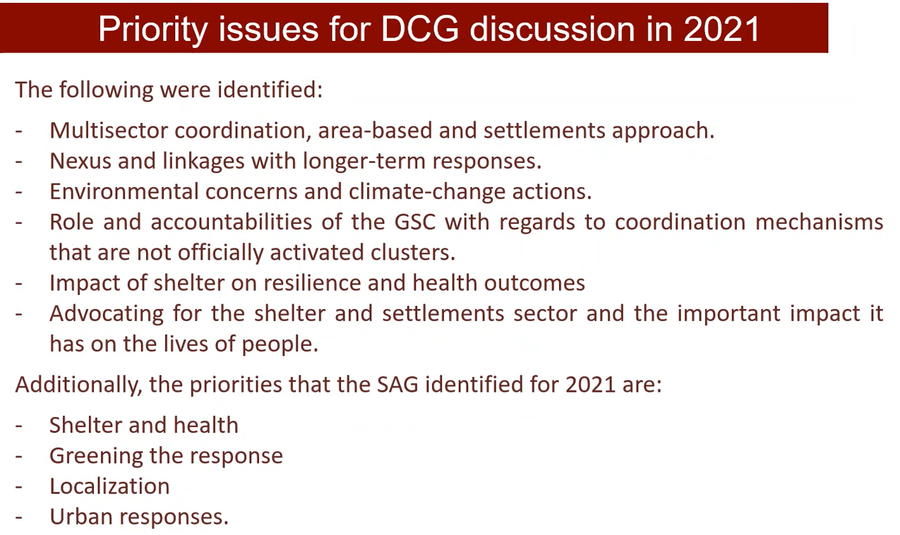
SAG members proposed the following points to be prioritized for the July meeting:
- Provide an overview of the outcomes of the GSC meeting: BHA, FCDO, and World Bank were very present in the meeting. It would be good to include the key highlights of the meeting captured in the EasyRetro of the closing session.
- It would be good to discuss the scope of what we do in terms of delivery, needs, what is the gap, what we are able to do and what we are not.
- It would be good to reflect on how donors can help unblock some of the key challenges that the sector has and share that with them.
- Donors could be asked to spell out better their strategy and priorities for the coming year.
- The funding of Shelter and Health research work that CARE has been receiving from GCRF will end in September. It would be good to know if any donor would be interested in following up on this funding.
- It is important to continue explaining to donors the role and priorities of the GSC, the challenges that the sector is facing, and the issues that we are dealing with at a strategic level.
Action Point | Who | Deadline
SAG members to provide any additional ideas for the DCG meeting. | SAG members | Mid-day Monday 28 June
Prepare a draft agenda for the DCG meeting to be shared with SAG members | SAG chairs | COB Monday 28 June

- AOB
- The call for Expressions of Interest to access GSC ECHO funding will be launched very soon. Some small changes of an administrative nature have been included to fully satisfy UNHCR procedures.

The next SAG meeting will be on 29 July 2021
at 13:00 Geneva time, 12:00 London time, 07:00 Washington, 21:00 Melbourne

