Handover Document
Dr Regan Potangaroa ES&NFI (Shelter) Cluster Coordinator, Afghanistan seconded from RedR Australia to UNHCR 30 December 2014

These notes are for the incoming Shelter Coordinator and perhaps partly for the Cash for Shelter officer and briefly detail the relevant work to date and the work in hand. I use ES&NFI and Shelter Cluster inter changeably.

- Coordinating Mechanisms
There are several coordinating levels within the shelter cluster.

The first is with cluster members through Shelter Cluster meetings. The contact list for the shelter Cluster is currently on my email list and I have emailed that to you. The cluster meeting are typically being held from 10am-12 on the Monday around the middle of the month (2nd or third week). Hence for 2015 that would be Jan 12 (indicated Jan 19 to OCHA with the expectation of the coordinator being here by the 15th), Feb 16, March 16, April 13, May 11, June 15, July 13, August 17, Sept 14, Oct 12, Nov 16 and Dec 14. And are usually held in the main conference room at UNHCR. (book the conf. room through the country reps secretary, let the tea lady know the numbers and the time and also arrange with the front gate to hold people in the waiting room at the front gate and then escort them in for the meeting). Note that the projector is not great and photos are “washed” out and details are made murky. I usually take out the first two chairs in the conference room out so that whoever is presenting has room to move in the front. Flip charts can be useful at these meetings. I usually chair these meetings but officially it is co-chaired with IOM. The split of roles is that Sultani (a great guy) from IOM looks after the Data management issues. This is a great help. These meetings are usually attended by CARE, NRC, AfghanAid, ACTED, OCHA, IOM, INTERSOS, CONCERN, UNHABITAT ECHO and DRC.

The next level is inside UNHCR and this is via the weekly OPS meetings. They are held on a Wednesday and the different sections briefly report on what is happening. Shelter cluster should be at report at this meeting.

We were communicating with our Govt counterpart in the MRRD but the minister and his team are no longer there and we are awaiting the new team to be established.

The regional clusters are established in Mazar and Herat and starting up in Jalalabad. These will need support and will also be feeding info back to Sultani. UNHCR Programme will report anything on Refugees, the rest is to be reported via the Shelter Cluster.

There is the monthly ICCM Meeting run by OCHA. That is where the different clusters try to fill in the gaps between them. It is not working very well and for 2 months there was no meeting called.

There is also feed back to Miguel in UNHCR Geneva and I have loosely been discussing issues every 1-2 weeks as necessary. You already know the team in Geneva and so you will be quite comfortable and it will be quite familiar.
There is a Shelter Cluster Performance Monitoring that Shirin Narymbaeva at UNHCR (Geneva) is setting. (I sent through the last email) There were some hitches but she will presumably be coming through with the survey tool early in January. I have asked about the email addresses requested....that is not clear. Note that this will be a “lite” version with a full version to be done by all clusters in April/May...the shelter cluster apparently didn’t do one in June/Aug this year before I arrived.

- Preparedness
At the moment there are the Winterisation and NFI lists for the different regions. Sultani is coordinating this and the need for them has come from the President who has requested an update every 2 weeks. OCHA have a standard reporting template that does not work very well. We were presented with it after discussions about reducing the number of NFI items which we got down to 29...OCHA unilaterally reduced this to about 11...which can not accurately convey the differences between a kitchen module from IOM and a kitchen set from INGO’s or a kitchen kit from UNHCR. information accurately. Nonetheless, we are running with it and Sultani is doing the “translation” into the OCHA template.

There are two and possibly a 3rd winterisation schemes. There is the one for the President, there is one for the 1st Lady and there is possibly one for the Chief Executive Officer. That lastly hasn’t appeared as yet and so we are dealing only with two at the moment.
Note that Charles (Head of SO in Mazar) has a list of 250 possible families that could be assisted via any winterisation package...and that IOM has a smaller (but growing) case load of undocumented people in Khost/Pakita area.

- Needs Assessments
The Cluster is usually involved but Needs assessments in the response/emergency phase of any disaster are handled by an IDP Taskforce who collate and then share that data with the different Clusters and the Govt counterpart. The required Emergency Shelter and NFI will then follow from that assessment. IOM look after the Natural disaster data base through the RAF (Rapid Assessment Forms) while the PMT (Population Movement Tracking) for conflict affected is handled by UNHCR.
The ES&NFI cluster will then follow up with subsequent RAF surveys which Sultani will brief you on when you get here. As usual most Shelter Cluster members have their own forms and own mandates so the RAF has its problems and short comings from their collective perspective.

I have done a Quality of Life (QoL) Study, that I maybe able to look at when I get back to NZ....but I wouldn’t count on it. This looks at the how shelter really adds value to those we assist...rather than us guessing what that could or should be.

- Standards and Guidelines
This has been something of a gap in the shelter cluster documents in several areas which I have tried to address.

Seismic: There are no seismic guidelines and once the CHAP2015 had been completed I put together a discussion paper for determining the seismic loads on the typical types of houses the cluster members are constructing. These loads can be combined with appropriate materials codes to see whether houses were compliant or not. The real concern of this work is that 9,000 people have died as a direct result of earthquakes from 1948 to 2006 in Afghanistan. This makes seismic the major cause of fatalities (and is probably greater than the death toll due to floods and mud slides combined). The claim that areas have a low seismic level should not be confused with a “no-seismic” activity which seems to be a common “excuse”. These points need to be followed through the cluster meetings.

Heating: there are no heating requirements for shelter despite Afghanistan’s obvious cold climate. These have been addressed and criteria suggested that define “cold” and define the heating requirements which will be in response to the type and detailing of the shelter. That is 1 kw or less for heating. A spreadsheet to calculate the heating requirements has been shared with the cluster but the uptake has been unfortunately low; due I suspect to the lack of suitable technical people. I have also tried using a thermal camera to try and highlight some of these issues.

Soil Testing: The cluster/UNHCR now have a scala penetrometer for checking the soil bearing capacity for houses; and I have written a spreadsheet for determining the founding depths for house foundations based on those test results. At the moment the house plans specify a standard 500mm depth for foundations regardless. This requirement and the rock material specification means that over half the cost of the house is in the “ground” (plus the 500mm part above ground). Our experience is that the minimum of 200mm should be sufficient and this represents a major cost saving. Training has been done for the shelter cluster and at the recent programme workshop. Nemat can assist you with this equipment.

Rebound Hammer: This can be used for checking concrete strengths....and also if you calibrate it properly for testing bricks and stone. Again Nemat can help you with it.
Steel Roof Beams: A spreadsheet has been done to check the beam size and spacing. Nemat is doing the drawing as these can be spaced wider (and hence less in number) than what is currently specified.

Foundations: A “Below” ground alternative and several “Above” ones have been determined and Nemat is working on the drawings. These are expected to lower the 50% cost of house to something like 15% or less. The below ground involves a scala test to determine the depth of foundation, and then mixing in cement at a rate of 7% base on weight with the excavated material and placing back in the excavated trench lightly compacting and watering to hydrate the cement. The top should be levelled or stepped as required depending on the site. This should be prototyped by the shelter people in Herat, Mazar and possibly Jalalabad.

There are several above ground options with the aim to protect the foundation from flooding. The sand bag option is perhaps the most novel but has been used by UNHCR in Africa.
These have been presented to the cluster, the UNHCR regional focal points and at the Programme Workshop.

Nemat is finalising the drawings and then they should be compiled as alternatives for the Shelter Guideline Documents.

- Info Management
This is being handled by IOM (Sultani). There are two main sheets related to the Northern Response for Flooding and Mudslides; and Winterisation.

The Northern Response worksheet is also being used for the CHF funded Cash-for-Fuel.
The ERF funded housing in the North is being handled out of the Northern Region Cluster and Charles usually updates this monthly. That won’t be happening over the winter period but the house construction (which has been part of the 2,100 “permanent” houses) will presumably resume in the spring.

- Cross Cutting
SBGV: There was a very good presentation at the last Cluster meeting and this issue is being more evident. There have been issues of 14 child marriages the night before the land allocation at Abe Barek and a recent high profile case where a young girl (2-3 years old) was raped and the family for their own security had to shift to Kabul. The President heard about their situation and gave them a $200,000USD apartment. The following week there were 5 further reported cases of young girls being raped (no media coverage but reported by CONCERN who is working in the area). Thus, shelter programmes need to be doing an SBGV “audit” of their processes and certainly the check list for the Cash-for-Fuel seeks a deeper involvement of women; whether that was achieved or not (and whether it could have been better) should be explored in the post distribution evaluation.

Cash or Voucher Working Group: the use of this modality for shelter in 2015 is expected to increase as agencies try to find ways to seemingly reduce costs and also address security issues. This however, is expected to cause more “technical” issues and attached below is the sort of problem that we have currently in Herat. The technical issue vary in each SO/FO and below is one example of a house built in a flood plain in Herat.
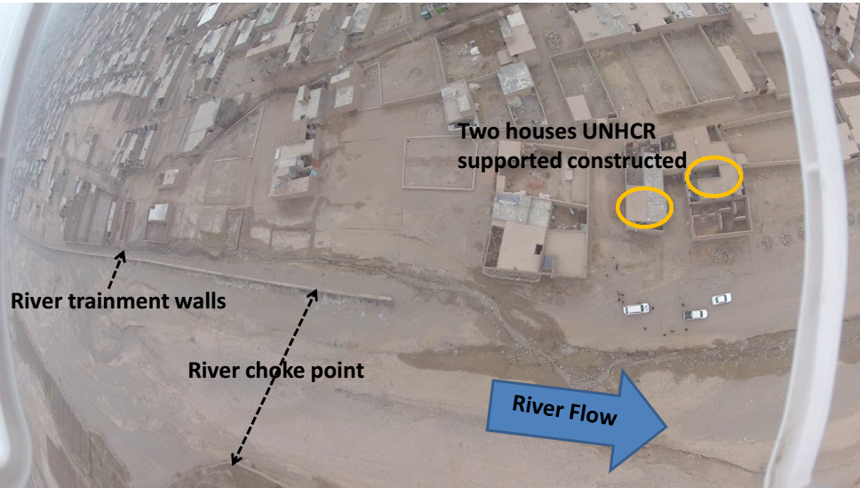

- Advocacy
There is a need for advocacy with OCHA. Firstly, for shelter cluster members in terms of funding such as ERF (none next year), CHF (Cash for Fuel), CHAP2015 and secondly (and perhaps more importantly) for the shelter strategy. OCHA seem to have a blinkered perspective of shelter’s role being solely emergency as in the name (Miguel will explain the difference between the ES&NFI Cluster and the Shelter Cluster). Certainly there is the issue of “Chronic” (the annual recurring case load) versus “Acute” (the case load that occurs because of a genuine disaster)...... but Afghanistan has a sub arctic climate that means that emergency tents and tarpaulins also sets up the case load for winter. In addition, the notion of a transitional shelter is elusive in the harsh cold of Afghanistan.

This year the cluster supported INTERSOS f or a shelter proposal in Faryah and put together the concept paper that became the cash for Fuel programme. This advocacy role could be expected to be more intense in 2015. Much of this will come from informal meetings with Shelter cluster members.

