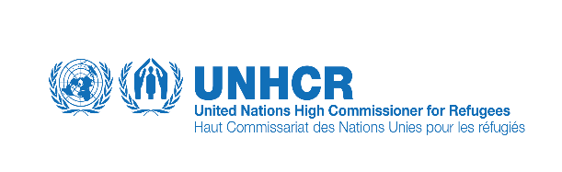
Inter Cluster Mission to Orakzai Agency
11/04/2016- 13/04/2016
Brief Background of Orakzai Agency Map:
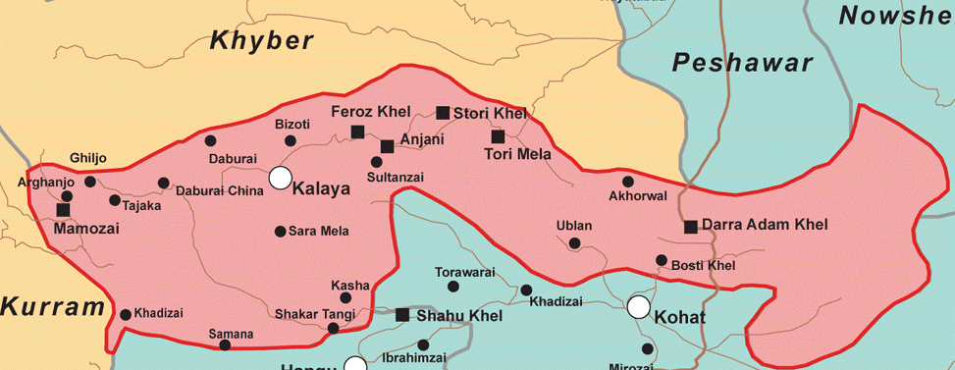

Orakzai Agency:
Orakzai Agency consists of Upper and Lower Sub-divisions. The Upper Sub-division comprises two Tehsils, Upper Tehsil and Ismailzai Tehsil, while the Lower sub-division also has two Tehsils, Lower Tehsil and Central Tehsil. It is bounded in the north by Khyber Agency, in the east by FR Kohat, in the south by Kohat and Hangu districts, and in the west by Kurram Agency. The Agency is characterized by intensely cold winters and mild summers. December, January and February are the coldest months and snowfall occurs in these months. Surrounding mountains are covered by dense, thick forests, which produce a cooling effect in summer. Due to geographical position of Orakzai and its thick forest cover, it rains throughout the year. In winter the precipitation is in the form of snowfall over the surrounding mountains as well as in the valley itself. The Orakzai tribe consists of; Ismailzai, Daulatzai, Alizai, Muhammad Khel, Sultanzai, Ali Khel, Malla Khel, Mishti and Sheikhan sub-tribes. In total, there are about twenty four major sections of these tribes. The largest tribe is Ali Khel.
Lower Orakzai has some very good landscapes and picnic spots, featuring lush green meadows and mountains covered by forests. Coal and wood are the major product of the area. Crops are grown on a small level while others items of daily use are purchased from Kohat and Hangu.

Background
The FATA Secretariat formally notified Upper and Lower Orakazai as conflict affected areas on 26 November, 2009. The security operation was started in Orakzai Agency in 2009 which displaced 38,275 families from Mishti, Feroz Khel, Utman Khel Sheikhan Stori khel and Bezot tribes. Majority of the IDP population took refuge in the adjoining districts of Kohat and Hangu. Vulnerable families were accommodated in Togh Sarai Camp where all the clusters provided the basic facilities. Though during recent visit some spontaneous return was observed in Rabia khel area.

The Inter Cluster Assessment was conducted to rapidly collect relevant information from the newly de-notified areas and provide information to enable the Humanitarian Country Team in making informed decision on the projected returns. Furthermore to gather information on the status, quality and quantity of services available in the Agency.

Security situation
The security situation observed to be satisfactory and the families satisfied with the current arrangements. The areas under the full control of the military.
UNDSS conducted a security assessment of the area and noted that acceptable security arrangements were in place at returnees villages. The security situation in the areas was observed to be stable. The main roads were accessible and dominated by Law Enforcement Agencies with additional security check points on road and on surrounding peaks.
All the newly de-notified villages are sensitized and cleared for return. Level -3 clearance has been done, however, as per military SOPs bomb disposal units carry out sweeping of the tracks in routine.

Objectives:
The mission intended to meet Military command on ground, political administration of Orakzai Agency, concerned line departments and visits to the de-notified villages. In order to assess the situation in view of the prospects of return, available basic facilities, identification of needs/gaps in services and also security situation in the areas.
Methodology:
The mission comprised of UNOCHA, UNDSS, UNDP, UNHCR, UNICEF, WFP, IRC and Hayat foundation visited Kurram from 10th to 13th of April 2016.It comprises of:
Mission Members:
# | Name | Nationality | Cluster | Agency
1 | Shaista Attullah | Pakistani | Coordination (Team Leader) | UNOCHA
2 | Faraz Ahmad | Pakistani | Shelter | UNHCR
3 | Ghulam Samdani | Pakistani | CCCM | UNHCR
4 | Yasir ull Husain | Pakistani | Safety & Security | UNDSS
5 | Shukria Sayed | Pakistani | CORE | UNDP
6 | Daud Khan | Pakistani | Food Security | WFP
7 | Asif Mehmood | Pakistani | WASH | UNICEF
8 | Mr Jawadullah | Pakistani | Protection | IRC
9 | Asghar Ali | Pakistani |  | PRDP
10 | Raheel Khan | Pakistani | Polio Vaccination | UNICEF
11
12
13

The mission conducted the following;
- Meetings with military and political Authorities
- Visits to de- notified villages and interview with females
- End mission meeting among members
Lower Orakzai
As per information and field observation, only around 10% of the families of these areas were displaced. Some of their family members had already returned to rehabilitate their houses. A few kiosks have been established in the area however, the main market is Hangu or Shahoo Khel which is 13-18 KM from Hangu town. Their main sources of income are remittances, agriculture and livestock. The team also observed minor destructions on government buildings like schools, BHU.

The team visited villages of Jaozarah, Lodhikhel, Dram sheikhan Dobandi, Terato Mela, Nari kada, Kandi Mishti, Bezoti, Chapper Mishti, Toi Mishti and Kanki Sheikhan tribes. The de-notified villages of the Lower Orakzai were easily accessible and visited most of the villages as they were close to the road. It was observed and corroborated by the locals that only 10% of the total families were displaced and those were all the families of government servants. The displacement was for a short period of 15 to 20 days. The Families were very much satisfied with security provided in the area and were feeling safe. There is no psychologist/psychiatrist with the Health Department.
Though the government has provided facilities to the already returned people but still there is gap in water and sanitation services like other parts of FATA. Main sources of drinking water is nearby river and water supply systems. Limited number of people are relying on WSS. In terms of water, the situation is somehow satisfactory while sanitation is still an area of concern. Open defecation is widely being practised. Latrines coverage in the area is quite low and sanitation activities will boost up the coverage and awareness among the masses will be enhanced. People lack adequate supplies for drinking water handling and storage. WASH facilities in schools are in poor conditions and would require rehabilitation interventions.
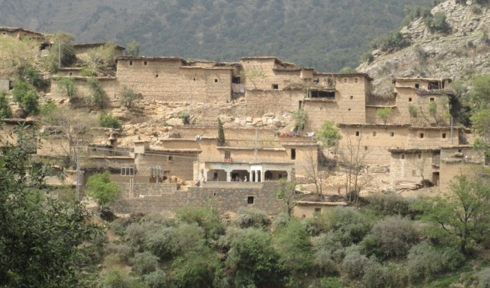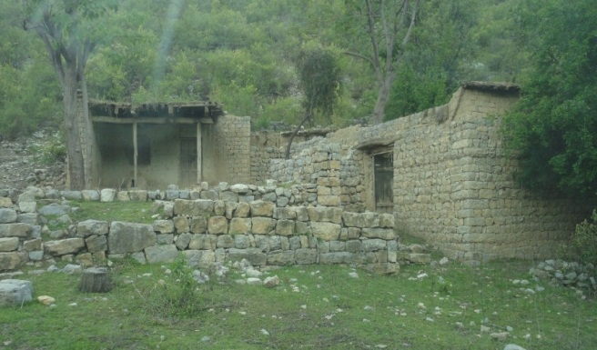
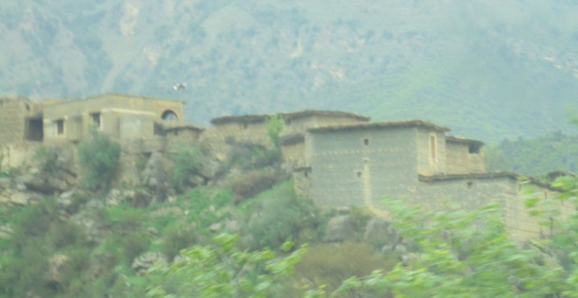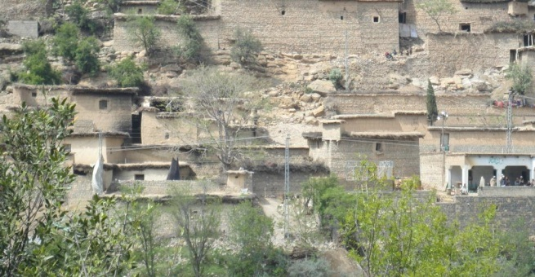
However 90% houses are intact and few ever damaged structure is found as there was no major displacement from the area.
The livelihood and people are in good condition. The partially and fully damaged houses are those houses where population yet not returned or partially returned.

Upper Orakzai

It’s worth mentioning that most of the infrastructure in Upper Orakzai got damaged as a result of military operations against non-state actors and weather effects due to the prolonged displacement for 8 years. The team visited the four major tribes including Akhel, Alikhel, Mulakhel & Rabiakhel.
Akhel Tribe:
According to FDMA Akhel tribe has 3000 HH .It is approximately 50 km from Hanggu (Orakzai) PA office. The team visited Darr, Narrak, Samsarkey khel, Ghiljo Bazar. The level of houses damage in this area is critical and 30% houses damaged fully and 40% houses partially damaged and some 30% dwellings require minor repair work.
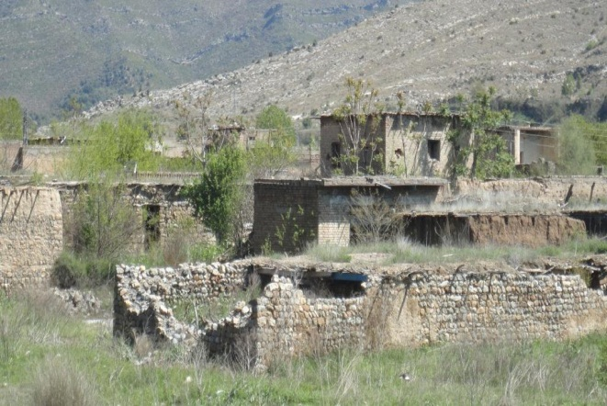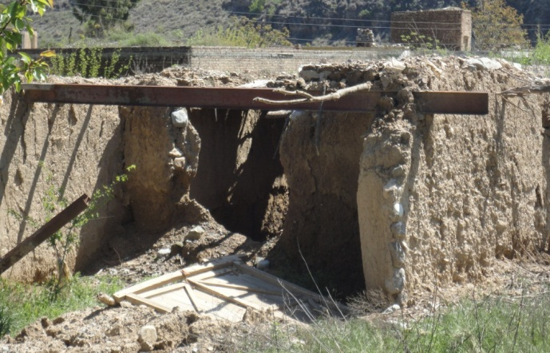
Alikhel tribe:
It consist of 4000HH and is 62 km from Hanggu. The team visited Chapper alikhel, Talay, Taang, Habib Garay, Mastang, Zaftan, Baghnak. The level of distruction is more than 70% in this area.
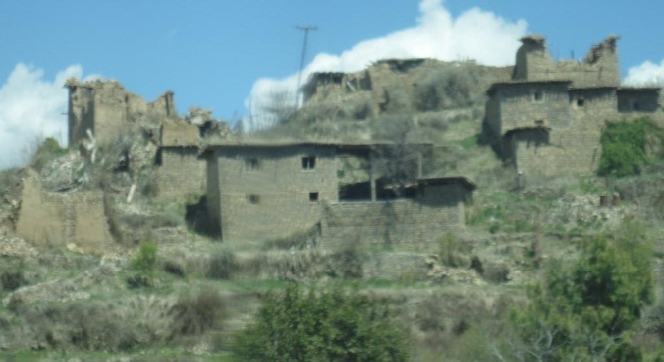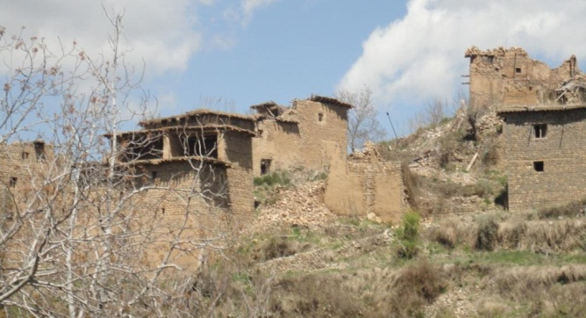
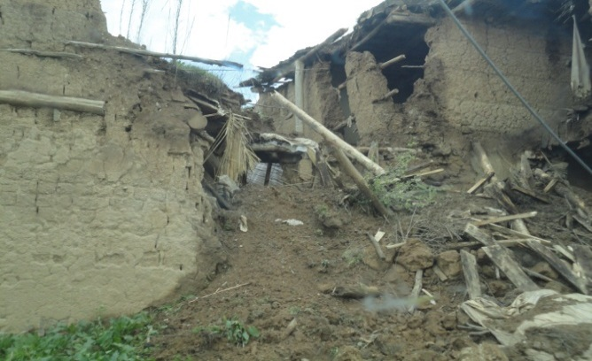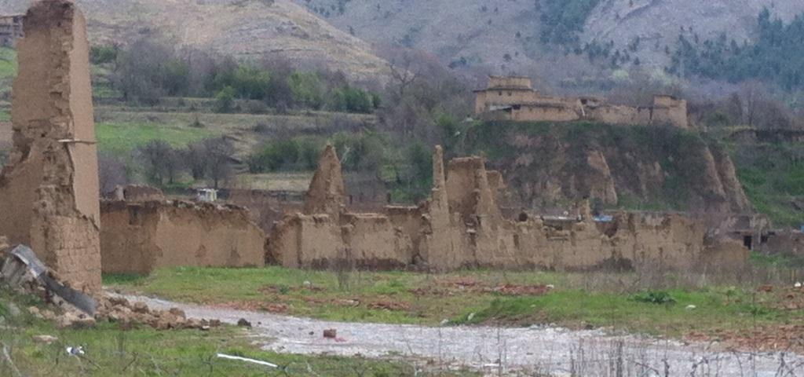

Mulakhel and Rabia Khel:
It has 8000-10000 HH altogether, The mission members visited Dabori village . In this area the level of destruction is comparatively low and it is 30%. In this area the 10% spontaneous return took place.
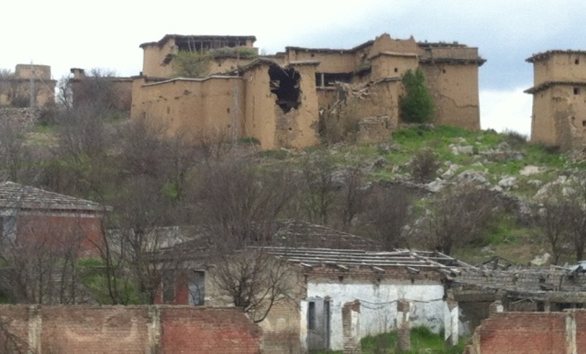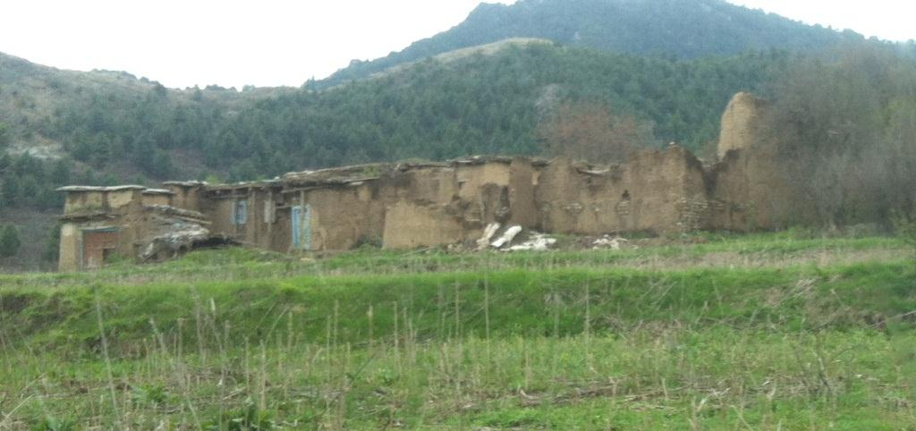

The accessibility by road remains a challenge though the road is 60% Blacktop and 40% gravel but due to non-usage of the area from last 8 years and land sliding most of the road require cleaning and repair. The security situation is normal as the security forces recently cleared the area. According to the security forces no major security incident took place in nearby past.
As per field observation, only 1-2% IDPs are already spontaneously returned to Rabia Khel tribe which is nearest tribe bordering district Hangu. All big markets like Ghiljo, Khadizai & Dabori were destroyed during conflict. None of them is currently functional. According to the local administration, the first phase of return will only target the tribes of Akhel. The government has already been reconstructed some of the institutions (education, health, roads, VDCs etc.) under Akhel package.
The main source of income are remittances, timber business, agriculture and livestock. Provision of fruit plants like walnut, apple etc. will also be help boost the revival of livelihood activities. Rehabilitation of irrigation structure can play a big very big boost on the revival of livelihoods. The road infrastructure is good and all areas are accessible through cars, jeep, trucks, etc. A number of humanitarian intervention will be required for the revival of livelihood activities. During the meeting with Political Administration, they requested that an additional humanitarian hub be established at Ghiljo near to the administration compound. The distance from ShahoKhel road Hangu to Ghiljo via Saifal Dara is 30-35 KM.
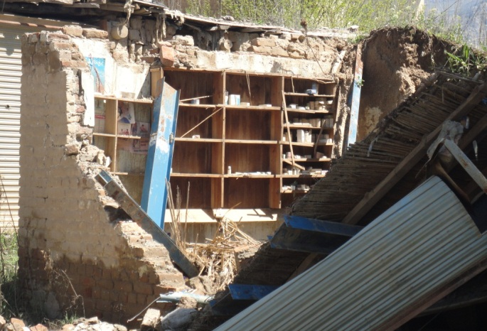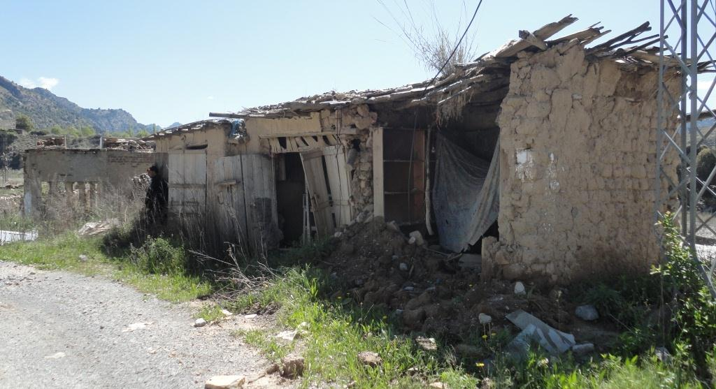

As observed by the team, no return noted in the visited areas and there was no sign of livelihood activities and two main markets “Ghiljoo” and “Dabori” totally destroyed. Though the dwelling walls are in contact but due to long displacement and harsh weather condition the roofs of most houses destroyed. All the facilities are fully or partially damaged. 100 % of the area was sanitized before the de-notification. The Upper Orakzai region is the worst affected area among all the areas projected for returns.
The Government has piloted Akhel package for Akhel tribe, where they have rehabilitated 99 % of the water, health, educational and other services in the area. One of the major issue is that the Government plans to return a total of 15,553 families in whole of Orakzai agency but in reality the return is much more as the IDPs were not registered by FDMA and partners after blast in ICRC registration camp at the time of displacement. Subsequently the registration was stopped and estimated 50,000 plus families were never registered, nor got any humanitarian assistance nor will benefit from any return or compensation package.

In areas of Upper Orakzai situation of WASH is extremely unfavorable for the returnees. Almost all the infrastructure has been damaged either due to non-maintenance over the period of displacement or due to the conflict. There were no functional water supply systems and no sanitation facilities available. All the houses had been badly damaged which have resultantly impacted the latrines inside homes.
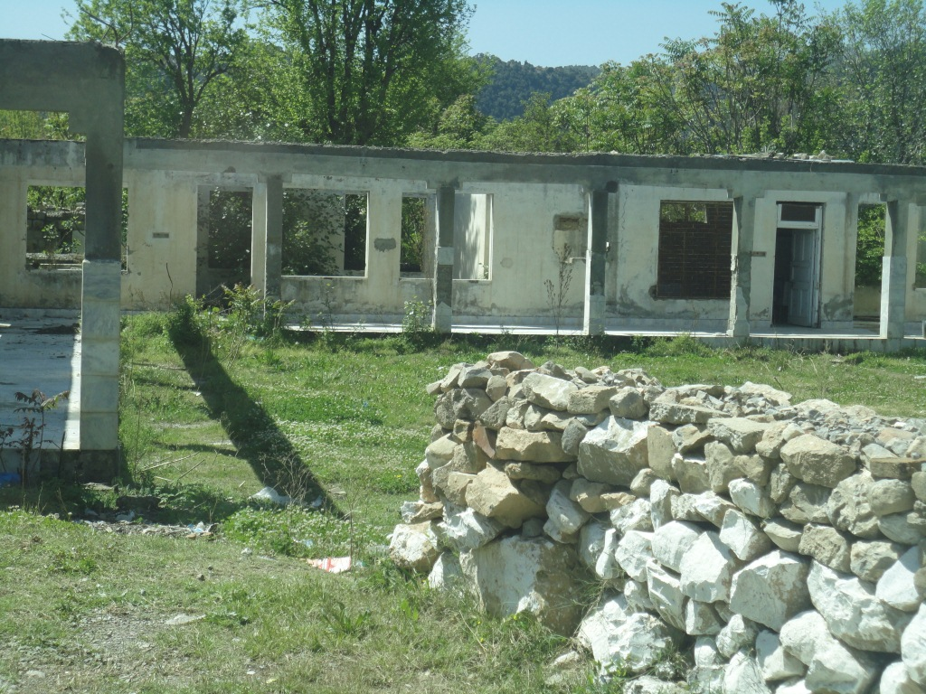
Schools and health infrastructure had also been observed as non-functional and accordingly WASH infrastructure is non-existing in these facilities. Post return situation may be alarming keeping in view the basic needs of water supply and sanitation. Open defecation will be practiced after the return which will affect the overall status of communities. Occurrence of Water and Sanitation borne diseases will be common and will effect children and women especially. The overall nutritional status of children will be at risk posing children to different kind of diseases. Provision of basic sanitation facilities and hygiene promotion activities would be very much required once the return takes place.

Recommendation:

Immediate need is shelter. For second phase they should provide them plastic sheets and CGI sheets including HH kits for repair and maintenance. The houses are made of mud and stone construction. The upper area require CGI sheet as that is snow bound area so Mud roofing will not serve the purpose. In regard, emergency shelter is required in this area as most of the houses are not in livable state. The 45% needs the immediate shelter assistance while 30% of houses are partially damaged will be in need of shelter tool kit and roofing material. Beside shelter need, the health, water and education facilities needs restoration on urgent basis.
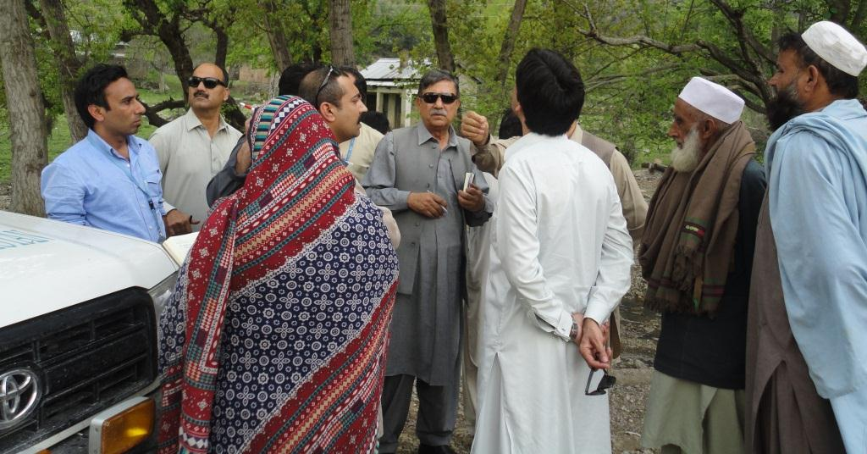

Prepared by:
Faraz Ahmad
Ghulam Samdani
UNHCR, Peshawar

