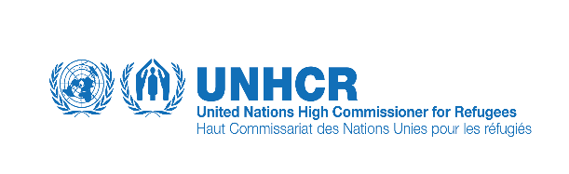
Inter Cluster Mission to Kurram Agency
From: 08-04-2016
Brief Background of Kurram Agency Map:
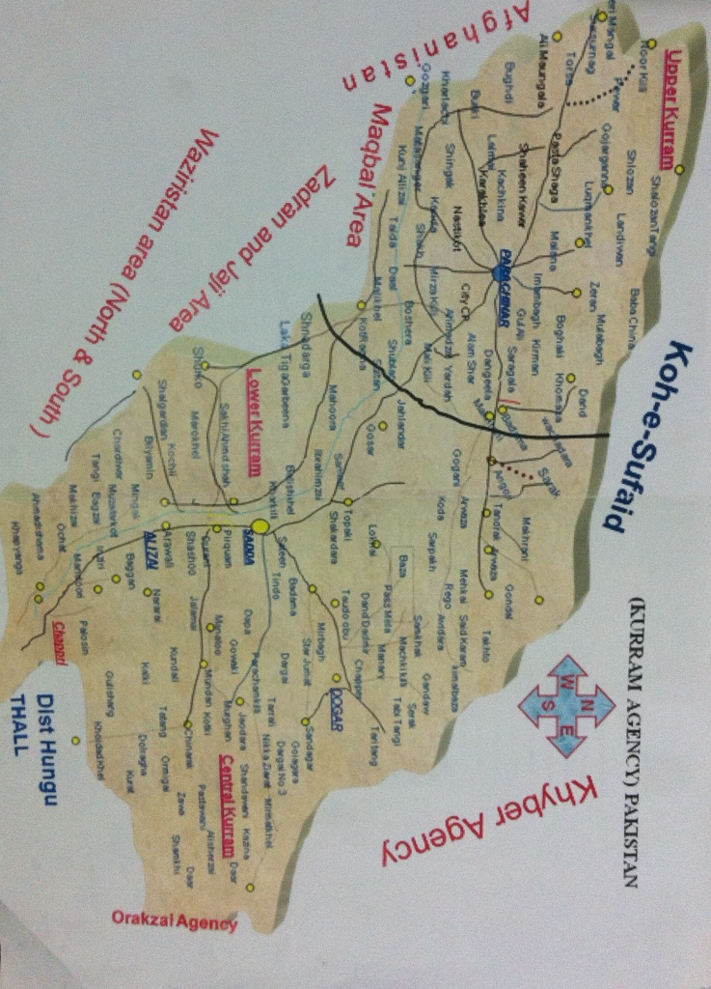

Kurram Agency:
Kurram was declared as an agency in 1892 and was made part of Pakistan in 1947. Like other tribal agencies of the FATA, Kurram is also still governed primarily by the, now outdated, Frontier Crimes Regulations (FCR) instituted by the British in the late 19th century. The main access, perhaps the only one to Parachinar from the rest of Pakistan, is from Kohat, through Hangu. The primary access, thus for the Kurram Agency is through Orakzai Agency; thus what happens in Orakzai has a direct implication on Kurram and vice-versa. The population is divided into three sub-divisions, namely Upper Kurram (almost 80% Shia), Central Kurram (95% Sunni) and Lower Kurram (80% Sunni).
It is inhabited by the Bangash and Mangal tribes. But there are other tribes likeTuri, Para-Chamkani, Bangash, Zazai (Jaji), Alisherzai, Alizai, Mangal, Muqbal and Masozai.
Kurram agency is mostly hilly and mountainous. The Koh Sufaid Mountain forms the territorial boundary between Kurram Agency and Afghanistan. There are limited forests in the return areas with spring and stream. The area has the potential for producing good quality fruits and crops. Around 95% of families’ source of income is from foreign remittances.
It is mostly mountainous area mixed with valley, small nullahs. Due to availability of water in the area it is highly rich with agriculture, livestock including fruits and vegetables.

The first phase of return to Kurram IDP’s started in 2009 and continued in different phases to the clear areas under the guidance of Return Task Force and agreed return framework. The humanitarian community has played an important role in provision of assistance in terms of registration, food, shelter/NFIs, WASH, health, nutrition and livelihood support to the IDP’s during the displacement and upon return.

Background
During the period between the 8 – 13th April, an inter cluster mission was undertaken to Kurram Agency in line with the Returns Policy Framework and Returns Activity Matrix. This was based on the outcome of the Return Task Force (RTF) meeting held on 22nd March 2016 at FDMA. The authorities had de-notified about 151 villages where a total of 12,000 families from Alisherzai, Zemusht and Masozai tribes are supposed to be assisted to return as from the 20th April, 2016.

In order to have a good understanding on the situation and to assess the needs of the these returnees, Inter Cluster Assessment Mission members visited these tribes & held meetings with Assistant Political Agent of Central Kurram, line departments, 152 Wings THL Scouts, key informants and community elders. The mission also had the opportunity to visit some of the newly de-notified villages and interacted with families who had returned spontaneously with a view to make recommendations on the way forward.

Security situation
UNDSS conducted a security assessment of the area and noted that acceptable security arrangements were in place at returnees villages. The security situation in the areas was observed to be stable. The main roads were accessible and dominated by Law Enforcement Agencies with additional security check points on road and on surrounding peaks.
All the newly de-notified villages are sensitized and cleared for return. Level -3 clearance has been done, however, as per military SOPs bomb disposal units carry out sweeping of the tracks in routine.

Objectives:
The mission intended to meet Military command on ground, political administration of Kurram Agency, concerned line departments and visits to the de-notified villages. In order to assess the situation in view of the prospects of return, available basic facilities, identification of needs/gaps in services and also security situation in the areas.
Methodology:
The mission comprised of UNOCHA, UNDSS, UNDP, UNHCR, UNICEF, WFP, IRC and Hayat foundation visited Kurram from 8th to 10th of April 2016.It comprises of :

Mission Members:
# | Name | Nationality | Cluster | Agency
1 | Shaista Attullah | Pakistani | Coordination (Team Leader) | UNOCHA
2 | Faraz Ahmad | Pakistani | Shelter | UNHCR
3 | Ghulam Samdani | Pakistani | CCCM | UNHCR
4 | Yasir ull Husain | Pakistani | Safety & Security | UNDSS
5 | Shukria Sayed | Pakistani | CORE | UNDP
6 | Daud Khan | Pakistani | Food Security | WFP
7 | Asif Mehmood | Pakistani | WASH | UNICEF
8 | Mr Jawadullah | Pakistani | Protection | IRC
9 | Asghar Ali | Pakistani |  | PRDP
10 | Raheel Khan | Pakistani | Polio Vaccination | UNICEF
11
12
13

The mission conducted the following;
- Meetings with military and political Authorities
- Visits to de- notified villages and interview with females
- End mission meeting among members
Situational Overview from the authorities
As per discussion, with APA Central & FDMA, Zemusht, Alisherzai & Masozai returnees can easily access the existing humanitarian hubs i.e. Tindo dag and Sateen for their return food rations and hence no need to establish a separate hub(s) for the families who will be returned.
The authorities requested for 6 months return package, support in agriculture interventions and support in livestock’s restocking, arrangement for vaccination, and expansion of livelihoods activities in the newly planned return areas as such activities will play a very vital role in the revival of livelihoods.
As per information, 22 schools are located in these tribes and will be operationalized with return. All these 22 schools are accessible.
As per livestock department, during return a campaign for vaccination of cattle with veterinary services will be provided to farmers.
The political Administration shared with the mission that an embarkation point will be established at New Durrani camp.

Alisherzai Tribe:

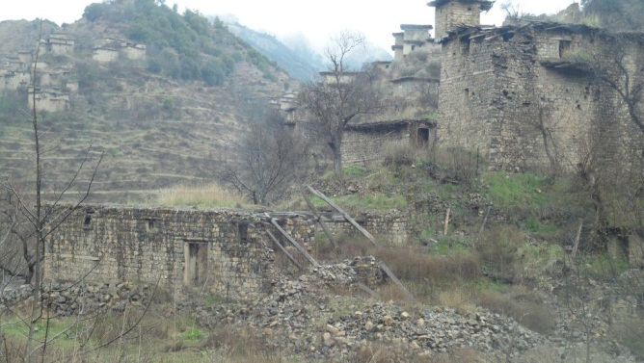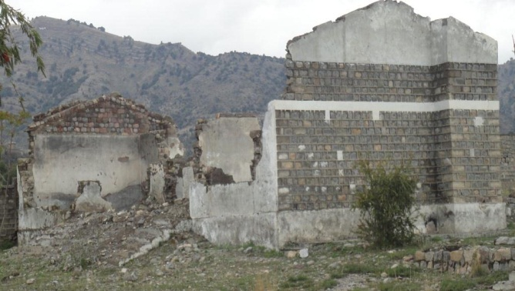
The team visited sarakdarzai, Mamatu, Murgan, Khotara Mela, Bedary and Spedary villages. Sadda market is the main hub for all the tribes of central Kurram. The accessible road is in average condition, some part are tarmacked whilst the recently de-notified areas is gravel. The first villages of de-notified area is about 21 km from Sadda. The team visited only 7-8 villages of the area due to time constraint and bad weather condition. The average distance of these villages are 35 km from main Sadda.
The access to the area was average as the area is hilly. The security situation observed to be good. The team was allowed to visit the areas and according to the military there is full security in the area for the people. As observed by the team, majority (30-70%) damages to the houses and even those that are still standing, remain dangerous for habitation. The houses are built by stone construction in which walls are made of dry stone or stones with cement or soil moratar and the roofing is made of wooden trusses and soil plaster on top.
Markets were totally damaged and no basic facility was available at the time of the visit. No single family have spontaneously returned to the area and no single shop was intact.
It was observed that the condition of shelter coupled with harsh weather condition can slow the pace of returns to the area. It is therefore recommended that shelter and NFIs should be pre-positioned in area of return at a common place and prompt assessment should be done for provision of tents as it will be difficult for the families to spend the night in the damaged shelters. The area receives frequent and heavy rain showers which will compound the situation further, particularly the vulnerable families or people with specific needs. Due to prolonged displacement, Alisherzai area needs a lot of support.

Zaimusht tribe:
The team could not visit all the de-notified villages for Zalmusht tribe due to hilly tracks and time constraints. The team had a bird eye impression of the villages in the hills while Sarkhwaidara village was seen across the road. It was observed that there had been no schools and hospitals in the area even before displacement. According to Political Administration around 80% spontaneous returns had taken place to these villages. As per APA of Central Kurram, additional 150 levy personnel will be deployed for the security of these villages. Electricity has not been restored in the de-notified villages.
The accessible road is in average condition. It is situated opposite to the main Thall Parachinar road and having access roads from different locations, Duaba, Thall, Hangu district, Ochatt, Bagan, Arawali and Shashaoo. The people use donkeys for carrying their possessions. There is no obstacle observed in physical access to the area. The security situation according to military and political administration is fairly good with no major incident reported and the area is clear and safe to return. Almost 80% of the IDPs have spontaneously returned to their houses and have started their routine activities with majority of the agricultural land cultivated.
Masozai Tribe:

Only 4 members from the inter cluster team together with FDMA staff were able to visit Samo Kali, Soor Tapo, Zarha Mela and Neka Ziarat of Masozai tribe due to access as the AVs could not go through the suspension bridge linking the main road from Sadda to Masozai. The team observed that 90% of the IDPs had already returned to their houses and have rebuild them.

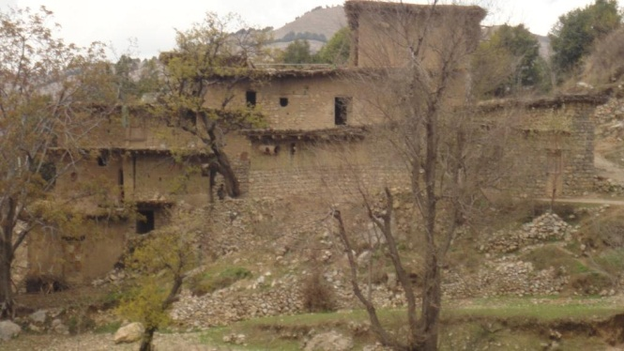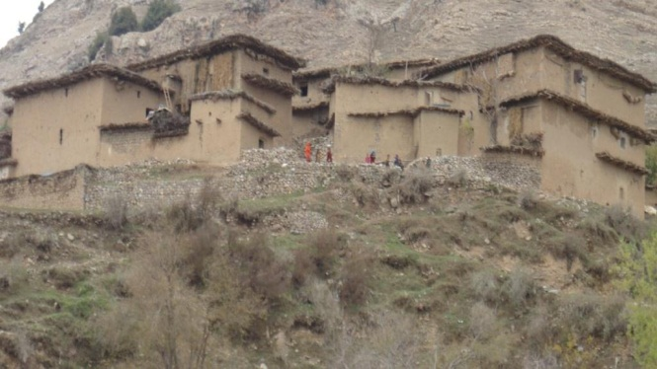

The Markets with all the essential items were functional. Physical accessibility was fairly easy to the villages of Masozai tribes. The tarmacked road towards Masozai tribes is linked through 2 newly constructed suspension bridges at a distance, people were using these bridges for their daily movements; electricity has not been restored in the area. The tribe was linked to the main Dabori village which has some basic education and health facilities. In Masozai tribe a small market is also located in Doggar which is 10-15 KM away from Sadda market. It is also functional and fulfilling the majority food needs of Masozai tribe returnees. Access to main market is not a problem and can be accessed through the use of pickups, small trucks, motorcar, and tractors within an hour.

Recommendation:

Both Collateral & weather damage were observed in the visited villages. The 10 % houses are completely damaged and are not in live able condition. The 50 % houses has damaged badly and require major repair work in the form of Roof erection and treatment. They also require crakes filling and requirement of wall erection as well.

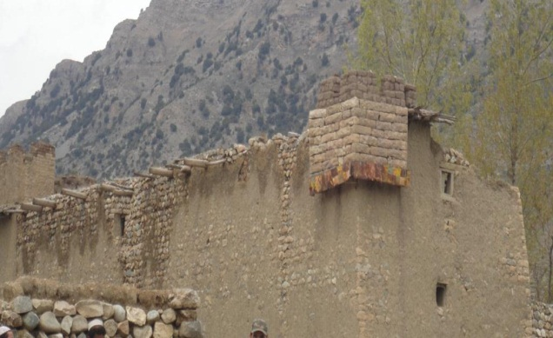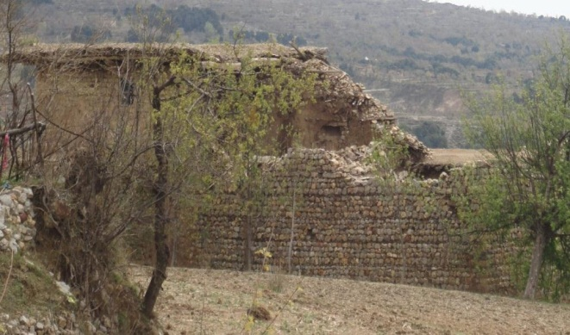

Immediate need is shelter tents. For second phase we can provide them plastic sheets and CGI sheets including HH kits for repair and maintenance.
Road structure including infrastructure damaged badly. The schools and hospital damaged badly and there is no school and health and school facility. For Education and health facility we can assist in large tent in order to meet their immediate requirement.

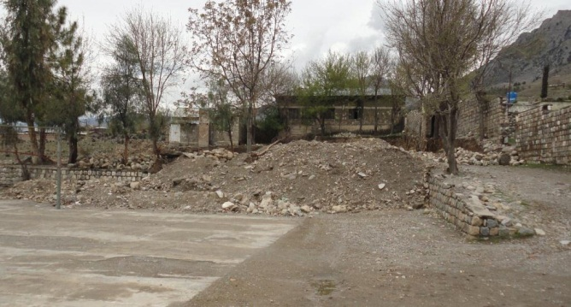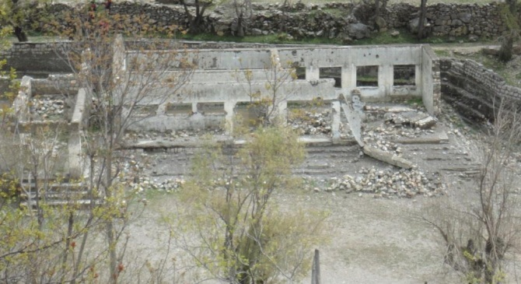

Prepared by:
Faraz Ahmad
Ghulam Samdani
UNHCR, Peshawar

