Waiver for import duties for construction materials

- Following Hurricane Maria, the Government of Dominica has waived the following import duties on most construction materials for all commercial and non-commercial imports.
  - Import duties (varies between 5% - 30%),
  - Value Added Tax on imports (15%)
- The waiver is applicable for the following items:

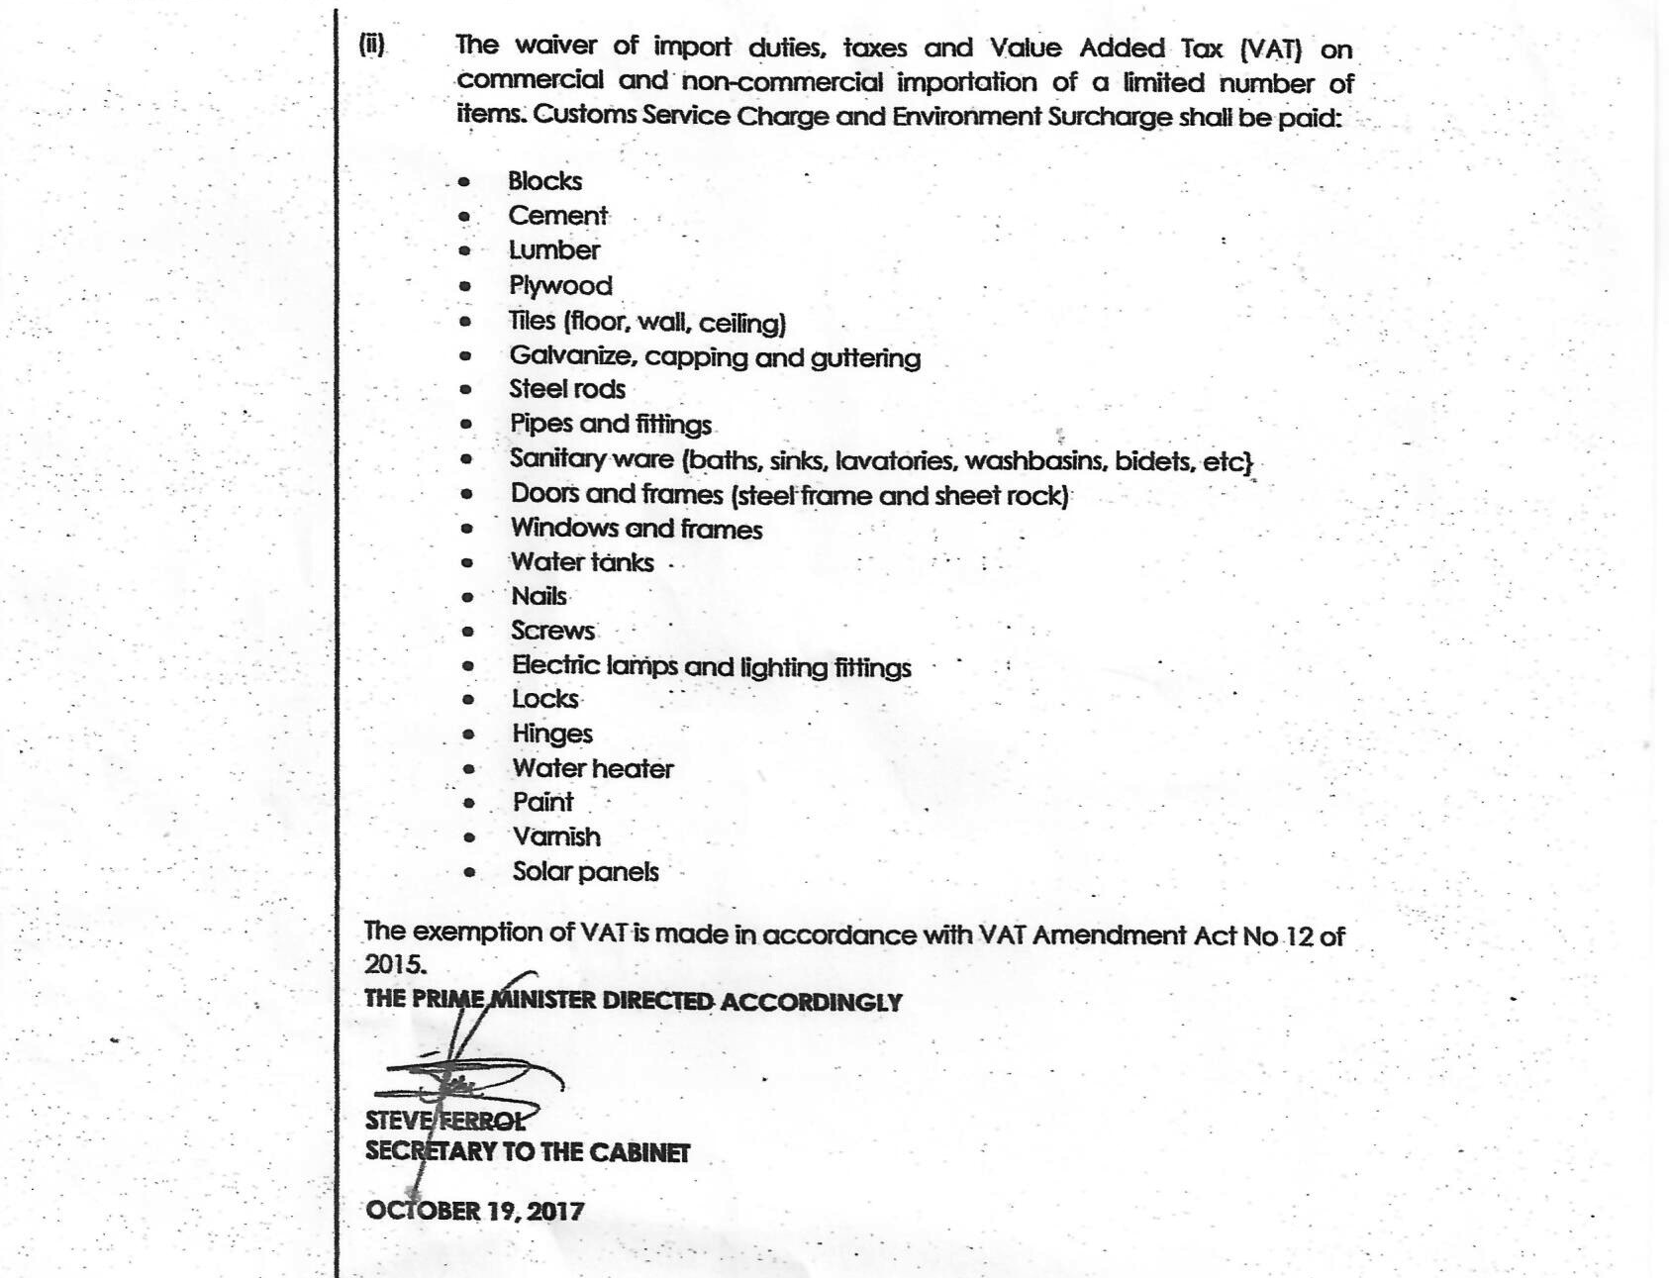

Concession for commercial ad non-commercial imports in Dominica

 | Import duty | Environmental Surcharge | Customs Service Charge | Value Added Tax
NORMAL Times  (after 19-04-2018)  During waiver period  (19-10-2017 – 19-04-2018) | Varies per product 5% to 30% | 1.5% | 4% | 15%
Regular commercial and non commercial imports | Applied  Waived | Applied  Applied | Applied  Applied | Applied  Waived
Donations to approved Chartable organizations | Waived  Waived | Waived  Waived | Waived  Waived | Waived  Waived
Purchase by charitable organizations | Waived  Waived | Applied  Applied | Applied  Applied | Applied  Waived
Imports by diplomats or regional and International Organisations | Waived  Waived | Waived  Waived | Waived  Waived | Waived  Waived

- The waiver period started on 19-10-2017 and will be valid for 6 months till 19-04-2018
- For more information about import duties in Dominica contact: Nandalawrence@hotmail.com from the ministry of Finance.

