 |  |  | 

Joint Rapid Multi-Sectoral Assessment

IDP Populations in Lafole District

Afgoye Corridor

Lower Shabelle Region / Somalia

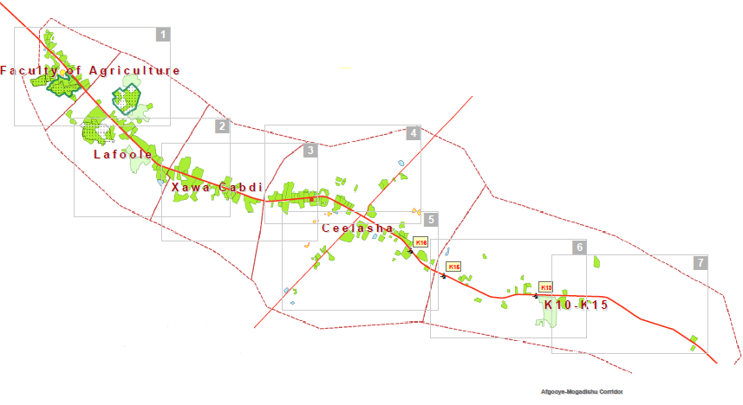
8 – 14 September 2014

Drafted by:
ACF International
Mogadishu – Somalia
TABLE OF CONTENTS

1 EXECUTIVE SUMMARY 3
2 OBJECTIVE 3
3 METHODOLOGY 4
4 LIMITATIONS 4
5 KEY FINDING 4
5.1 FOOD SECURITY & LIVELIHOOD 4
5.2 NUTRITION 5
5.3 HEALTH 5
5.4 SHELTER 6
5.5 WASH 7
6 HUMANITARIAN ACTORS 9
7 SECUIRTY & LOGISTICS 9
8 RECOMMENDATIONS 9
9 CAMP DETIALS 10
10 LIST OF PARTICIPANTS 11

EXECUTIVE SUMMARY
The Afgoye corridor including Arbis, Hawo Abdi & Elasha has been hosting many IDPs since 2007. In the past six months of 2014, new IDPs arrived due to the military offensive and clan clashes in Lower shabelle region, approximately more than 2500 HH of IDPs are either living in substandard make shift huts or are hosted by resident families in the target areas.

The majority of IDPs originate from Lower shabelle and Banadir Regions while others are from Bay, and Bakol Regions. Those were living here since the last drought as the community confirmed during the assessment. At the moment, there are approximately 19 settlements which have been assessed. Those are in urgent need of a humanitarian intervention including WASH, FS&L, Nutrition & Health.

Lack of essential services and poor community coping mechanism have led more vulnerable to water-borne diseases especially AWD, malnutrition status, disease outbreak frequently damaged for vulnerable household addition to livelihood deterioration and general economic recession from host community those cannot offer any support to the newly IDPs.

OBJECTIVE

The main objectives of the assessment:

- To obtain overall IDP situation in Arbis, Hawo Abdi, Lafole & Elasha areas.
- To identify gaps and prioritise immediate humanitarian needs of the vulnerable affected populations.
- To identify potential response options to address immediate to longer-term humanitarian needs in the affected areas.

METHODOLOGY

The assessment was executed through collaboration with Local Authority, host Community and IDPs camps those in Lafole District from 08th – 14th Sept 2014. This information has gathered two major methods including:
- Key Informant Interviews (KIIs),
  - IDPs Committee,
  - Community leaders.
  - Host community.

- Field Observation:
  - Shelter &WASH sector
  - Nutrition & Health IDP status.
  - FS& Livelihood
  - Security & Logistics.

Through these techniques and tools, relevant qualitative information was collected that can be reliable sources for future implementations of humanitarian projects.

LIMITATIONS

Due to security constraints, limited timeframe, the assessment had done through collecting basic information to provide a snap short of overall situation and considered main sectors and gaps in IDPs area, therefore; this will highlight major humanitarian context both host and IDPs communities in Lafole District to give us an indication of the situation.

KEY FINDING

FOOD SECURITY & LIVELIHOOD
The Multi-sectoral Assessment was carried out in three different Locations: Arbis, Hawo Abdi & Elasha in Lafole District. The food security and livelihood survey focused on key ‘themes’; sources of food which mainly depends on Agricultural production, pastoralists and local markets while Sources of income depends on small business/petty trade, and casual labours in IDPs communities as well as expenditure patterns depends on the level of household income. In view of the fact that both men and women make significant and most often very distinct contributions to the household economy are integral in determining household food security.

The assessed displaced population relies mainly on casual labour in agricultural area. These Communities also practice food production, Animal Husbandry and small scale business, casual labour on tenant lands and Green Leaf collection while most of the mothers Collecting Grass/ Pasture for the Animal in their locations to create some income for their family.

During the last drought crises 2011, the majority of IDPs shifted to Mogadishu and Elasha (e.g. Badbado camps near KM7 in Dharkenley District) to survive on the little humanitarian aid available there while some others remained in Lafole District.

NUTRITION
Some Malnutrition cases (<5 children as well as Pregnant and Lactating Women) were found among the newly arrived population in the Lafole area. According to their copying mechanism is very poor depend on casual labour in nearby farming area in Afgoye District, while most women depend on maid, begging and small kiosks. The food price is a bit expensive rather than Mogadishu as high inflation of food price exists which made them not to afford.

During the past two years, no nutrition intervention took place in the area although several LNGOs had previously worked during last drought 2011, but currently not functioning in Lafole District

HEALTH
In Arbis area, there is a MCH/OPD centre established by Islamic Relief in June 2009 which is run by Somali Women Concern Organization during last drought of 2011 but currently not functioning nearly years while AMISOM sometime provides medical support to the IDPs which is not adequate to health needs exist in the area.
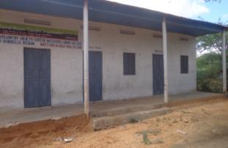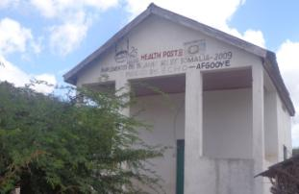
SWC – MCH/OPD Centre
GPRS
N 02°06.673°
E045°09.136°

Islamic Relief – Health Post centre

In Lafole area, another MCH/OPD centre exist which run by HIJRA since 2007 those provides medical treatment as observed. This is the only free medical centre which they depends on both host community & IDPs as below shown:
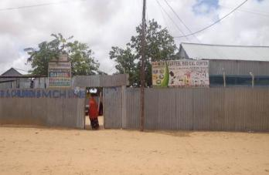
HIJRA – MCH/OPD Centre

GPS Point:

N 02°06.130°
E045°09.024°

SHELTER
Proper shelter was invisible as people were living in temporary houses made of polythene bags and sticks. This has increased poor structure vulnerability and lack of protection regarding to Shelter typology system. 90% of IDPs have un-planned settlement while 10% settled university building in Lafole those are part of IDPs.
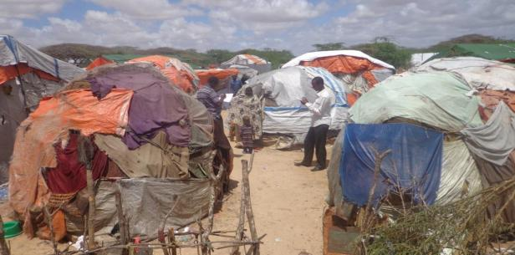

WASH

Water accessibility:
Several water sources are available, including private boreholes and AMISOM donation through pipe system in the corner of Arbis village, which is approximately 500m far away from IDP settlements. Some few camps have access to free water but most people cannot reach this free water due to the distance to be covered; only one pipeline extension is reaching to where inhabitants buy water from private boreholes. Overcrowding at water source is always witnessed with people seen queuing for more than 10 minutes in AMISOM base.

Due to the failure to continue previous piping system, and none-functioning constructed of Burkads in IDP area were extremely deteriorated to have safe access water sources. Burkads and pipes have already collapsed due to lack of maintenances. Access to credit and water payments to vulnerable community were extremely limited due to lack of income from own production.
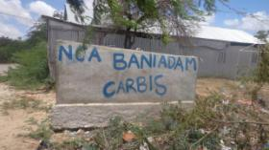
BARKHAD - LIBAN IDP CAMP

In terms of Elasha area, IDPs have access to water sources through previous boreholes in(WAKALADA) which is functioning since Barre government but currently limited to high charge (2,000 sh.so/20ltr) and most couldn’t afford to pay while some none function pipes constructed during last drought season.

Latrine, Hygiene & Sanitation:
A very poor state of latrine facilities has been observed where most of those used are actually outside of the camp parameter. This has caused inadequate latrine facilities, contaminated water and poor garbage disposal in IDPs areas has left behind main sanitation and hygiene problems affected by vulnerable health in Lafole District. The Hygiene situation is at the lowest level as shown below:
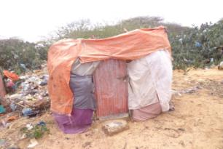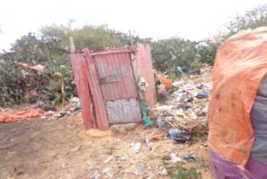
Open defecation is a common practice in the camps due to limited availability of latrines, and poorly constructed latrines, filthy and almost full to the prim which are made thatches and sticks were used whereas cleanliness was never observed and garbage could be seen everywhere.

HUMANITARIAN ACTORS

- Previous Actors:
During last drought 2011, Some INGOs/NGOs have worked in Arbis, Hawo Abdi, Elasha those implemented several project as following:
  - Islamic Relief – both construction & rehabilitation of wells as well as implemented Health post in Arbis.
  - Muslim Aid – MCH/OPD Centre in previous Lafole University area, but not function at moment.
  - SWC – implemented by MCH/OPD centre in Arbis area.
  - Bini-adam – constructed Burkads and pipes systems.
  - Hormud Foundation – Constructed by wet feeding centre since 2011 during last drought displacement.
- Current Actors:
  - Only HIJRA – implements MCH/OPD center in Lafole District.

SECUIRTY & LOGISTICS
During Observation, two Military bases in Lafole District which is under control of AMISON & SNF (Xero Kacan Base) both entry and exit controls. The Communities have no challenges regarding to security concerns although under control of Lafole Administration Authority.

According to Logistic, accessibility of transportation means is available always and there is no constraints or challenges exist except normal events such explosions, or road blocks. There is only one way from Afgoye to Mogadishu which is mainly use all time.

rECOMMENDATIONS
Based on assessment outcome in IDPs, the team has recommended following points:
- To rehabilitate Water Points including previous piping system and Burkads to increase water accessibility of safe water in IDP zone.
- Hygiene promotion and sensitization should be highly considered in vulnerable IDPs area; therefore, Hygiene promotion should include future project implementation to raise community health awareness and acceptance of behavioral changes in vulnerable groups.
- To establish income generation activities in vulnerable household through cash grants, vocational trainings, and tools to reduce hunger and poverty level among community.
- Enhance local production among Agricultural community through seed distribution, tools and relevant train skills to reestablish better livelihood system.
- To establish proper shelter typologies such CGI–(Corrugated Galvanized Iron) and enhance shelter protection concerns.
- To establish health/nutrition centers to reduce vulnerability and enhance health status among IDP communities.

CAMP DETIALS

Table 1: List of Major Camps in Lafole District – Shabelle Region – Somalia.
S/N | CAMP NAME | Location & District | GPRS Point | # of Households | ORIGIN
 | DUROW IDP CAMP | Arbis – Lafole District. | N 02°06.767°  E045°09.244° | 110 HH | - Buulo.  - Qoryooley
 | SHAMOW IDP CAMP | Arbis – Lafole District. | N 02°06.834°  E045°09.178° | 172 HH | - Bulomarer.  - Farhane  - Kunturwarey
 | AL-AAMIN IDP CAMP | Arbis – Lafole District. | N 02°06.746°  E045°09.255° | 50 HH | - Qoryoley.
 | AL-AHLI IDP CAMP | Arbis – Lafole District. | N 02°06.822°  E045°09.148° | 240 HH | - Farhane  - Kunturwarey  - Bulo-marer
 | HAMDI IDP CAMP | Arbis – Lafole District. | N 02°06.691°  E045°09.269° | 40 HH | - Lower sh.
 | KUSOW IDP CAMP | Arbis – Lafole District. | N 02°06.704°  E045°09.247° | 75 HH | - Qoryoley  - Golweyn
 | JIMCALE IDP CAMP | Arbis – Lafole District. | N 02°06.591°  E045°09.117° | 80 HH | - Qoryoley
 | LIBAN IDP CAMP | Arbis – Lafole District. | N 02°06.577°  E045°09.144° | 63 HH | - Burhakabo,  - Waamo villages.
 | EYL IDP CAMP | Jamacada – Lafole District. | N 02°06.052°  E045°09.600° | 120 HH | - Lower sh/  - Middle sh/
 | MUSBAH IDP CAMP | Hawo Abdi – Lafole District. | N 02°05.487°  E045°10.296° | 112 HH | - Farhane  - Abdi ali  - Turey.
 | AAMIN YARE IDP CAMP | Hawo Abdi – Lafole District. | N 02°05.459°  E045°10.305° | 130 HH | - Bulo-Marer  - Kunturwarey
 | DARYEEL IDP CAMP | Hawo Abdi – Lafole District. | N 02°05.494°  E045°10.378° | 100 HH | - Qoryoley.  - Bulo.
 | CAWALE IDP CAMP | Hawo Abdi – Lafole District. | N 02°05.505°  E045°10.358° | 50 HH | - Kunturwarey.  - Golweyn.
 | SAMO-SAMO IDP CAMP | Elasha – Lafole District | N 02°05.161°  E045°12.046° | 100 HH | - Bay & Bakol  - Middle sh/
 | SHABELLE IDP CAMP | Elasha – Lafole District | N 02°05.110°  E045°12.091° | 85 HH | - Jeebey.  - Farhane
 | HORSEED IDP CAMP | Elasha – Lafole District | N 02°05.120°  E045°12.123° | 350 HH | - Farhane  - Abdi ali
 | GARGAAR IDP CAMP | Elasha – Lafole District | N 02°05.172°  E045°12.096° | 320 HH | - Kunturwarey  - Bulo-marer
 | BASRO IDP CAMP | Elasha – Lafole District | N 02°05.241°  E045°12.155° | 55 HH | - Lower sh/

LIST OF PARTICIPANTS
Table 2: List of Assessment Members & Participating Agencies
Name | Agency | Mobile | Email
Mohamud Abdullahi Mohamed | ACF – ( Lead Agency) | 615-800-665 | Emergnecy.mo@so.missions-acf.org / Mohamudcm@hotmail.com
Diis Hassan Abdi | Polish Humanitarian Action– PAH | 616-202-321 | Diis671@hotmail.com/ diis.hassan@pah.org.pl
Hassan Ahmed Ali | Save the Children | 617-059-385 | Hassan.heef.@savethechildren.org
Zaima Abdullahi | DRC | 615-372-878 | Z.Abdullahi@drcsomalia.org

Physical observation

