NATIONAL ONLINE SHELTER CLUSTER MEETING MINUTES
15TH DECEMBER 2021 - 10:00-12:00

 | List of participants
# | Name | Organization
1 | Omar Hassan Mohamed | AYUUB NGO
2 | Mohamed Sheikh Dahir | DRC
3 | Ibrahim Dubat | HAPEN
4 | John Wanjohi | HAPEN
5 | Mohamud Abdillah | HAPEN
6 | Hameed Irfan | IOM
7 | Abdirahman Abdulkadir Yasin | Islamic Relief
8 | Ahmed Essa Omar | NRC
9 | Nadeem Ilyas | NRC
10 | Alexandre Koclejda | Shelter Cluster
11 | Nurta Mohamed Adan | Shelter Cluster
12 | Padmore Okal | Shelter Cluster
13 | Mohamed Omar | SOCDO
14 | Abdikarim Mohamed Noor | UNHCR
Agenda
- Introduction
- Drought Response
- Update from Shelter cluster partners
- Cash + Plastic sheeting
- Update on HRP
- 4W matrix update
- Contingency stock update.
- Presentation from NRC on shelter response in Baidoa.
- GBV risk mitigation technical working group.
- Localization workshop and action plan.
- Bamboo update
- AoB

- Introductions
The Shelter Cluster coordinator, Alex Koclejda, welcomed the meeting participants and presented the agenda of the meeting after a round of introductions. The meeting started at 10:05 hrs.
- Drought Response
- Somalia is the most severely drought affected country in the Horn of Africa. Over 2.8 million people are currently affected.
- At least 133,000 people have been forced into internal displacement due to the drought.
- A state of emergency was declared by the Federal Government of Somalia on 23 November with urgent appeals for international assistance.
- Additional humanitarian funding for priority sectors is urgently required to save lives and livelihoods in the most affected communities.
- The Shelter Cluster has advocated to include Funding for Shelter and NFI for people displaced by the drought.
- Updates from partners
- NRC is advocating for and optimistic to receive funding for Shelter and NFI drought response.
- HAPPEN is continuing with implementation of the shelter and NFI project targeting 2333 households in Belet hawa. However, there are reports of new displacements in Belet Hawa, Luuq, Bardere, Garbaharey and Dollow. HAPEN does not have further resources to respond to the new displacements.
- AYUUB has recently distributed 1450 NFIs and 1450 ESKs in Middle Shabelle Region through SHF funds. AYUUB, together with other humanitarian organizations have conducted rapid drought assessment for displaced communities in Qoryoley, Barawe, and Kurtunwarey Districts.
- SWS subnational coordination unit: has conducted shelter needs assessment for IDPs in Baidoa with a sample size of 383. The kobo tool was developed by the national cluster and data collection done by shelter partners in Baidoa.
- There are reports of high influx of IDPs displaced into Baidoa from villages ravaged by drought.
- IR is implementing drought response with a shelter intervention in Baidoa. They have constructed 12 shelters for IDPs in Abdula A IDP settlement, in Baidoa. They are optimistic to receive funds early next year for shelter response in SWS.
- SSWC reported the significant displacement from rural areas to Adado and Dhusamareeb due to drought.
ACTION POINTS:
- HAPEN to share with the Cluster assessment report from Bardere, Garbarey, Dollow, Belet Hawa, and Luuq.
- AYUUB to share with the Cluster the drought assessment report from Qoryoley, Barawe, and Kurtunwarey Districts.
- SWS subnational and the national Shelter Cluster to discuss and agree on how assessment data analysis and report writing will be done.
- SSWC to share with the Cluster a report on drought induced displacement into Adado and Dhusamaareb.
- Cash + Plastic sheeting
- The Cluster has had some discussions with UNHCR, IOM and SHF regarding emergency response which highlighted the slow speed of emergency response by the Cluster.
- The Cluster has suggested to include a preparedness plan in SHF. This will include prepositioning cash and plastic sheet in every new SHF allocation so that response can be done within few weeks.
- Cash has been proposed due to PDM results which has shown that beneficiaries prefer cash to in-kind assistance. However, it has been observed that the quality of plastic sheeting procured in the local market is poor. Therefore, the Cluster proposes to include in-kind plastic sheets.
ACTION POINTS:
- Shelter Cluster to have further discussions within the SAG regarding the cash + plastic sheet proposal.
- Update on HRP
- The Cluster has finalized the 2022 HRP process and has presented the proposals to OCHA. HRP proposals from 21 partner were approved by the cluster.
- These targeted around 1.2 million people with the following: NFI -800,000 individuals; ESK – 420,000 individuals; site decongestion and infrastructure support – 52,000 individuals; transitional shelter – 28,000 individuals; and durable shelter-10,000 individuals.
- The total financial requirement for HRP 2022 for Shelter Cluster is 58 mullion USD.
- 4W matrix update
- In November 2021, cluster partners reached 24,906 individuals with shelter assistance, and 24,141 individuals with NFI.
- In total, cluster partners have reached 199,155 individuals (9%) with shelter assistance, and 264,448 individuals (11%) with NFI of the 2021 HRP targets

- Contingency stock update
- The cluster has received October contingency stock updates from IOM and UNHCR.
- The stock dashboard can be viewed here: https://www.sheltercluster.org/response/somalia
- Subsequent calls for 4W matrix updates will include a page for contingency stock data to be filled by partners.
ACTION POINTS:
- Cluster to organize a 1 hour session for partners on how to share contingency stock data.
- Partners to start sharing their contingency stock data when updating the 4W matrix.
- Presentation from NRC on shelter response in Baidoa
- In May 2021, Norwegian Refugee Council (NRC) received funds from SHF to construct 50 Transitional shelters at Awal Barwaqo and Keerow Margan-2 IDP camps.
- This was a community driven prototype featuring local designs, techniques and materials.
- NRC gave a presentation of the 5 different Shelter prototypes that were selected by the community to be piloted.
- Details of the presentation can be viewed here: https://www.sheltercluster.org/working-group/pilots-sustainable-shelter-solutions
ACTION POINTS:
- NRC to share a draft PCM tool with the Cluster for inputs and endorsement by the SAG before conducting the PCM by early 2022.
- GBV risk mitigation technical working group
- The cluster plans to activate GBV risk mitigation Technical Working Group at the beginning of 2022. The purpose of this TWG is to look for solutions for making the shelters safer by:
- Providing situation analyses to guide programme design and understand the impact of current shelter and NFI Response on GBV
- Identifying potential issues and improvement
- Providing guidance and technical support to be adopted by cluster partners
- Coordinating training for cluster partners.
- Terms of reference have been written and shared with the GBV AoR as the Cluster would like this TWG to be Co-lead by the GBV AoR .
ACTION POINTS:
- Partners interested to join the TWG to inform the Cluster.
- Localization workshop and action plan
- The shelter cluster in collaboration with the localization focal point (SSWC) is planning a half day workshop for the shelter partners tentatively in January 2022. Invitation for the workshop will shared with more details.
- The workshop will be attended by shelter cluster partners and other stakeholders.
- The objectives of the workshop are:
- To learn more about the facts of localization
- To get feedback from local partners about what they need
- To discuss opportunities for the shelter cluster partners to maintain its pledge for broader localization efforts in 2022.
- Develop the Shelter Cluster localization action plan.
ACTION POINTS:
- The Cluster to discuss bilaterally with SSWC the plan of the localization workshop.

- Bamboo Update
- HAPEN gave a presentation on bamboo farming piloting in Kismayo and Belet Hawa. The main purpose of this pilot is to address the issue sustainability in large scale shelter construction, address shortage of wood by introducing an alternative construction material, and open economic opportunities.
- Interesting links of examples of Bamboo use:
- http://shelterprojects.org/shelterprojects2011-2012/A09-Ethiopia-DolloAdo-2011.pdf.
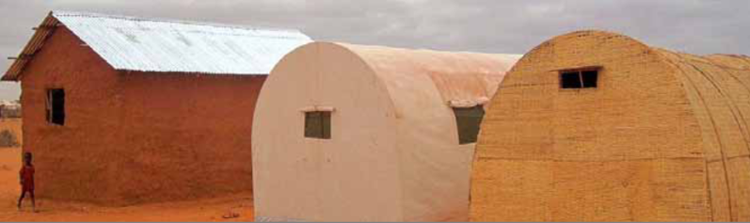
- https://shelterprojects.org/shelterprojects8/ref/A11-bangladesh180821.pdf
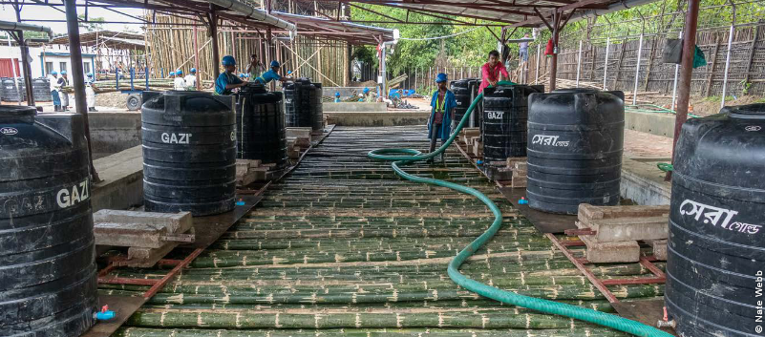
- The proposed piloting sites are riverine areas in riverine areas in Kismayo (Yontoy and Gobwe) and Belet Hawa (Malkariyey farm).
- The roll out plan includes:
- Import initial bamboo seedlings from Kenya
- Start with about three varieties by the end of this month then narrow down to the best performing
- Encourage more farmers to plant and grow the better performing variety
- Mobilize resources to expand and popularize bamboo based on performance and benefits.
ACTION POINTS:
- The Cluster to put HAPEN in touch with FAO and UNHCR who are exploring similar initiatives.

- AOB
Partners have requested the Cluster to plan coordination meetings so that they do not clash with other cluster meetings like WASH cluster.
ACTION POINTS:
The Shelter Cluster discuss with the WASH Cluster the issue of meetings calendar
- Adjournment
There being no other business, the meeting was adjourned at 12.07 P.M. EAT.

