Template for Shelter Cluster Partners on Beneficiary Targeting and Prioritisation

Purpose of this document
This document aims to support Shelter Cluster partners in the targeting and prioritisation of beneficiaries for the purposes of delivering shelter assistance to families in dire need, particularly where resources are limited and a “blanket” approach to distributions is not possible or appropriate for agencies.
It offers a “score-card” “prioritisation” approach to support the identification of families which are especially vulnerable and in need of priority assistance.

Principles for targeting and prioritisation
The Shelter Cluster’s strategic goal is to deliver a shelter response that supports appropriate, flexible, progressive solutions to affected, vulnerable populations that contributes to their own self recovery to provide a safer, more resilient and durable shelter.
This goal is underpinned by a number of principles, which are also usually included in the Shelter Cluster Strategy. Of relevance to beneficiary targeting and prioritisation are the following:
- Families impacted by the earthquake come from a wide variety of pre-existing socio and economic circumstances and geographic conditions. These differences may result in differing levels of vulnerability and may mean that underlying needs for assistance may not be homogenous and may require more informed and flexible approaches and a variety of considered solutions. Assistance solutions should involve affected people themselves through consultation in the planning, implementation, and monitoring and evaluation steps in delivering the assistance required.

- “Appropriateness” will be understood as shelter interventions which align with the needs of affected families/communities and with best practices as recommended by the Government of Tajikistan and IFRC co-led Shelter Cluster.

Vulnerabilities
In terms of the socio-political context, the impact of the earthquake will be varied and mediated in some cases by dimensions of poverty/vulnerability, and can be exacerbated by pre-existing situations and conditions. Poorer building materials and poorer quality of construction have rendered houses more vulnerable to damage/collapse; geographic remoteness or lack of political leverage or representation renders some social groups less able to access relief/support. There is a need to take into consideration that groups have varied capacity and access to resources for self-recovery. Some groups have fewer assets or networks, and this often correlates to poverty and historical marginalization. From this lens (and taking stock of wider dimensions of vulnerability), some people need greater assistance than others.
Factors that contribute to vulnerabilities are many and varied, and often it is the intersection of a number of these that have a greater impact on a person/family’s capacity to access resources and to rebuild. Important considerations include family composition and socio-economic factors; gender, disability, age, ethnicity, income, education, etc (refer to the score card below for a more comprehensive list). Also key is geography and remoteness, as well as physical capacity to rebuild. All of these therefore have implications for the type and level of assistance required. The score card is a tool to facilitate the documentation and analysis of as much of this information as possible, and to then use (score) this information to assess relative vulnerability in the target population.

Approaches to beneficiary selection
There are two ways that assistance can be provided; either a ‘blanket’ or ‘targeted’ approach. Annex 1, Approaches to Beneficiary Selection provides more detail on these two approaches in terms of the opportunities and risks and provides some guidance re-risk mitigation on best practice for implementation modalities, and suitability of response options based on needs and monitoring.

About the score card for beneficiary prioritisation
Below is a score-card to assist household prioritisation (for a targeted approach to emergency shelter). The score card can also be used later for permanent shelter with some modifications as deemed necessary.
Should the Government of Tajikistan introduce its own prioritisation tool and/or process then that will supersede this tool.

Rationale for the score card approach
Due to the limitations of funding, it is not always possible to reach all the people in need of humanitarian assistance for shelter. Therefore, it is crucial to use existing funds to target and prioritise the most vulnerable households and settlements i.e. those most at risk due to social-economic conditions as well as their capacity for self-recovery and/or to prepare for monsoon and winter seasons to achieve safer sheltering options.
This will require targeting geographically, considering the existing hazards (i.e. Floods and landslides that will further impact displacement) and, within those identified areas, targeting the families most in need based on a range of criteria.
Such targeting should consider personal factors such as the family composition, along with a family’s capacity to recover (for example what resources are available for rebuilding, including salvaging and market resources and access), as well as taking account of environmental issues (such as exposure to known and potential hazards and risks).
This tool brings these key factors together and adds a weighting process to assist with prioritisation; however, agencies are advised to consider the local level situation and make informed choices on the best and most appropriate approach. At the core of the Shelter Cluster’s approach is the objective of supporting self-led recovery and building back safer sheltering.

What this tool is and is not
This is a beneficiary prioritisation tool. It is not a household assessment or a needs assessment tool. It is not a tool for selecting communities and it does not replace community consultation processes. The function of this tool is to assist with filtering assessment data through a vulnerability lens. As a tool, it may be amended or adapted by users to suit their organisational processes and systems.

Families rather than households
It is recommended to use this tool is to prioritise families rather than households; the intention behind this is to consider that many people are living together temporarily because of the earthquake, and that to assess them together as a household unit may not be the best method of assessing vulnerability (for the purpose of shelter) for the medium to longer term.

Who can use this tool?
Any organisations, large or small, government or non-government willing to contribute in the post disaster response, who do not already have processes, systems and practices to filter and analyse assessment data through a vulnerability lens.

How to use this tool?
Each family in an identified distribution area should be assessed in accordance with the scorecard. The higher the score in the score card, the higher priority the family should have for receiving assistance.
Ideally the information you have already collected (primary or secondary) in your assessment process should be fed into this prioritisation tool, or alternatively the tool could be used to inform agencies assessment framework. If agencies have a computerized database to record household assessment data then it may be possible to design a formula that attributes the right information into the prioritization categories and can then automatically calculate the score. However without a database that can undertake this function, it will be necessary to attribute and score the criteria manually.
Users are strongly encouraged to validate assessment data to ensure that all families/households are included and double counting is minimised.

No minimum scores
There is no proposed minimum score attached to this tool or ranking process; more simply it is suggested that those families who score the highest are prioritized within the context of available resources.

Other resources
The development of this tool should be informed by Shelter Cluster Partner discussions and linked to fund-raising mechanisms.
The following documents can serve the development of the tool:
- Vulnerability Criteria (Protection Cluster) March 2014 (Typhoon Hiayan, Philippines)
- Minimum Standard Commitments to gender and diversity in emergency programming (pilot), International Federation of Red Cross and Red Crescent (2015)

Score-Card to Assist Beneficiary Prioritisation
(FOR A TARGETED APPROACH TO SHELTER SUPPORT)
Precondition: This criterion must be met before proceeding with this checklist |  | Yes/No
- House is totally damaged and family is presently displaced OR is house is partially damaged and is unsafe
If the answer is yes to the following statements, apply the allocated score. If the answer is no, the score is 0.

Vulnerability criteria for priority assistance:
A. Family composition and social characteristics | Points |  | Score
- Household is headed by a single woman (widow, unmarried, divorced/separated) | 2
- Elderly-headed household (60+) | 2
- The family is made up of more than 5 members | 2
- There are children in the family less than 5 years of age | 1
- Caring for separated, unaccompanied or orphaned children. | 1
- Family with pregnant and lactating women | 1
- Child-headed household (head of household is below 18 yrs. old) | 2
- Family member(s) have a disability, chronic illness or special needs (physical, mental, sensory, behavioural, cognitive or emotional impairment or limiting conditions) | 2
- Member of traditionally excluded group including religious minority, GLBTI, bonded labourer) | 1
Total this section: | 17
B. Social and Economic Characteristics | 0
- Family lives below the poverty line (below XXXX annual income) | 2
- No one in the family is currently engaged in income generating activities | 2
- Family debt repayment exceeds total income (including remittances) in the last year | 1
- Family has needed to sell assets or take loan(s) since the earthquakes | 2
- No adult (18 yrs. +) in the family has received formal education | 2
- Household does not have or has lost key documentation (citizenship, marriage, birth certificates, land or property deeds/agreements) and/or report not being issued a ‘victim’ card for access to relief/recovery support | 1
- Property is self-occupied, or family is a renter | 2
- Other known vulnerabilities (undocumented, refugees, trafficked person) | 2
Total this section: | 14
C. Family Capacity to Rebuild – Physical and Geographical
- Family with no adult (16-60) physically able to rebuild | 2
- Head of household has died or incapacitated as a result of the disaster | 2
- Family is unable to salvage/reuse 50% available materials | 2
- Household is more than 1 day travel from nearest market | 2
- Household is only accessible by foot (more than 2km from nearest road) | 2
- Household is particularly vulnerable to further disaster (landslide, floods) | 2
- Market is not functioning | 2
Total this section: | 14
Total: | 45

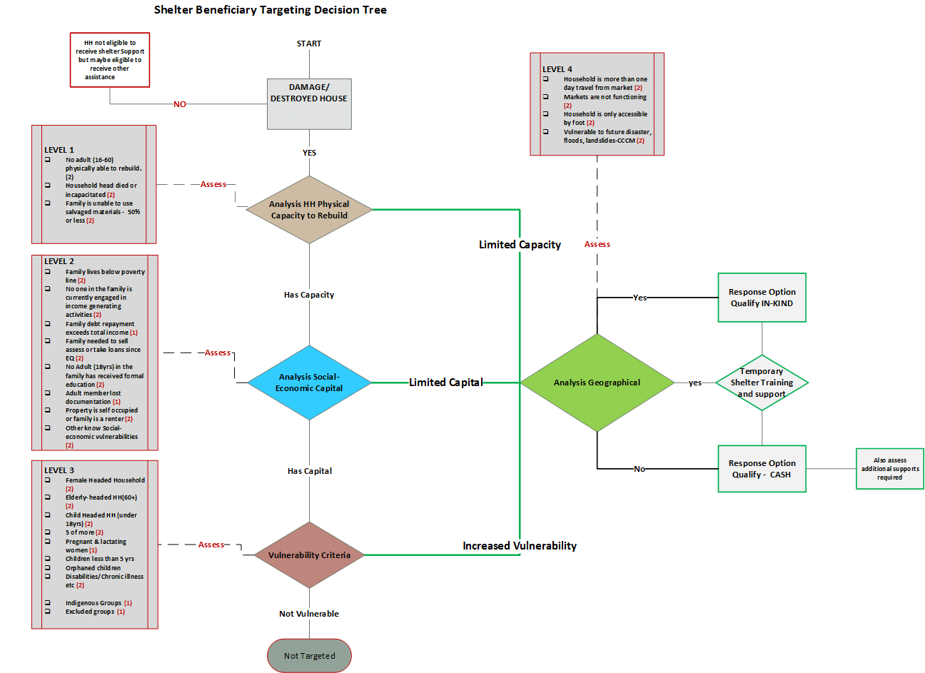
Annex 1: Approaches to Beneficiary Selection

Approaches | Opportunities | Risk | Risk mitigation
‘Blanket ‘Approach (Community level approach/ locational) reaching all households damaged or partially damaged with relief and/or temporary shelter assistance. | - Reach maximum number of population  - Easy to ensure participation of community  - Efficient and timely, in that ‘blanket’ avoids a more detailed needs assessment and associated analysis  - Risks around partiality/politics/social disparity of prioritization avoided | - Ignores severity of the impact of disaster or need of assistance (potential waste of resources)  - Spreading resources thinly, not meeting acute needs or expectations for the most vulnerable populations  - Potential need to wait until sufficient resources are gathered before distribution causing detrimental delays  - Agencies are not in position to report on severity indicators  - Agencies not meeting donor requirements  - Agencies unable to maximise coverage | Specific to ‘Blanket’ Approach:  - Potential ‘top-up’ targeted assistance to most the vulnerable  - smaller response option that may not meet the needs for shelter interventions  Applicable to both approaches:  - Understand the context, history of socio-political relations  - Understand existing social divisions and map them against the proposed criteria  - Ensure capacity and skills of the communities and supporting organisations (their staff and volunteers) and coverage  - Establish a communications strategy and ensure effective implementation  - Sustained information sharing with both beneficiaries and non-beneficiaries on targeting criteria and selection processes  - Ensure that complaints are adequately addressed and followed up.  - Ensure robust M&E in place and use the data/evidence to refine/strengthen processes  Specific to Targeted Approach:  - Facilitate community participation in determining targeting criteria  - Test proposed targeting criteria with communities to achieve required outcomes for programmes  - Engage District Disaster Relief Committee
‘Targeted’ approach (Household or level approach or other grouping community groups) | - Enabling maximum appropriate solution for those most in need of assistance  - Potentially counter-acts exclusion and mitigates ongoing vulnerability of affected population  - More community/ household/ individual engagement, creating opportunities for participation  - Agencies in position to collect household level data for reporting on indicators | - Shift from blanket distributions to targeted interventions could result in a backlash from those who expected to benefit or who will lose out, including against the recipients of assistance themselves  - Needs assessment is more time consuming to collect, verify and analysis data  - Targeting criteria might not be well understood by all stakeholders  - Selection processes might not be transparent or fairly implemented  - Political interference possible

Please also note that by focusing on families there are people who fall outside a family arrangement and are therefore at risk of being omitted from humanitarian assistance. Extra effort is required to include this group of people.
Tool recognised as best practice in the report ‘The Evolving Picture of Displacement in the Wake of Typhoon Haiyan (An evidence based overview), IOMIDMC (May 2014) p.42
Note: distinctions across categories are not always clear cut; it is acknowledged that characteristics in Part A all have socio-economic impacts; and together Parts A and B have implications for capacity to rebuild. Every effort has been made here for ‘best fit’ and to avoid duplication (and hence double counting) across categories.
Temporary shelter assistance must contribute to households or/and communities achieving adequate temporary shelter solutions that contributes to self –recovery and/or monsoon temporary shelter.
Selecting

