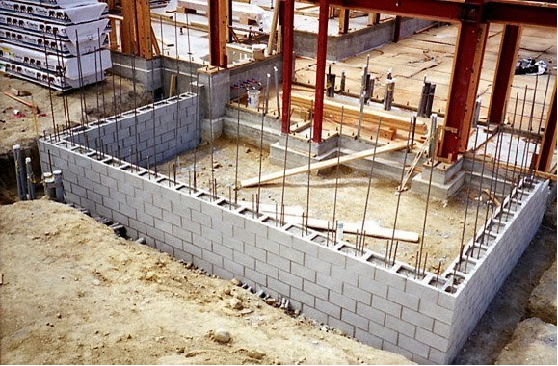

Overview video: http://video.arup.com/?v=1_isyi5dwf
Full-scale testing at 1.0g: https://www.youtube.com/watch?v=Oqyyky1vUJ8
Timelapse of construction: https://www.youtube.com/watch?v=rncbTUJlbHg
IStructE website: https://www.istructe.org/features/august-2015/homes-for-el-salvador
Photos during construction: https://plus.google.com/photos/100442608797967788097/albums/6106645542059619697?authkey=CO6p8_a0_NLSYQ
Photos on complete: https://plus.google.com/photos/100442608797967788097/albums/6106627880516249857?authkey=COy1ruzY1_nJKQ
Photos of shake-table testing: https://plus.google.com/photos/100442608797967788097/albums/6062113547299831457?authkey=CLCt25XP1_fyogE
Arup website: http://arupcommunity.org/projects/r/resilient-housing-for-el-salvador
Photo of the blockwork system is attached

