Gender and diversity in emergency shelter programming

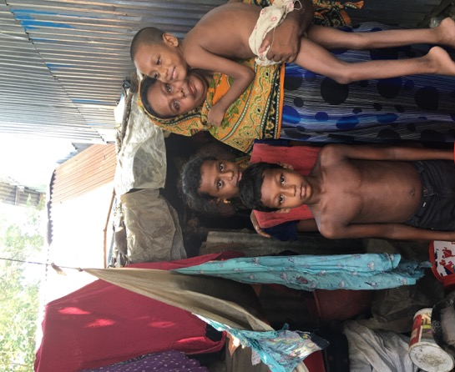

INFORMATION BRIEF

NOV 2017

About this Information Brief

This information brief was prepared by the Bangladesh Shelter Cluster to support agencies delivering emergency shelter to:
- Better understand the importance of including gender and diversity into emergency shelter programming in Bangladesh.
- Improve the responsiveness and inclusiveness of emergency shelter for people with special needs in Bangladesh.
- Identify key resources for further information.
The brief draws extensively on the work of other agencies and guidance documents, which are referenced at the end of this brief.

Contents
Gender and diversity in emergency shelter programming 1
About this Information Brief 2
Contents 2
What is gender and diversity? 3
Why is gender and diversity relevant in emergencies? 3
How should emergency programming respond to gender and diversity? 6
Four areas of focus to consider when programming for gender and diversity. 6
How to integrate gender and diversity in emergency shelter programming 8
Shelter needs assessments 9
Protecting Dignity 10
Settlement planning and site layout 10
Shelter design 11
Ensuring access 12
Beneficiary selection 12
Distribution points 12
Design of shelters and infrastructure 12
Cash transfers for shelter 13
Equality 13
Safety measures 14
Consultation and communication 14
Construction and repair 14
Facilitating participation 15
Consultation on needs and priorities 15
Diversity of assessment and response teams 15
Representative committees 16
Equal involvement in activities and training 16
Monitoring 16
Improving safety 17
Security of shelters 17
Separate and safe areas 17
Protection of children and young women 17
Gender based violence 18
Further resources 19

What is gender and diversity?

Gender refers to the social differences between females and males throughout their life cycles. These social differences between females and males are changeable over time and are different both within and between cultures. Gender determines the roles, power and resources for females and males in any culture.

Diversity means acceptance and respect for all forms of difference, including for example: gender, sexual orientation, age, disability, HIV status, socio-economic status, religion, nationality and ethnic origin, including minority and migrant groups.

Why is gender and diversity relevant in emergencies?
In Bangladesh, as elsewhere, women face more difficulties when exposed to disaster and emergencies.
- Women have restricted livelihood opportunities and lower rates of education, hence, women and in particular, women-headed households experience more poverty, less access to decision-making and less ownership and control over assets.
- Women practice various forms of self-sacrifice which they see as in the family interest, such as taking less quality and quantity of food and are less likely to go to a medical centre for their health issues.
- Women carry an unequal burden of household tasks and the care of family members. Their mobility outside of the home or away from their immediate family / community is often restricted.
- Unaccompanied girls, women headed households, the elderly can struggle to access secure shelters and may have difficulty reaching distribution points.
The incidence of gender-based violence (GBV) increases during and after emergencies.
- 87 percent of ever-married women in Bangladesh have experienced some form of violence (Bangladesh Bureau of Statistics 2013).
- A 2008 study found that 71.6 percent of women were subject to more violence during disasters.
- Married women mentioned an increase specifically in physical and psychological forms of violence.
- Sexual harassment including forced sex, rape at home and in shelters were also reported by women and girls.
- Many women and girls do not take refuge in shelters during disasters due to a lack of personal security.
- Sexual violence can have long-term impacts on the health of women and girls affected, including increased exposure to sexually transmitted infections (STIs) and unwanted pregnancy.

Other social factors, including age, disability, health status, social status and ethnicity, also shape the extent to which people are vulnerable to and affected by emergencies.
- These differences must be recognised and incorporated into all emergency responses.
- Understanding those with specific needs and the obstacles they face can help the development of more effective programmes and ensure that people’s needs are met.

How should emergency programming respond to gender and diversity?

Emergency response programming needs to be tailored to meet the specific and diverse needs of all.
- This is achieved through consultation as well as gender and diversity analysis, design and implementation.
- Adopting a gender and diversity perspective also highlights opportunities and resources that support reconstruction and recovery efforts.

Four areas of focus to consider when programming for gender and diversity.

- Dignity
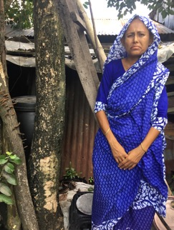
- The right to life with dignity is reflected in the provisions of international law.
- The concept of dignity means different things to different people and is influenced greatly by the cultural and social context.
- Safeguarding the dignity of those affected is a fundamental part of humanitarian work and should be prioritised in all emergency response programmes.

- Access
- Emergency response programmes should provide access for all individuals and sub-groups within the affected population.
- Beneficiary selection and prioritisation criteria must be informed by a gender and diversity analysis to ensure that the assistance and protection reach the most vulnerable.
- Four dimensions of accessibility can be identified in relation to humanitarian assistance and protection: non-discrimination, physical accessibility, economic accessibility/affordability and information accessibility.

- Participation
- Participation refers to the full, equal and meaningful involvement of all members of the community in decision-making processes and activities that affect their lives.
- The level of participation that different people will engage in will depend upon how rewarding they find the experience and whether they gain something from the process.
- Instead of informing and deciding for people, we listen to them and facilitate discussions and analysis with affected people so that they can identify their own priorities and preferred outcome

- Safety
- Females and males of all ages and backgrounds within affected communities have different needs in relation to their physical safety.
- Monitoring the safety of project sites from the perspective of diverse groups is essential.
- Safety considerations should include gender-based violence, child protection and sector-specific safety issues.

How to integrate gender and diversity in emergency shelter programming

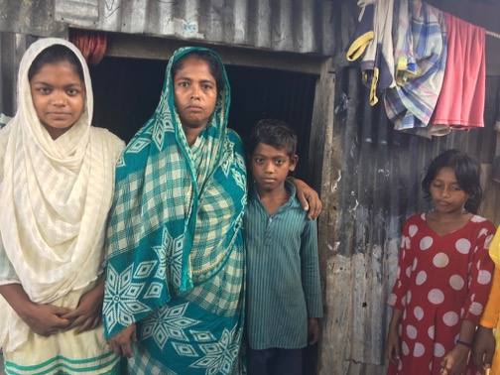

Shelter needs assessments

All shelter agencies should collect sex and age-disaggregated data (SADD) as part of their assessment.
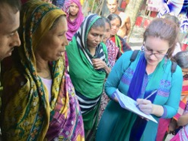
- Collecting SADD informs better planning of shelter interventions and achieves greater gender equity in meeting the needs of the affected population.
Pic 1 It is essential to collect disaggregated data and information about the special needs of women, girls and other vulnerable groups
- It also helps specialised and mandated agencies to identify and respond to specific needs.

The following gender analysis questions should be incorporated into all assessments by agencies providing emergency shelter:

- What are the usual practices and cultural patterns for household and care arrangements for the affected populations?
- What are the concerns and needs of women, girls, boys and men in relation to emergency shelter(s)?
- What security solutions have been/were put in place in (all) emergency shelter(s) and settlement(s)?
- What modifications should be made on emergency shelter facilities for use by women, children, the elderly and the disabled, or do alternative means need to be provided?
- In what ways are/were women and men involved (if at all) in decisions that affect them regarding emergency shelter response and in the wider community governance structures?
- Do shelter agency key performance indicators (KPIs) track performance on gender?

Protecting Dignity

Settlement planning and site layout
- Settlement planning, site layout and shelter design should provide privacy and dignity, and be culturally appropriate for all occupants.
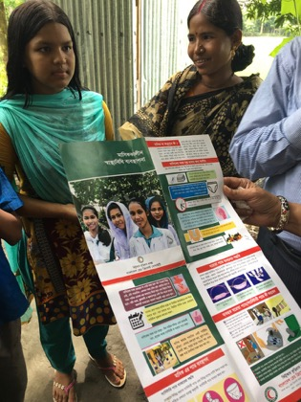
  - Ensure that protection or community services staff work alongside shelter specialists and site planners in all multi-sectorial assessments.
  - Identify separate and private space for women to bathe, wash and dry sanitary items.
  - Communal latrines should be separated between male and female.
  - Where possible, provide latrines at household level or shared between small family groups to better protect the privacy and safety of women and girls.
Pic 2 Particularly in congested urban areas, camps or collective shelters, women and girls need designated private space to attend to their hygiene needs. (Above: Distribution of menstrual hygiene awareness materials)

Shelter design
  - Materials for internal subdivision should be provided to individual households where needed
  - Consider screening around shelters to enable more privacy for women to carry out essential tasks outside the home such as cooking and hanging clothes.
  - Large families should be accommodated in a way which preserves family unity.
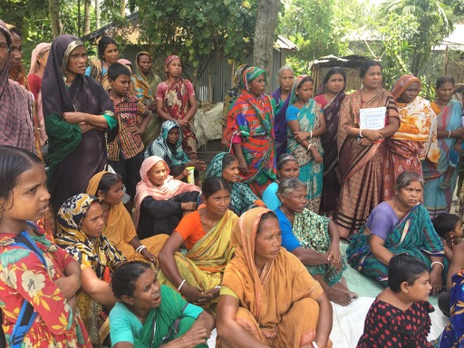
  - In collective shelters, families or social groups such as unaccompanied women should be grouped together and materials to screen personal and household space provided.
Pic 3 Consultation with communities, in particular women and vulnerable groups is essential for good shelter programming.

Ensuring access

Beneficiary selection
- The beneficiary selection and prioritisation criteria for participation in all shelter activities should be informed by a gender and diversity analysis to ensure that the activity reaches the most vulnerable.

Distribution points
- Consider household-level distributions for especially vulnerable groups, for example those with limited physical mobility and women unable or unwilling to travel outside of the home or community.

Design of shelters and infrastructure
- All shelters and infrastructure should be designed or adapted so that all people can physically access them, especially older people and people with disabilities, for example:
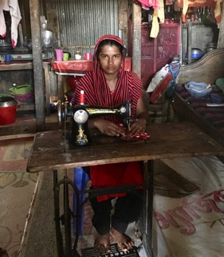
- Avoid steps or changes of level close to exits and provide handrails for all stairways and ramps.
- Allocate space on the ground floor, adjacent to exits or along access routes for occupants with walking or vision difficulties.
- Shelter design (internal or external) should enable access to cooking, washing, livelihood and sleeping areas.
Pic 4 Many women have home-based livelihoods which may need to be considered as part of shelter design.

Cash transfers for shelter
- Men and women often have different roles and make different choices about household expenditure, which ideally should be researched and understood prior to decisions about if, how and to whom cash transfers should be made.
- Cash transfers to women can be empowering and have positive impacts on resilience and family cohesion, but also have the potential to exacerbate family tension and conflict particularly in male-headed households, or place women at risk of exploitation, so these factors need to be considered during the assessment process.
- Cash transfers should always be accompanied by technical assistance and guidance to ensure that women without previous experience in shelter construction can make decisions about materials, safe construction techniques and employment of labour.

Equality
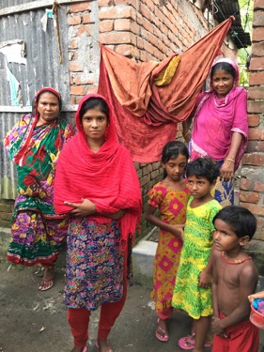
- Treat displaced persons equitably, whether they are living in host-family arrangements, collective centers, are self-settled in urban or rural locations, are self-settled in camps, or are living in planned camps.

- Shelter quality should be consistent across diverse groups, such as majority and minority ethnic groups.
Pic 5 Shelters should be suitable for household members of all ages and gender.

Safety measures
- Ensure that separate living areas for groups such as women, people with disabilities, marginalized groups and children are ‘safe’ including:
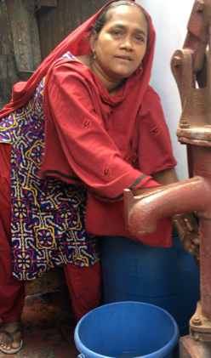
- Safe and central locations such as near families.
- Lighting in and around shelters and in communal areas.
- Windows and entrances that cannot be looked into.
- Secure entries or lockable doors if possible.
- Water and sanitation facilities in close proximity.

Consultation and communication
- The shelter should be designed in consultation with relevant groups.
Pic 6 Women are often responsible for collecting household water so these facilities should be located in a safe and accessible place.
- The affected community should by informed of shelter assistance entitlements and such information can be transmitted by radio, on a poster – in all relevant languages and picture format - at distribution points, at reception areas and around displacement camps/ shelter sites.

Construction and repair
- Special consideration should be given on how to support people such as female- and child-headed households, older people, people with disabilities in the construction/repair of shelter.

Facilitating participation

Consultation on needs and priorities
- Females and males of all ages, including those from marginalised groups, should be consulted about their specific shelter needs and priorities, tenure arrangements and other relevant issues.
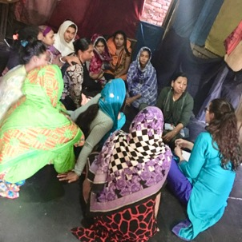
- Where possible, carry out single-sex focus group discussions with same-sex facilitators.

- Ensure that especially vulnerable people, such as people with disabilities, the elderly, young women and people from low socio-economic backgrounds are involved
Pic 7 Focus group discussions with women and girls are a good way to identify special needs for shelter planning.

- This information informs the design of all shelter facilities, services and activities.

Diversity of assessment and response teams
- Assessment and response teams should have balanced/fair representation of females and males, as well as marginalised groups.

Representative committees
- Shelter or community committees should have fair and balanced representation. This should include females and males and those from marginalised groups.
- Such representative committees should be involved at all stages of the shelter programme, including settlement planning, beneficiary selection, design and implementation of all shelter activities.

Equal involvement in activities and training
- Ensure females and males have equal or appropriate opportunities for involvement in all aspects of shelter construction.
- Consider childcare as part of cash-for-work schemes to enable greater participation of women.
- Females and males should receive equal pay for equal work.
- Women and other people who would not traditionally participate in shelter activities, should have opportunities for involvement in shelter training and other activities suitable to their interests and capabilities.

Monitoring
- Work with the community to set up monitoring or similar mechanisms to assess the living conditions of persons with specific needs in the community, such as older persons living without adult family members or child-headed households.

Improving safety

Security of shelters
- Shelter should be secure, with internal locks, lighting in and around communal areas, including latrines and bathing facilities, close proximity to accommodation, etc.
- Assess risks related to shelter safety including overcrowding; location of shelter; partitions for privacy and/or cultural purposes; locks and lighting; fire risk; and cost of rent.

Separate and safe areas
- Separate and safe areas should be established for children to play.
- A separate and safe area should be established for women to congregate.
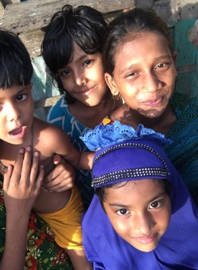

Protection of children and young women
Systems should be in place to protect unaccompanied children and young women, for example:
      - Ensuring registration
      - Separate safe shelter.
      - Access to basic services and goods.
      - Supervision by appropriately trained and approved personnel.
Pic 8 Unaccompanied children and young women are especially vulnerable during emergencies

Gender based violence
- Those at greatest risk of GBV should be involved in the siting, design, construction, management and coordination of shelter facilities including:
- Involving women and/or women‘s organisations and other at-risk groups
- Coordinating with other relevant sectors, such as WASH, health and protection.
- GBV survivors should not be sought out or targeted as a specific group during assessments. GBV-specific assessments should be conducted only in collaboration with GBV specialists or a GBV-specialized partner or agency.
- GBV specialists, if available, should be consulted to:
- Identify safe, confidential and appropriate systems of care for survivors who may share with shelter personnel that they have experienced violence.
- Ensure such personnel have the basic knowledge and skills to provide information to survivors on where they can obtain support.
- All humanitarian personnel should carry an updated list and contact details of agencies and professionals on GBV, child protection and formal and informal psychosocial support services to make referrals.`

Agencies which can provide further information and support on GBV:
- National Helpline Centre for Violence Against Women and Children: 109
- Multisectoral Programme on Violence Against Women: +880-283 210 41

- UN Women Bangladesh: +88 2 985 8593

- UNICEF Bangladesh: +880 2 556 68088

Further resources

Much of the content in this Information Brief is drawn from the following:
- IFRC, Minimum standard commitments to gender and diversity in emergency programming, Pilot Version (2015) Available here.
- Gender Equality in Humanitarian Action (GiHA) Working Group Gender Analysis Framework for Cluster Specific Gender Analysis for 2017 August Floods, Bangladesh Humanitarian Coordination Task Team (HCTT) (2017)
- UN Women, Baseline Study on the Socio-Economic Conditions of Women in Three Eco-Zones of Bangladesh (2014). Available here.
- UN Women, Disaster Management in Bangladesh: What Women Need (2015) Available here.
- Global Shelter Cluster, Shelter Programs: Tips for Protection Mainstreaming, Edition 1 (May 2014) Available here.
- Global Shelter Cluster, Site Planning: Guidance to Reduce the Risk of Gender-Based Violence, Trial Edition (September 2016). Available here.

Other key resources:
- IASC, Gender Handbook in Humanitarian Action (2006) Available here.
- IASC, Guidelines on Gender-based Violence (2005 and draft 2015) Available here.
- Child Protection Working Group (CPWG), Minimum Standards for Child Protection in Humanitarian Action (2012) Available here.
- Sphere Handbook (2011) Available here.
- Groupe URD, HAP International, People in Aid and the Sphere Project, Core Humanitarian Standard on Quality and Accountability (2014) Available here.

The information below is extracted from: Baseline Study on the Socio-Economic Conditions of Women in Three Eco-Zones of Bangladesh, UN Women, BCAS (2014).
The information below is extracted from: Disaster Management in Bangladesh: What Women Need, UN Women (2015)
The following information is extracted from the Bangladesh Gender Equality in Humanitarian Action (GiHA) Working Group, Humanitarian Coordination Task Team (HCTT), Gender Analysis Framework for Cluster Specific Gender Analysis for 2017 August Floods (September 2017)

