Shelter Cluster (NWSW) input to ICC Monthly Situation Report
Report for March 2021
Key figures
Indicators | Region |  | Total Reached
Indicators | NW | SW | Individuals | HH
# of households assisted with core relief items including prevention of COVID-19 | 575 | - | 3,116 | 575
# of households assisted with emergency shelter kits | - | 3,276 | 11,467 | 3,275
# of households assisted with cash for rental subsidies | 41 | - | 41 | 41
Total reached | 616 | 3,276 | 14,624 | 3,891

Shelter Cluster Humanitarian response
During the reporting month 3,891 households were assisted in which 857 households in North West and 2,974 households in South West
North West
- SHUMAS continue assisting 41 students with rental accommodation in Bamenda
- NRC through COMINSUD distributed 250 integrated kits (Hygiene kits, menstrual hygiene kits, household/kitchen items and COVID kits) in Bali, Mezam Division. Reaching 1495 individuals (M=707, F=788)
- NRC through partner CBC distributed 175 integrated kits (Hygiene kits, menstrual hygiene kits, household/kitchen items and COVID kits) in Oku, Bui Division reaching 982 individuals (M=453, F=529)
- NRC through partner CBC distributed 150 integrated kits (Hygiene kits, menstrual hygiene kits, household/kitchen items and COVID kits) in Noni, Bui Division reaching 765 individuals (M=363, F=402)
- COHESODEC reported the distribution of 212 Emergency shelter kits in Mezam devision, Tubah su-division in Bambui, Big Babanki, Small Babank and Sabga.
South West
- Plan International reported the distribution of 70 emergency shelter kits in Fako Division in Wotutu
- NRC through its partner AMEF distributed 750 Shelter kits comprising of temporary shelter NFIs, household and Kitchen items in Matoh town (400 kits) and Matoh Butu (350 kits) all in the Konye Subdivision in Meme, reaching 6,082 individuals in total (3145 females and 2937 males).
- NRC through partner FORUDEF, NRC also distributed 250 WASH kits comprising of Hygiene kits, menstrual hygiene kits, household/kitchen items and COVID kits in Ashum (125 kits) and Eshobi (125 kits) in Manyu division, reaching 1,796 individuals in total (851 females and 945 males).
- DRC reported the distribution of 2,035 emergency shelter kits in Fako and Meme divisions in Tiko, Mbonge

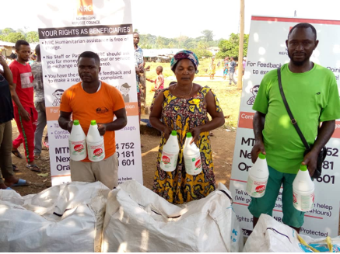 | 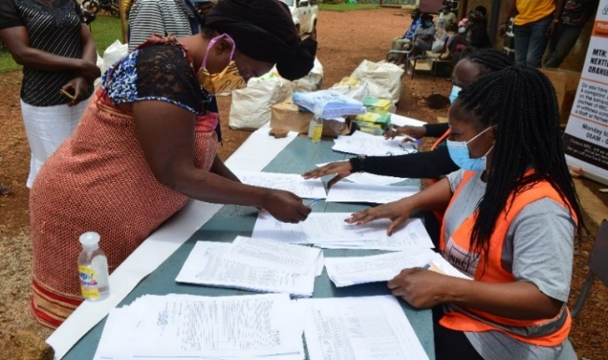
Figure 1. Distribution of Shelter NFI kits integrated with COVID 19 KITS in Matoh town. March 2021 | Fig 2. Female beneficiary signing acknowledgement form in Bali: NWR March 2021

Coordination:
- Update of Shelter Cluster Key Documents: update of shelter Cluster Strategic and ToRs for Shelter Technical Working Group.
- Discussion ongoing with North West authority about banned items within the shelter kits and Support needed from Yaounde to continue Advocating with Ministry of Territorial Administration.
- Funding to respond to shelter/NFI needs in NWSW and prohibited items within the shelter kits remained the main challenges of cluster partners.

