Shelter Cluster (NWSW) input to ICC Monthly Situation Report
Report for February 2021
Key figures
Indicators | Region |  | Total Reached
Indicators | NW | SW | Individuals | HH
# of households assisted with core relief items including prevention of COVID-19 | 3,315 | 3,437 | 6,752 | 1,000
# of households assisted with emergency shelter kits | 1,595 |  | 1,595 | 229
# of households assisted with cash for rental subsidies | 41 |  | 41
Total reached | 4,951 | 3,437 | 8,388 | 1,229

Shelter Cluster Humanitarian response
During the reporting month 1,229 households were assisted in which 729 households in North West and 500 households in South West
North West
- Plan International reported the distribution of 229 emergency shelter kits in Momo Division-Batibo -Tiben village
- NRC through was able to distribute 500 NFI kits comprising emergency shelter items, household items and kitchen items, hygiene items in the communities of Tingoh,Mbakong, Ndung, lower Bafut, Bafut sub-division, Mezam Division, reaching 3315 individuals(M=1745, F=1570)
- SHUMAS reported the assistance of 41 students with rental accommodation in Bamenda (
South West
- NRC through was able to distribute 500 NFI kits comprising of Temporary Shelter kits, Household items and kitchen items in Kembong, Egbekaw, Njeke, Besongabang all in the Mamfe Central Subdivision SWR reaching 3,437 persons (1,604male and 1,833female).

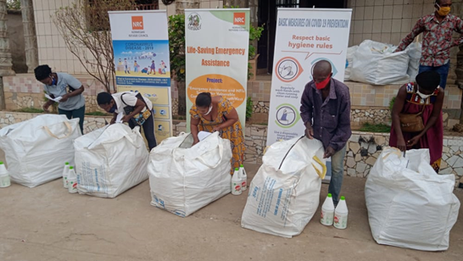 | 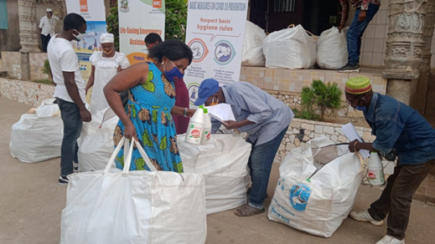
Figure 1. Distribution of 500 Shelter/NFI kits Mamfe with beneficiaries verifying the kits content with distribution letters, February 2021 | Fig 2. Beneficiary carrying Shelter/NFI kit In Mamfe February 2021

Coordination:
The last cluster meeting of year was held on 2nd March 2021, cluster members were informed about the new displacement in Nwa. NRC and Plan International plan to intervene with integrated kits comprised with light shelter kits , Wash and COVID-19 kits .
- NRC is following up closely and plan to intervene in Nwa and already have about 500 integrated kits that include WASH, NFI, shelter and some covid19 items. NRC to share the detailed content of the kits with the cluster.
- Plan International have some emergency kits that can be used for the rapid response up to 500 emergency kits

