Shelter Cluster IM Briefing Pack
This is a live document. Please add as you feel appropriate.

1 TEAM ROLES 2
2 Key dates 2
3 Introduction 3
4 Database Structure 4
5 Weekly workflow 4
1. Reporting by agencies 4
2. Handling incoming reports 5
5. Merging and verifying the agency data 6
6. Generate 3W data (for OCHA and Google Spreadsheet) 8
7. Split main database into agency files 8
8. Send the updated agency files to the agencies 9
9. Create the Shelter Cluster reports 11
9. Report updated figures to comms 13
10. Map creation 13
11. disseminate reports and maps 14
12. Share tables, dashboards and maps with regional cluster members 14
6 POPULATION, DAMAGE AND GAP DATA 14
1. Currently used damage data 14
2. Updated Damage Data 14
7 Troubleshooting 15
1. Tableau 15
2. Errors Copying in reporting template or other excel files 15
3. DATABASE 15
8 Information management system requirements 15
9 SETTING UP TOOLS 17
1. Dropbox 18
5. Thunderbird for reporting.phil@sheltercluster.org 18
6. PCoder tool 18
7. Shelter cluster app 19
4. Shelter Cluster online calendar and contacts 19

1 TEAM ROLES

Role | Who | Contact
National IM
Database IM
Incoming reporting IM
IM region VIII
IM region VII (Cebu)
IM region VI
Website IM
Mapping IM
Global IM focal point | Neil Bauman | Neil.bauman@sheltercluster.org

2 Key dates

External deadlines
To who | What | Cycle | Cycle start | Deadline

Internal deadlines
To who | What | Cycle | Cycle start | Deadline
Database manager | Update database
Membership | All 3W agency data on Google Spreadsheet
Database manager | Send agency data by email
American Red Cross | Map tables
Shelter Cluster Comms | National SC report
Membership | SC reports and maps on sheltercluster.org

3 Introduction

The Shelter cluster information management is a combination of tools that have been selected to meet the requirements of a shelter cluster deployment.
After consideration of multiple options this approach has been chosen as most suitable to meet the demands of a Shelter Cluster deployment. Some constraints are:
- infrastructure might be very fragile, a full web based solution is very challenging for most agencies
- differences in operating systems, browsers, etc in agencies
- updates to the data model are frequent. Designing a fixed state data model is not feasible
- due to high demands of agencies on the ground, the reporting system should be least demanding as possible, with people not having to learn new interfaces and tools.
- Due to high demands, it is a struggle to get agencies to take the time to report. Continuous dialogue is needed.
The current solution is based on:
- Email through Mozilla Thunderbird as a means to interact with agencies and to receive agency data
- Excel as a tool for agencies to add, edit and delete agency activities
- Excel as a database to store combined agency data
- Thunderbird Mail Merge add in to be able to send an auto generated mail with attachments to agencies
- VBA as a programming language to automate the combining and splitting of agency data
- Tableau to combine multiple data sources and to generate reports
- Google Spreadsheets to publish open (source) data online
- QGIS/ARCgis for creating maps
- Adobe Illustrator to layout the maps
- Javascript for interactive online maps
To learn more about information management requirements, please read the section on requirements.



Cluster shares analysis, dashboards, maps and tables with cluster members
Shelter cluster products are created
Agency sends all completed and planned 3W to the cluster frequently
Cluster returns corrected 3W data back to agencies shortly after processing
All 3W dataset are combined into one cluster database

4 Database Structure
The current Shelter Cluster database is a file based excel solution. The most current dataset is a collection of files, one per agency, on the Dropbox in
<DROPBOX>\07 IM\02 Databases\2 SC agency reporting\1. Incoming.
All latest agency data should always remain in the 1. Incoming directory, even if the agency phases out.
The most current combined database is a merge of all agency data into a single file that resides in:
<DROPBOX>\07 IM\02 Databases. On this merged file the database manager can validate the data, export data for reports and maps.
NOTE: Only the database manager should be accessing the Excel database. This is in order to ensure that the spreadsheet does not become corrupted and to ensure that numbers are not extracted incorrectly. If others want to rework the data they should make a local copy and edit that.

5 Weekly workflow

The weekly workflow is as follows:

Reporting by agencies
All agencies send their updated 3W data to reporting.phil@sheltercluster.org by Friday each week. This data includes all activities in the past, and planned data for the near future.

Handling incoming reports
Responsibility: Reporting IM
Workload: 5-10 hrs a week depending on number of reports and corrections needed.
This Reporting IM reviews each incoming email and answers questions related to reporting, or forwards messages to respective regional IMs. Whenever a report arrives, the Reporting IM opens the attachment and checks if the report has been properly submitted, that there is no erroneous data. Perform the following checks:
- Check if the right version of the reporting template is used
- Check if there are in between headers in the data
- Many missing rows (especially for big agencies)
- If there is a new sub-hub reporting which might double data in another report (especially for big agencies)
- Check the comments field to see if the agency is reporting shelter activities and if they have put the values in the right column (if you can derive this from the comments field)
Note: big agencies like IFRC, UNHCR, IOM have a main office and different hubs/parts all over the country. Some hubs/parts send in data directly to the Shelter Cluster reporting.phil. Others aggregate the data nationally and send it to the shelter cluster. Each week, look carefully if there is no overlap in the national vs hub reports.
If the file is valid, the file is archived in the folder “1. incoming” on the dropbox in .
<DROPBOX>\07 IM\02 Databases\2 SC agency reporting\1. Incoming
The template saved to this directory should be in the latest format that has been sent out to agencies. If not, the data should be merged into the new format.
If the file is invalid, the IM writes a reply to the agency to correct the data and submit it again. The erroneous report is archived in the folder “under investigation”. This way all IMs know the file is being handled, but not yet confirmed to be valid. If there is no time for the agency to resubmit the report, it is the call of the Reporting IM to see if the file can be manually changed to fit the latest reporting template:
- Insert the new columns in the report or delete columns that were deleted between versions
- If that is too much work, you could cut and paste data into an empty reporting template (paste as values).
If the “under investigation” folder is not empty by Sunday, the database manager decides how to handle these files. If the data can be made compatible this step is taken. Otherwise the agency is informed and the data is being ignored. In the latter case last weeks’ data will be used for this agency.
The 1. Incoming directory on dropbox is the main database. This means that all the latest reports for all agencies should always be there, even if the agency has not submitted any new reports this week.
- Handle new agencies reporting
Responsibility: Reporting IM
Workload: number of new agencies fluctuate over time. Adding a new agency will take about 10 minutes
Whenever a new agency reports, do the following:
- Add the agency to the reporting focal points list in <DROPBOX>\07 IM\2. Database\7. Reporting focal point.
  - The name in column ‘Agency’ needs to match the name that is used in the database on sheet 'admin name mapping' in the first column.
  - If an agency has multiple people to report different hubs/regions, then add a new row for each and specify ALL or the hub in the column reportinghub
  - Add one focal point. If you really need more people addressed, put multiple names in firstname or lastname (as they will be concatenated), and put a comma separated list in the email address field.
  - Set the sendweekly column to YES
  - Make sure the file column has the link to the filename by dragging the function down. If you forget this step the agency data will not be attached to the weekly email.
  - You can send the 3W reporting template to the agency separately, or include them in the weekly email on Monday with an empty template (explained further on)
- Add the agency to the 'admin name mapping' sheet in the main database (responsibility database manager. Reporting IM informs database manager that there is a new agency)
  - Add an abbreviation in the first column. It should match the name in the reporting focal points list. It will also be used in the file name of the agency data file.
  - Add the agency real name to the second column. If this name is too long to be presented on a map or table, try to find an abbreviation (together with the agency). This name should match the name in the 'implementing agency' column of the agency report in 1. Incoming.
  - Add in the third column if the agency is reporting in multiple hubs/regions. Add one row for each region.
- Add the agency data to the regional contact list
- Add the agency as a separate folder in the reporting.phil email to archive all this agency’s email.
- Add the agency to the agency presence list in <DROPBOX>\07 IM\02 Databases\2. Referencing data\Agency Presence.xlsx
- Handle agencies phasing out
Responsibility: Reporting IM
Workload: 5 minutes
Whenever an agency phases out:
- Mark in the reporting focal point list that the agency should not receive the reporting template weekly (Set to NO)
- Mark in the agency presence list that the agency has been here
- Leave the all the agency data in the database and in the ‘agency name mapping’ sheet
- Even if an agency phases out, its activity reporting file has to remain in the 1. Incoming directory. If not the agency data will disappear from the database.

Merging and verifying the agency data
Responsibility: Database manager
Workload: if no changes have been made to the data model and all templates are correctly formatted, this will take about 1-2 hours
On Sunday morning the database manager combines all agency reports in the 1. Incoming directory on dropbox and validates the data. This is done as follows:
  - Make a backup of the existing database in <DROPBOX>\07 IM\02 Databases\. Leave it in the same directory, since all Tableau report files are referencing it
  - Copy the main database into a new file and set it to today’s date in the filename
  - Go to the instruction sheet and follow the instructions
    - Make sure all the validated agency reports are in the 1. Incoming directory
    - Click the button 'Combine agency files'.
    - Click yes for the questions. The current agency data in the activities sheet is copied to the sheet ‘old activities’. This previous data is used to create the comparison sheets where you can compare the two versions of the data.
    - Select the 1. Incoming directory where the reports are
    - Select the 3W template xlsx file
    - You might get a similar message to the following. It could mean two things:
      - You have selected a newer or older version of the 3W template than the one the agencies used.
      - You have selected the right 3W template, but the agency has sent an older version, or has corrupted the template. If you know that the data in the agency report is in the right format, then click yes. If you have doubts about the data formatting then click no. If you click no, the update will be stopped. To continue, repair the agency report and delete the newly created database. Start again at step 1.
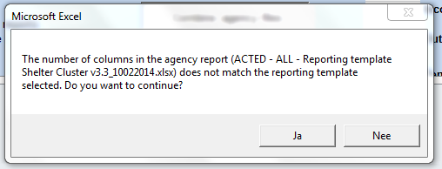
    - Wait for the process to complete. Don't use excel in the meantime
  - All data is added to the activities table. Compare totals by using the sheet ‘Total Comparisons’ to compare old and new data per agency. There are three pivot tables. The first has the new data, the second the previous data and the third highlights the percentage of change between the old and new data. The most important changes are highlighted in orange and red. Double check these agency reports and compare the previous report they have sent to the latest one:
    - If the increase/decrease is about 50%, then it is likely that the agency has been double counted. This happens if for that agency there are two agency data files in the 1. Incoming for one agency. Delete the oldest file and either rerun the database update (which you might dislike because you have to redo the data corrections), or manually delete the duplicate data for this agency in the activities sheet.
    - If the numbers are big, check if there are new big numbers in the latest report and if they make sense.
  - If you are confident that there are no reports doubled, then start validating and correcting the data:
    - Check if all geographical areas are pcoded correctly. Best is to filter the final columns for #N/A values. Correct names accordingly. Use the ‘Mapping’ sheet to find the pcodes.
    - Check numerical columns for text strings
    - Check if date format is ok
    - Check If columns with data list validation have invalid data
    - Sort numerical columns and check the biggest values.
  - Compare totals by using the ‘Province comparison’ sheet to compare data per province. Use this sheet as a separate validation tool if agency data is not sufficient to correct any big anomalies in the data.
  - When all errors are corrected, save the database under the filename with today’s date.

Generate 3W data (for OCHA and Google Spreadsheet)
Responsibility: Database manager
Workload: 5 minutes
The Shelter Cluster generates reports for UN OCHA that show the progress of the whole cluster. The deadline for this is Monday 10am on a biweekly basis. To do this:
  - Open the main database in <DROPBOX>\07 IM\02 Databases\
  - Follow the instructions on the instruction sheet
  - Save that one sheet to your local system. Give it the name Shelter Cluster 3W ddmmyyyy.xlsx (replace with date).
  - Go to the UN OCHA Dropbox on : Typhoon Yolanda IM\3W\Emergency Shelter\
  - Create a folder for today’s date and copy the sheet in there
The Activity data is also made available through a Google spreadsheet. This spreadsheet should be updated or replaced. Crucial is that the url to the file remains the same always. The spreadsheet can be found here: http://bit.ly/1fA7WA6
Instructions for updating the Google spreadsheet
- Log in with shelterclusterphillipines@gmail.com (use regular password with an additional 1 at the end)
- Upload the spreadsheet to google drive. Make sure you have the conversion on, so that the file is converted to a google spreadsheet
- Open the spreadsheet. Click the activities tab and choose move
- Move the spreadsheet to the permanent existing Google spreadsheet
- Delete the old sheet in the permanent existing Google spreadsheet
- Delete the newly created spreadsheet

Split main database into agency files
Responsibility: Database manager
Workload: 20 minutes
On Monday the agency data sheets are split again from the main database into separate files. The procedure is as follows:
  - Archive the directory <DROPBOX>\07 IM\02 Databases\2 SC agency reporting\2. Outgoing
  - Archive the directory <DROPBOX>\07 IM\02 Databases\2 SC agency reporting\1. Incoming
  - Open the main database in <DROPBOX>\07 IM\02 Databases\
  - Double check in the ‘Agency mapping sheet’ that all agencies are there
  - Go to The instructions sheet in the main database file. Follow instructions for splitting agency data.
  - Excel will now save all agency files separately. This can take a while depending on speed of computer
  - Double check that all agency files have been exported. Usually easiest by comparing numbers in popup when script finishes, or by looking in 2. Outgoing.
  - Copy all the templates from 2. Outgoing to 1. Incoming, so that we have a full set of data for next week that can be updated.

Send the updated agency files to the agencies
Responsibility: Database manager
Workload: the procedure will cost you 20 minutes, but sending the emails will depend on internet speed.
On Monday the Shelter Cluster sends out an email to all agencies that are reporting. The email has the latest information and also contains each agency’s latest data as an attachment. The next reporting deadline is communicated. The agency data is validated and might contain changes compared to what the agency has sent us. That is why we send it back each week. The email is to be sent as follows:
Make sure you have Mozilla Thunderbird installed (see 20140217 IM Briefing Pack.docx) and that the reporting.phil is configured as a imap. Install the mail merge add-in that thunderbird offers.
Open the reporting focal point list in <DROPBOX>\07 IM\2. Databases\7. Reporting focal points\. Change the path to the outgoing attachments in the tab ‘Variables. Make sure that on the sheet Mailing list, in the Agency name column, there are no invalid characters that go into the file name. So no ‘/’ for instance.
Prepare the reporting focal points .Copy the file to a new excel workbook and save it as a .csv comma separated file.
In Thunderbird, go to ‘write message’, or choose an existing message in the Templates folder. Update the email that you want to send out. (See screenshot below)

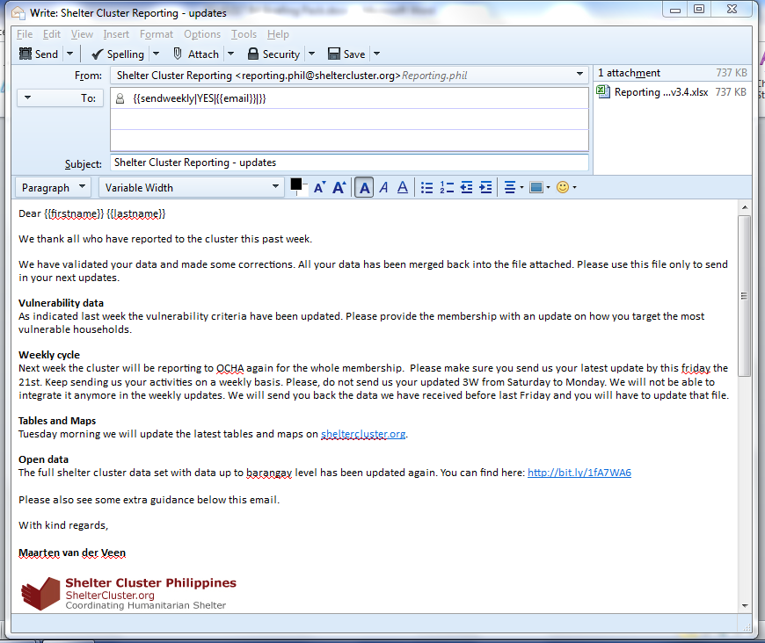
Make sure the FROM field is reporting.phil@sheltercluster.org
The {{variables}} should match the column headers in the reporting focal points list. To send only to agencies that should still receive the weekly email and data, use in the TO field:
{{sendweekly|YES|{{email}}|}}
Note that the value YES is case sensitive.
In Thunderbird in the new message, click File Mail Merge. Set the source file of the CSV you have created before. Make sure you have the right Character set. If it fails, try the others. Make sure you have delivery mode to ‘Send Later’. This will prevent emails from being sent straight away, but instead have them stored in the outbox for reviewing. Check if you csv has comma (,) separation or (;) separation and set the field delimiter accordingly. Click OK to send all emails to the outbox.
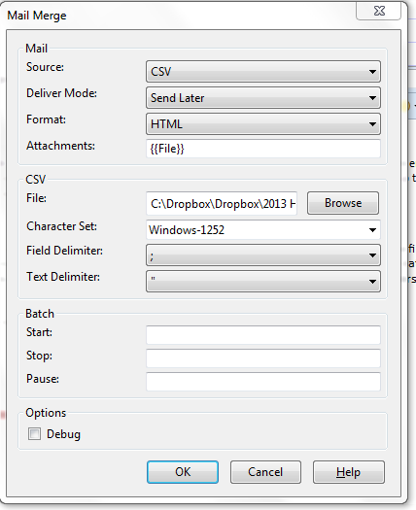
In thunderbird double check the emails that are in the outbox.
- Check if all files have an attachment. If not, check why, fix, remove all messages and run the mail merge again. (see screenshot below)
- Add the empty reporting template to those addressees that have never sent a report in. They would need the latest reporting template to start reporting. To do this, open the mail in the outbox, create as new, add the reporting template as an attachment and choose ‘sent later’. Then remove the mail without attachment from the outbox.
- Check that the addressee is correct (just check a few emails)
- Check that you are not sending to the wrong agencies (just check a few emails)
- Check that you are sending from reporting.phil and not another address
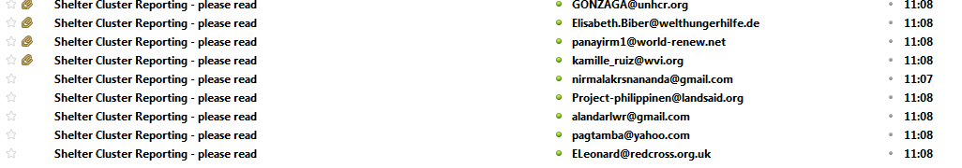
To send all message in the outbox, right click the outbox and choose ‘send all unsend messages’.
Forward one of the sent messages to all IMs so they know what changes were made.

Create the Shelter Cluster reports
Responsibility: National IM
Workload: If no changes are made to the reports this will take about 5-10 minutes per tableau file
On Sunday/Monday the national and regional reports are created. Each region has its own tableau file in which reports are formatted. Each time the database is updated, the tableau files have to repointed to the new excel file. To do this:
- Open the tableau file
- Right click the activities2 data source and select edit connection
- Select a new Excel Workbook: browse for the .xlsm file that is the new database and confirm changes
- Refresh the datasource and refresh the data extract for that datasource
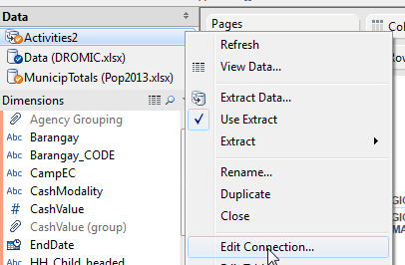
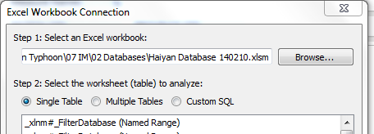

Quality checks
In the process of repointing to the new database the sheets and dashboards in tableau should be double checked. You can compare totals with previous generated PDF reports or check that the major agencies are correctly presented. If there is a major issue with the data, contact the database manager.
Make sure to correct formatting, especially for dashboards.
Generate national and regional PDF and excel reports
Each IM can create the regional PDFs themselves. To do this, first sort the dashboards and tables in the order you want them in the PDF.
Each region has its own dashboard. All dashboards are set up to be automatically populated with new figures. However, some key facts might be statically set. Before generating the dashboard as a PDF, update these figures.
Then Select the sheets (tabs) that you want to have printed (Use shift key to select multiple). In File Print to PDF, choose selected pages, print landscape. In the extra setting, make sure you print to the width of a full page, and that you can print multiple pages. Disable the option to print the selection.
Save the PDF to <DROPBOX>\07 IM\05 SC Reports in the folder for that week.
Additionally, you could export the Gap table to an excel file and save it in the same location.
Create municipality reports
Responsibility: Information manager for his own region
Municipality reports are not created with Tableau, but with Excel. Unfortunately at the moment Tableau does not have the possibility to batch generate (and save) different reports. Since the lower administrative levels (such as municipalities) are many, it saves time to automate this process.
To generate municipality reports:
- Open the municipality generator in <DROPBOX>\07 IM\02 Databases\6 Dashboard generators
- Set the Pcodes on the first sheet. For each municipality that you want to generate the report for, specify the pcode in a new row. Use the pcodes sheet to find the pcodes.
- Update the activities sheet by copying the activities from the Main database (1 header row only)
- Set the column in the activities sheet that has the Municipality Pcode in the first sheet
- Update the dashboard slide if you want to change the text, or even charts and tables
- On the first slide, click generate dashboards
- Select the directory where you want to store the municipality reports
- The reports will now be saved. This can take a while depending on the number of municipalities listed. Don’t use excel during the process.

Report updated figures to comms
Responsibility: National IM
Workload: 5 minutes
Beginning of each week, i.e. Monday the IM team leader provides updated figures to the Shelter Cluster communication officer (comms.phil@sheltercluster.org). The main figures to provide are:
- The number of HH reached through Emergency Shelter interventions (tents, tarps 1 per HH and tars 2 per HH). This number can be found in the national tableau workbook on the sheet ‘ESLoc’, in the column ‘total HH reached with emergency shelter solutions’. The reached number only.
- The number of HH reached through SSRS Roofing solutions (roofing materials, transitional/core shelter and cash). This number can be found in the national tableau workbook on the sheet ‘SRLoc’.
Note on the figures: the agencies do not specify if their activities reach the same or different households. It has to be mentioned when presenting the figures that there could be overlap in different activities. Therefore the number of unique households reached is probably lower.

Map creation
Responsibility: national IM
Workload: 10 minutes
On Monday night the Shelter Cluster creates the maps, tables and analysis for all agencies biweekly. Maps are produced remotely by the American Red Cross/British Red Cross. Sixteen maps will be produced weekly:
- 4 x emergency shelter 3W maps
- 4 x SSRS 3W maps
- 4x Emergency shelter gap maps
- 4 x SSRS gap maps
Liaising with the Amcross mapping team goes through national information manager. These products have been developed in consultation with hub coordinators and IMs, and have been standardised across areas to ensure a common look & feel. Maps are kept on the dropbox, here:
<DROPBOX>\07 IM\06 Maps\1 SC Maps
Creating data files for mapping team
In the National Tableau file (yymmdd - Dashboard National.twb), there are five worksheets set up towards the far right of the tabs. These are the files which support the production of the maps : GAP TABLE, 3W Map ES a, 3W Map ES b, SSRS Map ES a, SSRS Map ES b. (The a and b versions have been created as I’m not sure if AmAcross are using scripting to produce the 3W maps, or doing it by hand – so I’ve set it up to hopefully support them either way). These need to be exported as Excel (file menu worksheet, export, crosstab as Excel), and put into the folder : <DROPBOX>\07 IM\02 Databases\4 For Mapping.

11. Disseminate reports and maps
Responsibility: Website IM
One of the IM is responsible for uploading maps and reports to sheltercluster.org. The back-up for website uploads is Neil Bauman. As it is desirable that access to the ‘backend’ of the website is limited and that documents are uploaded with consistent tagging, further instructions are not provided here, but if required training can be given by the current Website IM, or by Neil Bauman.

12. Share tables, dashboards and maps with regional cluster members
Responsibility: regional IMs
Each IM can send the reports and maps to their regional mailing lists. This ensures they remain the regional IM focal point.

6 POPULATION, DAMAGE AND GAP DATA

1. Currently used damage data
Currently damage data is combined with 3W data to generate Gap data. The source being used is the DROMIC file in: <DROPBOX>\07 IM\02 Databases\1 Referencing data
The DROMIC data includes numbers on partially damaged and totally destroyed houses per municipality. It does not provide barangay level damage data. The no damage category is missing. Neither is there a total number of houses registered per municipality. Therefore, the number of houses has to be estimated. So far this is done by population data. The population data is a 2013 projection of a 2010 census. In the Philippines the average number of persons per household is 4.7. The estimated number of houses is therefore the population per municipality divided by 4.7. These formulas are encoded in the tableau files.

Updated Damage Data
There are multiple initiatives underway to collect better damage data at barangay and municipal level.
The Shelter Cluster has therefore compiled the DROMIC source data into another dataset that only includes the columns needed for shelter. This dataset is up to barangay level, also allowing for more detailed maps if data is collected at barangay level. Additionally there is a column ‘no damage’ added. The dataset is prepopulated with data from the DROMIC dataset. From DROMIC the totally and partially destroyed houses are used. From the Population 2013 census the total number of houses is measured. The ‘No damage’ category in the Damage dataset is calculated by doing the following formula: total estimated number of houses minus partially destroyed houses minus totally destroyed houses.
The Damage dataset has a matching Damage Data Reporting Template that can be used to collect damage updates from municipalities and barangays. The template can be found in: <DROPBOX>\07 IM\01 3W Template. If municipalities or provinces share with the cluster the data in this template, then the updates could be integrated in the Damage Data dataset.
The IM team can decide to switch to this updated damage data source, to enable updates to be reflected on maps and gap tables. It is important to note that damage data should be stored at either municipality level, or at barangay level, but not both simultaneously. Otherwise totals will be double counted. So either use totals per municipality, or replace that municipality totals by a full breakdown of all barangays in that municipality.

7 Troubleshooting

1. Tableau
If you open a tableau file and you get a similar error to the message below. Click YES and select the file with the same filename in the proper location on your drive. If multiple users use the same tableau file on different directory paths, it might be worth to move the files on each computer to the same filepath. The easiest way would be to ask all users to move their dropbox to C:\dropbox
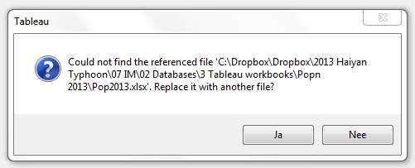
If you get errors when opening tableau about new fields being created with the name calculatedfield_<randomnumber>. Then close your tableau file without saving. Go to <DROPBOX>\07 IM\02 Databases\3 Tableau workbooks\Extracts. Delete the extracts (.tde files) that this tableau file was using. Then start tableau again. It will ask you to regenerate the .tde extract files. Make sure you save this under a regional specific name.

2. Errors copying in reporting template or other excel files
Some of the IM reporting template and other excel files use data validation and named ranges. If for whatever reason you need to copy data between sheets and you get errors, consider using the ‘paste values’ option. This will prevent any formatting or data validation to be copied along.

DATABASE
The database is scripted with VBA. Although there are numerous checks to prevent errors, it might be that there is a scripting error at one time. Most probably this is because of significant changes to the 3W template, or not having reflected those changes in the activities sheet. If that is not the case, then the script needs to be edited.
The VBA code can be found in the menu item ‘View’ Macros View macros. Make sure you have content/macros enabled on your excel file. Select one of the functions and choose Edit. The code is commented explaining what the logic does. However, to edit the script it is very much advised to have someone doing this with programming skills (VBA skills). If that is an issue, it might be best to outsource this or ask for remote support.

8 Information management system requirements

The Shelter cluster has the following information management requirements that have been used to create the current IM systems. Any future updates to the IM systems should consider these requirements. Requirements should be updated over time and could be specific for a deployment.
Data submission and collection | Current solution
The agency is informed if the data submitted does not comply with the input validation criteria | Reporting templates with agency data that do not comply with the latest reporting template, or contain errors, are returned to the sender with instructions on how to update. The responsibility of the data always remains with the agency
The agency can change the data and resubmit the data | The agencies receive all their data back every week. The agency then updates the data and resubmits it before the next deadline.
The agency can batch insert data directly to the system | The agency submits an excel based report containing all the agency’s data. Each week they send the full batch to the cluster
The agency can prepare and modify data offline | Since the agency data resides in an excel file, it is always editable offline.
The agency can submit data in a batch when an internet connection is available | The agency submits the data through email to reporting.phil. This has the additional advantage that questions can directly be returned to the agency. Email is still an effective and very widely used way to communicate and share files.
The agency is restricted in data entry to prevent data integrity issues and improve data quality | The reporting template has a number of dropdown menus for geographical data.. Additionally there is data validation on number fields. Although this method is not 100% fool proof, it still results in a huge increase in data quality.
Database requirements
The database keeps raw data so that analysis can be traced back to individual data | 3W data resided in one file per agency containing all the raw data. Additionally there is a combined database where all agency files are combined. All reports run off the raw data.
The database prevents duplication of data by assuring the uniqueness of the data | The way to uniquely identify an activity is through the name of the agency in combination with the administrative levels where the agency is working. It is the responsibility of the agency to make sure activities are not double reported.
The database is always available accessible from any location with an internet connection | The database resides on a dropbox which is accessible worldwide. An open data set is published to a Google Spreadsheet where every agency and others interested can find the raw data.
The database is scalable to allow for multiple simultaneous queries | The file based database is not accessible for simultaneous queries. The online spreadsheet however is.
The database keeps versions of the data, to be able to trace back edits | The agency data is versioned.. Each agency has a reporting focal point who is the only person to submit data to the cluster. Each time data is submitted it is versioned.
The database keeps backups of the systems | Incoming agency data, as well as the combined database, are backed up after each update. Since both are file based, each file is just another file on the dropbox.
The database can handle the number of records and requests generated by all users involved | The current Excel limits to number of records and fields far surpass that which is needed for any big disaster. However, the time needed to execute the database scripts for the weekly update are directly related to the number of agencies reporting. The more agencies the longer it will take to combine all agency data and to split it again
The database facilitates migration to a possible future solution | As long as the data model for the database is clean, it is possible to migrate it to other databases, such as relational databases.
Data validation and analysis
The database manager can easily clean data (find errors and correct these) | All data resides in a number of different tables (sheets) in a number of files. These are organized in one place. The main data cleaning and validation is on the agency 3W data, which is one table (sheet). Excel offers numerous possibilities to batch clean and edit data. With any database solution, data cleaning will be either human work, or requires a big investment on context specific programming to do automatic cleaning (which would still require a human to find exceptions)
The information managers can enrich data by linking data sources | In the database data enrichment is mainly updating the geographical names and PCODES of activity locations. This is accomplished with an updated PCODER, which allows to enrich an admin level with its pcode, or to correct admin level names.  The cluster works with Tableau for linking multiple data sources. Tableau can connect multiple excel files, or link to other (online) databases and data sources. All reports are generated from Tableau
The information managers validate data by comparing it to historical data | The database has a number of comparison tables that are populated with current and previous data.
The agencies can review its own data and correct mistakes | After each database update the agencies receive the validated data back from the cluster. The agency is responsible for updating that data set and to check it for errors.
Multiple administrators and users can work simultaneously on the data sets | Each agency works separately on its data during the week. Multiple Information Managers from the cluster can handle incoming reports and archive these. The database manager is the only one to combine these agency data sets into one database. From that one database each information manager can run reports and analyze the data.
Data dissemination
The agency can access its own data | Each agency is returned its own data by the cluster after every database update. Additionally all agency data is available in an online Google Spreadsheet.
The user can access pre-generated reports online | Cluster reports are available on the cluster website after each update.
The information manager can generate reports and publish these online | Reports are generated through Tableau. Tableau links multiple sources such as 3W data, damage data and population data. Reports can be generated in PDF, excel exports. It is possible to publish the dataset to Tableau Public, which is a free (and open) online data viewer. Currently data is published on Google Spreadsheet only.
A proper separation between data and data views (reports) is in place | Tableau links read-only to the cluster database.
Costs
Costs should be as low as possible | License costs for Tableau are 500 USD per license. Other products are Microsoft Office, and Mozilla Thunderbird (open source)
It should be possible to cancel contracts on short notice. | Tableau license is a one time license.
Costs are preferable based on a user/month fee | Not yet achieved

9 SETTING UP TOOLS

Dropbox
- Download dropbox from dropbox.com
- Install it in c:\Dropbox (the path will now be c:\Dropbox\Dropbox)
- If you have an existing dropbox installed, you can move it to the above path from the menu. It will not make you download all files again.
- Make sure you get the invite by one of the other IMs on the same email address that you used to create your dropbox account with
- Buy some extra space if you need it
Some notes
it is useful if the whole team has dropbox installed in the same directory. This would at least work for all on a Windows operating system. This way the absolute paths to some of the files are the same for all.
Dropbox has a versioning system. It is still useful to archive off some of the files if you change it. However, there is no need to keep a long history of each file (since dropbox does this). A reduced overall size of the dropbox prevents people from having to go through a lot of bandwidth issues.

Thunderbird for reporting.phil@sheltercluster.org
- Install Mozilla Thunderbird
- Create a new email account (use IMAP)
- Choose manual settings
- Use the same settings as in the screenshot below, however use the reporting.phil@sheltercluster.org email address
- Add your own name to make the messages more personal
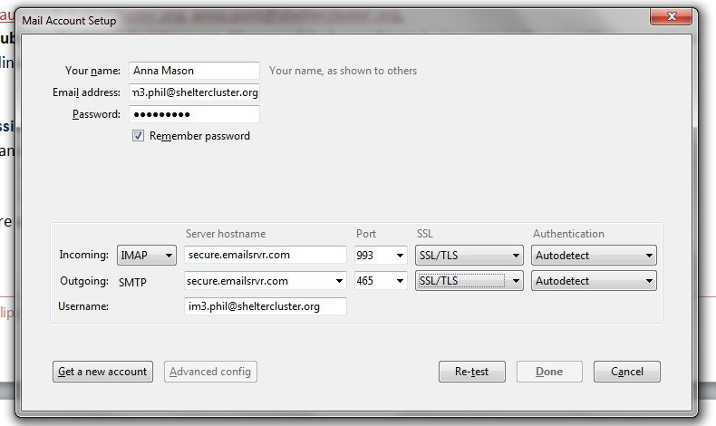
- Configuration settings for sheltercluster email in Thunderbird (imap account).
- Password: regular password. Select Retest. If settings found select done.

PCoder tool
The PCoder is an OCHA tool that can be used to do the following:
- Find the unique numbers (pcodes) for administrative levels by doing a name lookup on a dataset.
- Correct the names of the administrative levels
The Pcoder is an Excel plugin that you can find in: <DROPBOX>\07 IM\07 Admin\PCodeTool PHIL V3\
Open the Load-P-Coder.xls and enable content/macro’s. A popup should appear that the pcoder is loaded. You can close the excel file. The next time you open excel there should be a add in menu item with the pcoder in it.
If you open the pcoder, a screen like the one below appears. Select the administrative level that you want to correct (province, municipality, barangay). It will ask you to select the column with the names and the columns with the Pcodes of the next up administrative level.
Select ‘Skip empty’ to not have to skip each blank field. Use ‘skip character’ to skip fields that have comma separated barangay names (so: add the ‘, ‘ to the textfield to skip commas)
Now click next to start. Each time the string comparison is under 80% correct it will ask you to manually chose the best match. If there is no match, select skip, or skip all.
If you have gone through all the fields (which can take a while), then a number of new columns are added. Two of these could be useful: the column with the corrected name, and the column with the pcode. Use these values to update the existing columns. Be aware that if you skip a field in the matching process, it might be best to not replace the existing in the original column. So: be smart on how to combine to old and corrected data. Tip: use the =IF() function to test if a value has been corrected by the pcoder, and select the columns accordingly. Then copy all rows back as ‘paste values’ in the original column.
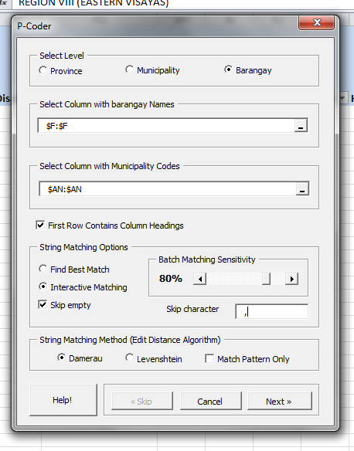

Shelter cluster app
A shelter cluster android app has been created to allow multiple mobile surveys to be done. The survey is hosted on formhub. The android app references online surveys hosted on the formhub sheltercluster page. Users that install the survey can download the surveys through the mobile application. Surveys can be taken offline and synced back to online when an internet connection is available. On formhub the administrator can export the results per survey and analyse these using Tableau.
To get started follow the manual in <DROPBOX>\07 IM\13 Mobile survey.

4. Shelter Cluster online calendar and contacts
To use a shared calendar and contact list with the cluster it is best to use an online calendar and contact list. This allows you to sync contacts and calendar items with everyone.
To set up the contact list:
- Go to Gmail and log in with shelterclusterphillipines@gmail.com use the regular password with an additional 1 at the end. We can all use this same login details on the website and the mobile phones. Not necessary to share it through private gmail accounts.
- On the top left you see GMail with a dropdown arrow. Click it and select Contacts

- Create one or more new contact lists. Please name them logically to distinguish them from other lists
- Add your contacts to this list using the webinterface, or syncing the contacts from other lists/mobile phones
- Have the cluster team add the gmail account to their phones and select the contact lists to sync per person
To set up the calendar:
- Go to Gmail and log in with shelterclusterphillipines@gmail.com use the regular password with an additional 1 at the end
- Go to the calendar
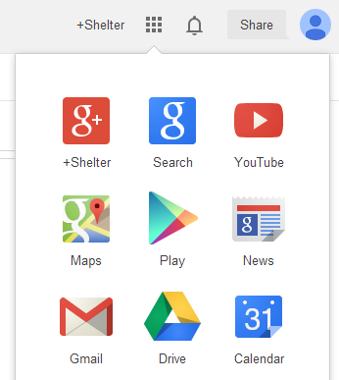
- Create a new calendar for a team
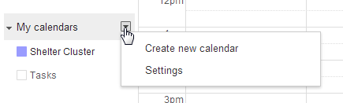
- Set up the phone to use the calendar through the same gmail account
Setting up Thunderbird for the contacts
- Open thunderbird and go to the addons sections
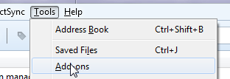
- Search for gContactSync addin and install it. Restart thunderbird
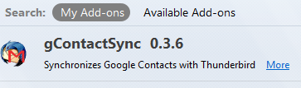
- In the menu go to gContactSync and click accounts
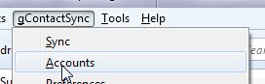
- Click Add new account and add the shelterclusterphillipines@gmail.com
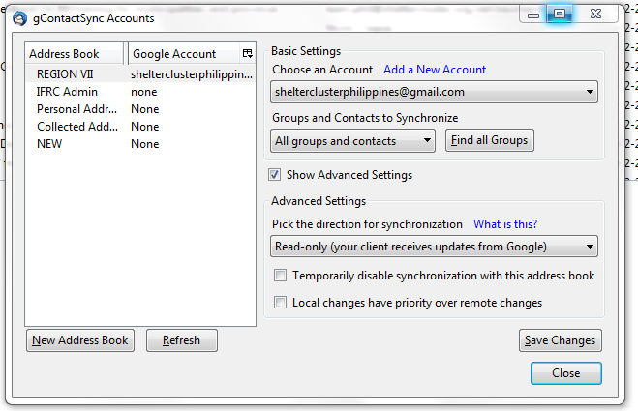
- Select the groups to synchronize
- In the ‘Show Advanced Settings’, set the direction of synchronization to Read-Only. This means you will have to edit and add contacts through either the website (gmail.com), or through the mobile phone
- Click save. Your contacts should be available now.
- To send an email to a group, use the name of the group in the TO field of an email. E.g. REGION VII

