SHELTER/ NFIS CLUSTER HNO 2021

People in Need:
The total number for the people in need for shelter is estimated at 432,940

Shelter/NFIs
Adequate shelter is essential to secure a decent, safe, and dignified life for people. In the Gaza Strip, the ability of families to build or buy housing units has become very limited as a result of the continuous blockade for more than 13 years and the deteriorated economic situation. Gaza Strip is classified as one of the most densely populated areas in the world with a population growth rate of 2.8%. The statistics of the Ministry of Public Works and Housing MoPWH in Gaza showed that the yearly demand for new housing units is 18,000 and there is a big shortage in the number of housing units, which exceeds 120,000 units in 2021.
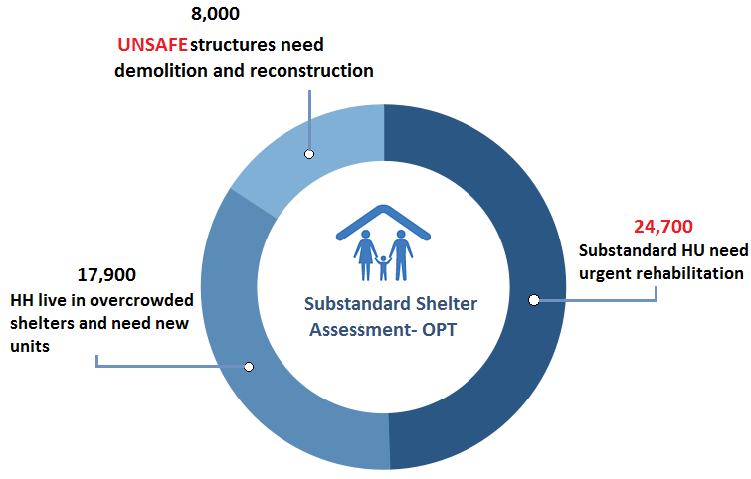
The conflicts and escalations in the previous years also led to the damage and destruction of more than 173,000 housing units, out of which 51,000 units are still in need of repair and reconstruction and 4000 people are still displaced since 2014 conflict. The findings of the recent shelter vulnerability assessment conducted by MoPWH and concluded in January 2020 in Gaza revealed that 7,000 units need complete reconstruction, in addition to 21,500 substandard units, which need rehabilitation of essential components to provide minimum requirements of waterproofing, hygienic living space, privacy, and protection from weather extremes. Overcrowding compounded with unhygienic living conditions is common in the substandard shelters in Gaza. Due to the lack of infrastructure, proper storm water drainage, and winterization preparedness, some 235,000 people are at constant risks of flooding during the rainy season particularly the people living in ground floors and houses located in low depression areas near the valleys or adjacent to Sewage Water pumping stations. Finally, the deterioration of economic conditions and lack of regular and sufficient income for some 9,500 families in rented accommodation according to MoSD database are repeatedly exposed to the risk of eviction for the inability to pay the rental costs.
Figure 1: Findings of Substandard Housing Assessment in the Opt

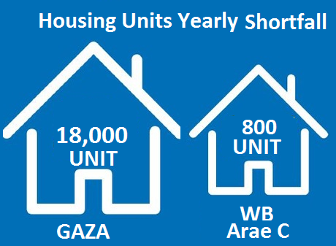
In the West Bank including East Jerusalem, the annual population growth is 2.2%, which is accompanied by an increased demand of new housing units to cover the needs, especially in the areas for which Israel is responsible in terms of planning and construction like area C, where the population suffers from a significant shortage of basic shelter units. The number of shelters in the communities located entirely in Area C has been almost the same for more than 20 years and the estimated shortage to cover the growing yearly needs is around 800 shelters. In such communities, the interventions for years were limited to rehabilitating and upgrading of the existing shelters without adding new ones to avoid demolition and displacement that are regularly and increasingly applied by the ICA in violation to the human rights treaties to have safe and adequate shelter. As a result of the discriminatory planning procedures and practices, many residents are forced to leave the area completely, especially young couples, to search for suitable shelter in areas that are safe and more secure. Shelters in Bedouin and herding communities in Area C are classified as substandard shelters and lacking the minimum requirements for a decent life while the residents in this area live in tents, metal tin shacks, or caves. The updated assessment for these communities as of August 2020 showed that there is an urgent need to rehabilitate at least 3,200 existing shelters. This situation also applies to residents in East Jerusalem, who suffer from a large housing deficit due to the significant restrictions imposed on new construction, forcing people to find alternatives in other locations like Kufer Aqab, and to other nearby towns like Abu Dis, Al-Eizariya, Anata, and AlRam.

In both WB and Gaza, the COVID 19 pandemic also showed the inability of poor families living in substandard shelters to find suitable isolation areas within their homes, particularly the people living in overcrowded conditions such as refugee camps, slums and the families who reside in area C. They are in need to improve the covered areas, provision of the hygienic and disinfectant materials and separating the shared facilities like toilets and kitchens. Due to the deteriorating economic situation related to the inability of the Palestinian Authority to pay salaries and the loss of jobs for many people due to the pandemic, it is expected that there will be a high increase in the number of tenants who are unable to pay the rental fees in Gaza, East Jerusalem and WB, which exposes them to the risk of forced eviction and to look for other options and negative coping mechanisms that are usually not appropriate and expose them to many protection concerns.

In the same context, there is an increasing need for the provision of the necessary NFIs and disinfection materials to quarantine/isolation centers and the families at home quarantine/ isolation.
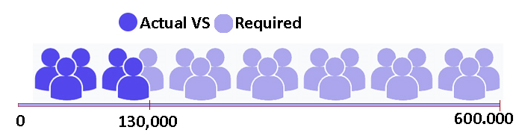
Maintaining an adequate stock level of NFIs is considered an absolute necessity in light of the escalating risks in the West Bank and the Gaza Strip. In Gaza, the instability may lead to a new devastating escalation and the displacement of large numbers of the population, estimated at 600,000, and this coincides with the increase in cases affected by the pandemic, and in both scenarios, the shelter and isolation centers need sufficient quantities of NFIs to meet different needs.
Figure 2: Actual Vs. Required Pre-positioned NFI Stock for Large Scale emergency
A similar situation is envisaged in the West Bank, especially in Area C, East Jerusalem and areas at risk of annexation. Shelters are subject to continuous and increasing demolition causing the displacement of families, loss of shelters and the need for quick interventions for the IDPs, in addition to the need to provide quarantine centers with the required NFIs materials in coordination with the ministries and UNRWA.

Adequacy means to have shelter with enough covered area and space for all family members to ensure privacy and carry out home activities without exposure to protection concerns, stress, and psychological problems. Additionally, it must be structurally safe to withstand various loads and to resist extreme weather conditions in winter or summer beside the existence of the necessary and basic facilities, such as the kitchen and bathroom.
UNESCO study 2017
WASH Cluster for oPt
Based on the comparison of the figures of the vulnerability shelter needs assessments conducted by the cluster partners in 2018 and updated on 2020
Shelter vulnerability assessment conducted by the cluster partners in 2018 and updated in August 2020
Planning figures for IACP in Gaza

