CCPM follow-up Action Plan – SNFI Cluster Turkey Hub (Gaziantep)
Cluster Coordination Performance Monitoring (CCPM) results and members’ suggestions for improvement. All information and feedback received as shown below was presented during the Cluster Meeting (12 Dec 2018) and opened for discussion and suggestions afterwards.
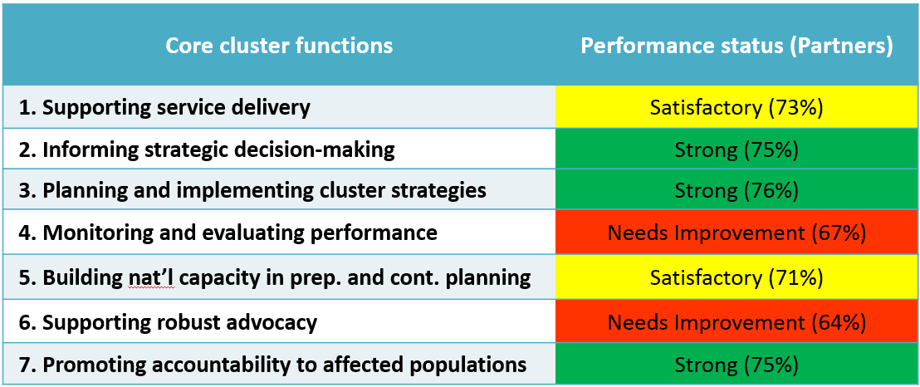
The results of the survey were:

Note: 21 Partner Organizations from Turkey Hub did the survey (local NGOs: 12; INGOs: 6; UN: 2; Other: 1)

Additional comments or information on cluster performance from members (out of 21)
- Cluster members are doing great work, thank for all of you
- Good work!
- عمل دورة لوضع مرجع او كود لارشادات ومعايير الانشطة التابعة للقطاع (Conducting a workshop to establish handbook or standards related to the activities of the cluster)
- We would like to hear more about the operations in Euphrates Shield and Afrin
- No

As the first step a follow-up suggestion survey was shared by the SNFI Cluster Coordination Team in Gaziantep, to receive more specific suggestions based on the received rating by Core Function.
Based on the initial ratings and the follow-up feedback survey a meeting with the SNFI SAG (Strategic Advisory Group) was held in Gaziantep, on the 21 February 2019.
The below drafted action plan is created based on the feedback of the surveys and the discussion of the Cluster Coordination Team and the SAG.

Action Plan:
Strengthen core function 1 - Supporting service delivery & 5 – Building nat’l capacity
Conduct more trainings in various fields affecting the Cluster Partner’s management, project planning and implementation throughout the humanitarian programme cycle.
Step1: OCHA is going to share a training needs survey in the coming days/weeks. The SAG decided to wait until the Training Needs Survey was shared and will create a follow-up survey based on the trainings that OCHA is going to conduct and/or repeat.
Step2: Develop Training plan to fill gaps based on the OCHA provided trainings which are essential for proposal writing, project planning and implementation as well as reporting.
- This includes initiatives based on the Lesson’s Learned Workshop of IOM’s Winterization 2018/19 conducted by implementing partners as well as PDM reports.
- A special focus will be put on ToTs - Training of Trainers, as one of the reported challenges of Cluster Members is the capacity building of staff in Syria. Turkey based staff have access to the trainings conducted by varies entities, like the OCHA and various Clusters. Even if encouraged the transfer of knowledge for the organizational focal points is challenging.
Strengthen core function 6 - Supporting Robust advocacy
The Cluster will ensure to communicate the efforts done in terms of advocacy for the Cluster more frequently with the Cluster Members.
- The question for advocacy for Shelter and NFI needs did arise from time to time during the Cluster Meetings during 2018. The Cluster Coordinator assured to the members, that he has/had frequent meetings with various donors and that the Cluster is providing all necessary input based on the partners reporting to OCHA and WoS reports so that needs are advocated for.
- To strengthen and highlight the advocacy done by the Cluster, the Coordination Team could include a special section for Advocacy on the monthly shared SNFI Factsheet under which donor meetings and official reports to which the cluster provided into will be listed.

Note on core function 4 - Monitoring and Evaluation performance
This core function ‘needs improvement’ based on the results of the CCPM Survey conducted by the GSC. The rating for this core function is understandable, as it is a fact that the Cluster’s operating Cross-Border from Turkey have no real means for monitoring and evaluating the implemented projects by Cluster Members.
The Cluster Coordination Team and the SAG are working on updates for the Standard operating Procedure and Post-Distribution Monitoring guidance documents, which are recommended to be used by all Cluster Members. It is encouraging to hear from the Cluster Members in the survey results, that they see the need for improvement in this core function as it highlights their understanding of the importance.
For the Cluster Coordination Team there is no other means than highlighting the guidance on this matter that can be provided, but the Cluster is not in a place to initiate a third party monitoring request. This can be done by only a few entities, like UNHCR in the case of their direct Partners or IOM who can request a PDM for the CCCM/SNFI contingency stock on special occasions. These are great examples that can lead to improvements on the ground and in the organizations project implementation as well as the general accountability of the Cross-Border implemented projects and hopefully guide other organizations to conduct their own PDMs.

