

SOHDA Emergency Visit Assessment Report
Tabeelaha Sheik Ibrahim Zone of Deynile
& Rabbi Tuug IDP Settlement camp of Sarkusta zone
Shelter Needs Assessment
Team from SOHDA: Somali Humanitarian and Development Action voluntarily went visit assessment today Tabeelaha Sheik Ibrahim IDPs settlement of Deynile District and Sarkusta IDPs settlement so as to know more about the evicted Internally Displaced Persons (IDPs) and new influx IDPs reached to the IDPs areas such as Rabbi Tuug camp.
Below photos show the previous lands they evicted from families and the new lands they are settling now.
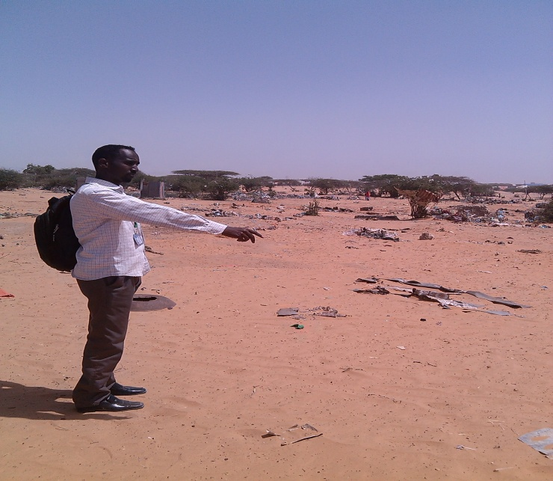
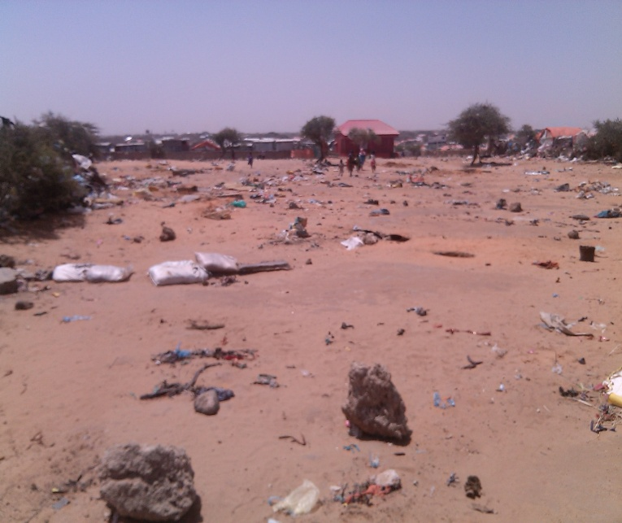
Sarkusta IDPs Evicted Lands Photos

As you can see above photos are the lands where the IDPs have been evicted from by the land owners.
The situation of the evicted families is too bad. The IDPs umbrella camps supervisors are appealing to the international and UN aid agencies for emergency response.
In addition, below photos indicate the newly areas that the evicted IDPs moved and settled.
Tabeelaha Sheik Ibrahim IDPs settlement and Rabbi Tuug Camp

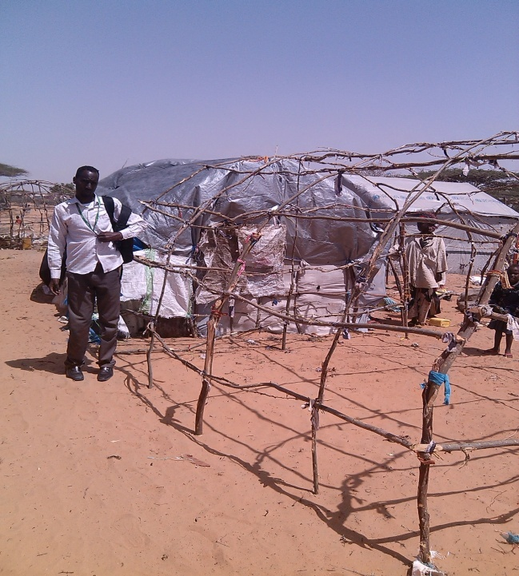
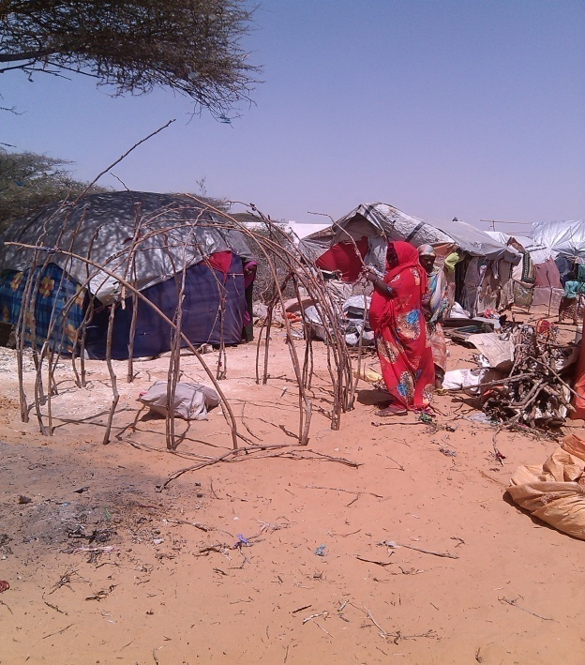

Majority of the IDPs camps visited by SOHDA Team were mainly complaining from lack of shelter and are in need of emergency shelter and NFIs assistance since they became and took refuge in the camps of Tabeelaha Sheik Ibrahim of Deynile and Sarkusta IDPs settlement.

Hence, the emergency needs of these families are tents, NFI kits, construction of toilets, water provision, and establishment of health center and emergency food aid in their respective camps.
The poor livelihood condition existing in these IDP camps in Tabeelaha Sheik Ibrahim and Sarkusta IDPs settlements coupled with the living in make shift slums covered with frayed clothes and cartoons make the lives of the poor IDP very complicated and victims of rain and wind. The kind of shanties which they use as shelter doesn’t prevent them from rain, cold and can be easily washed away by the simple wind and rains. Shelter is critical determinant of improving dignity and giving protection from such condition.

Table of Old IDPs Camps Tabeelaha Sheik Ibrahim IDP Settlement
Anab Abdukadir Hussein Chairwoman of the Sahal Center can be reached at 0615843397 and the below shown number of IDPs camps comprise of their umbrella:
No | Camp Name | HH Figure | Supervisor | Mobile | Area/Zone | District
1. | Al-rahma | 450 | Rahma Mohamud Mohamed | 0615802286 | Tabelaha Sheik Ibrahin | Deynile
2. | Qaayib Camp | 395 | Sako Elmi Warsame | 0615503623 | “ “ | Deynile
3. | BilBishaaro Camp | 286 | Salad Ahmed Nur | 0615170291 | “ “ | “ “
4. | Bardhere Camp | 425 | Dhofo Abdi Hnashi | 0615180740 | “ “ | “ “
5. | Buulo Golweyn Camp | 310 | Ali Sharif Mohamed | 0615439136 | “ “ | “ “
6. | Mubarak Camp | 290 | Ayan Osman Mohamed | 0615595685 | “ “ | “ “
7. | Fatxi Camp | 387 | Halima Hassan Kahiye | 0615580314 | “ “ | “ “
8. | Samajacel Camp | 320 | Jim’alle Ali Yabarow | 0615836921 | “ “ | “ “
9. | Towfiq Camp | 481 | Mohamed Nur Isaq | 0615119821 | “ “ | “ “
10. | Al-Hidayo Camp | 415 | Anab Abdulkadir Hussein | 0617505357 | “ “ | “ “
11. | Liibaan Camp | 300 | Halima Abtidon | 0615922235 | “ “ | “ “
Towxid Center can be reached at 0615537730
Ahmed Ali Qayre Chairman
and the below shown number of IDPs camps comprise of their umbrella:

1. | Xiis Camp | 715 | Ahmad Ali | 0615537730 | Tabelaha Sheik Ibrahin | “ “
2. | Manya Fuul Camp | 505 | Muhudin Abdulle Yabarow | 0615855301 | “ “ | “ “
3. | Geed Weyn Camp | 580 | Siidow Hajji | ---------------- | “ “ | “ “
4. | Darban Camp | 315 | Maxamed Nur | 0618881699 | “ “ | “ “
5. | Ayan Camp | 615 | Shukri Ali Mohamed | 0615921444 | “ “ | “ “
6. | Sucdi Camp | 315 | Xawa Ali Mohamed | 0615831277 | “ “ | “ “
7. | Dalabey Camp | 209 | Osman Dalabey | 0615545186 |  | “ “
 | Sarkusta IDPs settlement
8. | Rabbi Tuug Camp | 209 | Ahmed Mohamud Alofey | 0615994199 | Sarkusta | Sarkusta
Rabi Tuug New Influx IDPs (Sarkusta Zone)
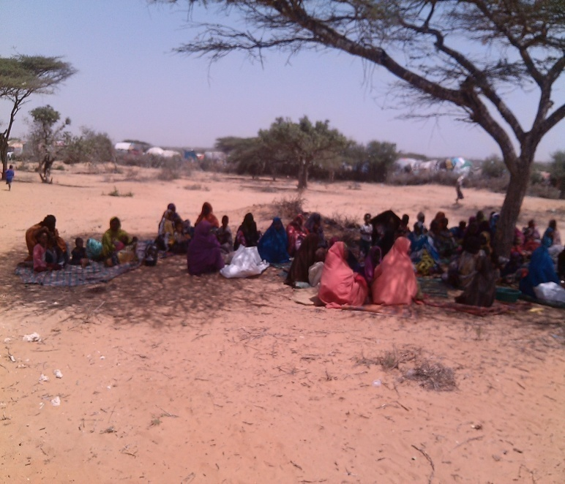
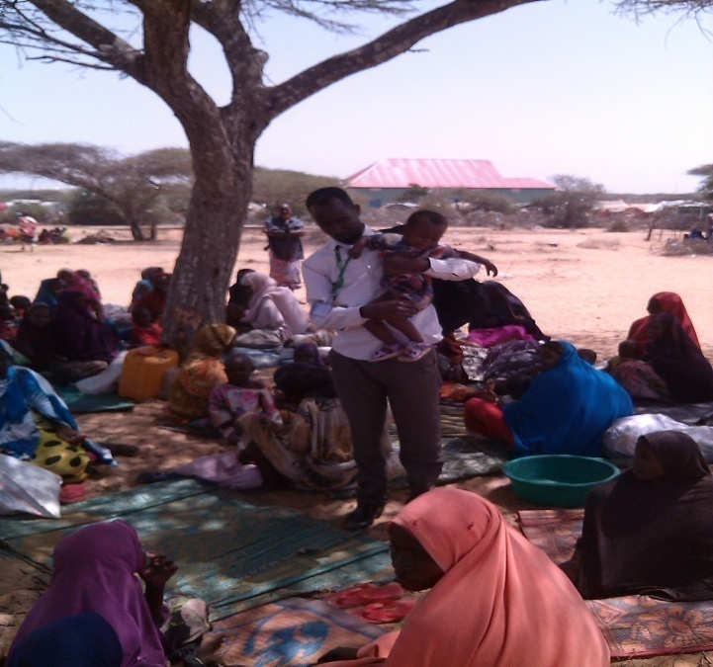
Below shown photos indicate new influx Internally Displaced Persons (IDPs) as we have witnessed with our eyes and camp supervisor Ahmed Olofey confirmed to SOHDA team. These new displaced families are 245 HHs both from Lower Shabelle region various villages and some of the evicted HHs of near areas of Sarkusta and still are coming.
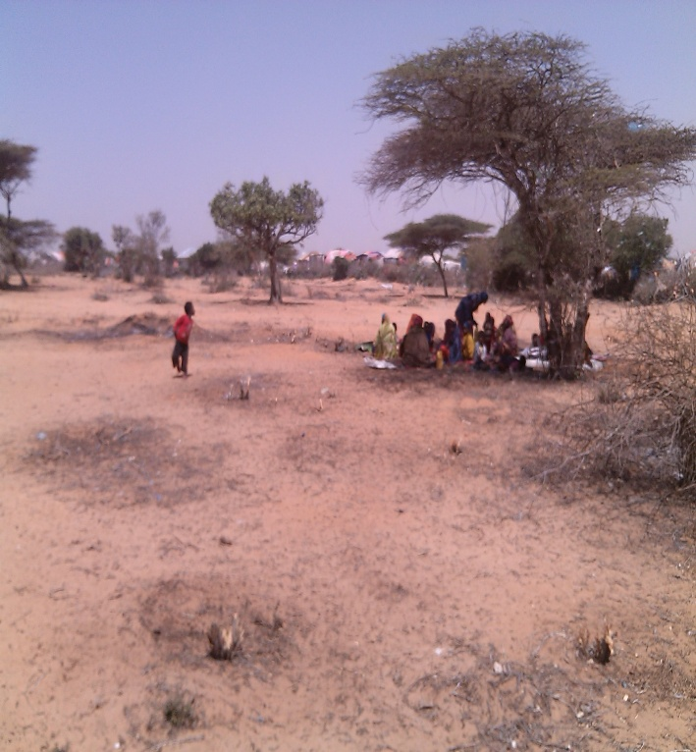
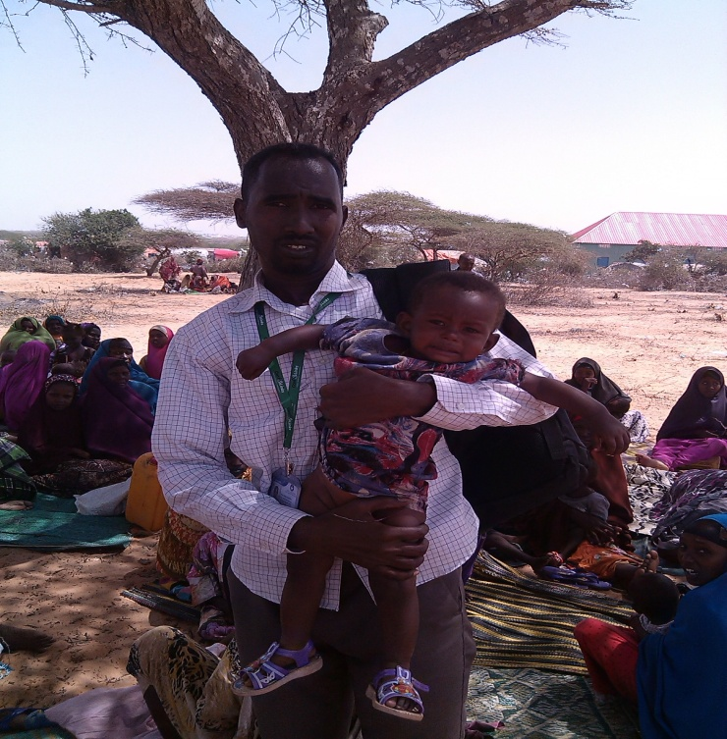

For further facts can be reached to Ahmed Mohamud Alofey as Rabbi Tuug Camp Chairman 0615994199.
Current General Emergency Needs
Without doubt, the previous old IDPs camps based at Tabeelaha Sheik Ibrahim and Sarkusta IDPs settlements and also new influx IDPs are currently in need of to be supported from following emergency needs as they stated:
- Emergency Shelter provision (Tents & NFI kits)
- HHs Utensils to cook
- Wash
- Food Aid
- Establishment of MCH
The umbrella camps supervisors confirmed to SOHDA that the eviction movements are extensively greater than ever at the areas of Tabeelaha Sheik Ibrahim and Sarkusta IDPs settlements as the land owners forcing IDPs to move, SOHDA encourages the shelter cluster and the protection cluster to be alert on this subject and to take action.

Somalia homes to the largest population per capita of Internally Displaced Persons (IDPs) in the world of today. Almost 30 percent, which means over a quarter of a million people, have been displaced and nearly half of the country’s population is malnourished and totally dependent on external food aid.
3.2 million Somalis are in need of humanitarian assistance.

As a result of the recent fighting against Al-shabaab and a prolonged drought and loss of shelter, thousands of people living in make-shift huts, whose life depends on begging, have starved to death.

Consequently, SOHDA today’s assessment visit with the local authorities and community leaders at Tabeelaha Sheik Ibrahim and Sarkusta IDPs settlements indicates emergency shelter distribution for Tabeelaha Sheik Ibrahim and Sarkusta IDPs settlements families are preeminent at the moment.

At last, SOHDA recommends and proposes to Organizations involved in shelter for emergency shelter provision to the most of IDP camps especially Rabi Tuug new Influx IDPs and old IDPs camps stays in the makeshift houses that cannot prevent from them rain, winds and cold at night.

