Emergency and Transitional Shelter in South Sudan

Context

The longevity of the conflict in South Sudan, which started in December of 2013, has surpassed the expectations of Humanitarian partners and it is therefore essential to reconsider original designs and strategies for shelter provision.
Acute emergency shelter provision is not sustainable beyond the intended three to six month life span of the materials. However in some places such as PoCs, permanent shelters are not appropriate and will not be accepted by management and administrative agencies. A move towards a medium term shelter, being more robust than standard emergency shelter is therefore vital for ensuring a sustainable, responsible and dignified shelter solution for displaced populations in South Sudan.

Robust Emergency Shelter and Transitional Shelter

Robust Emergency Shelter  General Characteristics | Transitional Shelter  General Characteristics
- Transported by truck rather than air  - Top up kit for a standard emergency kit  - Meets SPHERE standards  - More reinforcement than standard emergency shelter  - Lifespan: 6 to 12 months | - Transported by truck rather than air  - Design acceptable by local culture  - Structure fully reinforced and stable including some elements of a permanent dwelling  - Made from locally sourced materials  - 70 % of the materials shall be reusable and transportable.  - Lifespan: 12 to 24 months
Robust Emergency Shelter is appropriate when the following conditions are in place: | Transitional Shelter is appropriate when the following conditions are in place:
- Expected stay of 3 months or more  - Unsecured returns  - Land Tenure un-cleared (population stranded or in transit)  - P.O.C. | - Road transport is possible with safety and weather permitting  - Expected stay of more than 6 months  - Secured returns  - P.O.C. with high security constraints  - Land Tenure cleared

Key Considerations and Recommendations for Shelter

General Structure and Vertical Elements
- The most appropriate emergency shelters are generally square or rectangular shelters with 3.5 square meters per person and approximately 2m in height (keeping in mind cultural traditions for opening sizes such as doors). Vertical poles should be properly fixed in the ground and rigidity is essential to avoid collapsing shelters.
- Always allow flexibility in materials provided by the beneficiaries themselves (ie. Doors) and do not undermine their own coping mechanisms and/or sense of self-sufficiency and independence.
- Ensure materials are sourced responsibly and are not causing further problems or tensions elsewhere.
- Partners have suggested that additional poles should be added to our shelter designs as it would improve durability and weather resistance and also facilitate any transition into a medium term shelter solution.
Roofing
- The roof structure should focus on a combination of simplicity, strength and the incorporation of readily available materials.
- Hip roofs and complicated trusses or gables prove to be too difficult and inappropriate for emergency or transitional shelters.
- Curved roof structures (Image 1)using split bamboo have been proven to be effective in their design however they require more technical skills to construct.
- A double pitched roof, also called a single gabled roof (Image 2), has been established as the most suitable option for PoCs in South Sudan when taking into consideration the required skills for construction, availability of materials, weather resistance and cultural appropriateness.
Ventilation
- Proper ventilation is essential to ensure comfort and health. Ventilation by means of “gaps” or openings between the roof and walls must be considered for warm weather climates.
- Openings of different sizes allow for a greater increase in airflow.

Bracing
- Bracing is the process of using additional wood, wire or poles at strategic angles to ensure the structure does not sag or sway.
- Bracing can be done using an angle in a corner, a full “X” on the walls or in the roof. See the below for an example of cross bracing, v bracing and k bracing.
- At the moment, emergency shelter interventions in South Sudan have been poor at incorporating proper bracing into their designs.
- Bracing is essential to ensure longevity and integrity of the shelter.

Tying/Pegging
- Partners have agreed the most effective method for pegging the shelter is the “wall base method” (Image 3).
- Observations in PoC areas have seen that many self-made shelters are not pegging or tying in any way and it is advisable that IDPs be shown the importance of this process.

Termite Control
- Given the climate and conditions of South Sudan, termites are a continuous problem. Using oil as a deterrent is common practice but some partners are reporting it to be ineffective.
- A possible alternative is the use of fire ash spread in a line around the entire shelter as this has been proven effective to deter Insects.
Plastic Sheeting
- Plastic Sheet distributions are unsustainable and do not provide a viable medium term solution. The PoCs are now being seen as medium to long term in nature and therefore more robust or transitional shelter solutions need to be further discussed.
- Using grass or palm leaves on top of the plastic sheet is a common and appropriate way of protecting the plastic sheet from UV damage and should be encouraged whether the shelters are considered for a short term emergency or otherwise.
- Appropriate fixing of the plastic sheeting is vital in ensuring it lasts the intended 6 months.
Flooring and Drainage
- Raising floors of shelters or providing a means of keeping water at bay is crucial.
- Soil types must be considered carefully as some areas have inappropriate soil types, for example the black cotton soil of the Upper Nile region.
- Sand bagging and dykes or ditches can be a very effective solution however sand bags are susceptible to UV damage. A light layer of soil covering sand bags is suggested to protect them from the sun.
- In some areas rice husks or sugar cane waste can be used to stabilize soil and make excellent floors, however this is not an option in South Sudan.
Wattle and Daub
- Wattle and Daub could be defined as a process of using a lattice work of flexible material such as sticks or grass and daubing it with a sticky substance such as clay to form a wall or roof.
- Clay soils such as black cotton soil are useable for wattle and daub (See Image 4)
- It is possible to amend breakages with fibers or sand. For fiber better to use animal hair if termites are common as termite will not eat hair.
- Reinforcing the wall in this manner does not reduce the need for proper bracing.

Recommendations for Adjustments to Kit Contents

The Shelter NFI Cluster in South Sudan is recommending a top up kit for shelter interventions. It would be in addition to standard emergency shelter kits. Referring to the kit a Robust Emergency Shelter (RES) it would likely include the following:
- 8 extra wooden poles (for a total of 12)
- 3 bundles of bamboo
- 10 extra sand bags (for a total of 46)
- 200g of 6 inch nails for structure
- 400g of 2.5 inch roofing nails
- 50m of 1.2mm binding wire
- Appropriate tools need to be discussed further however a basic mallet/hammer is suggested
- Feasibility of glue and patches should be considered by the cluster for the purpose of allowing the IDP to repair their plastic sheet by themselves. (This would require training and explanations to be done during distributions)

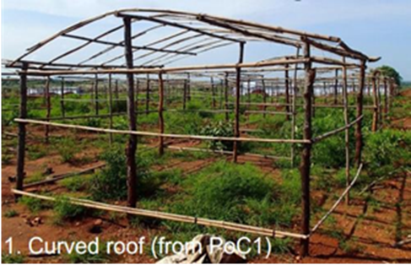
Curved Roof
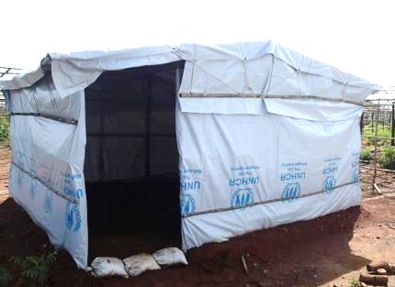
Double Pitched Roof

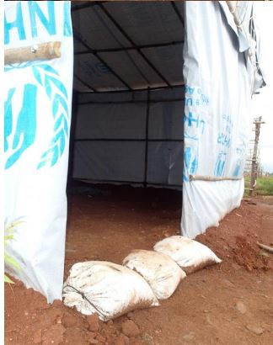
Wall Base
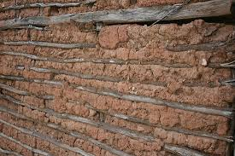
Wattle and Daub Wall

