

Rauhella Spring Bonanza
22 March 2025

Safety and Rules:
Safety is paramount and everyone´s responsibility. Anyone who observes an unsafe act or event, must/can call a “cease fire” at any time during the course of a match.
- Treat all guns as if they are loaded
- Muzzle awareness is crucial. Keep the muzzle pointed in a safe direction at all time, either up, towards the firing line or in the safezone on each station.
- All movement with the rifle must be done with the bolt open
- Don´t close the bolt until you´re in position and the have the rifle pointed towards the target
- If you are running a semi-auto, place the weapon on SAFE during transitions and say out loud “SAFE” before moving
- Keep your finger off the trigger and outside the trigger guard until you are ready to shoot
- The chamber flag is mandatory and must be in the camber until the RO tells you to remove it
- Cheating equals match DQ
- Unsportsmanlike conduct may result in a warning, a stage DQ or match DQ. The assessment is up to the RO and/or the MD and not up for discussion
- Follow the international PRS rules on precisionrifleseries.com

Equipment/behavior:
Magazines must not be filled with more than 10 rounds. Violation of this rule will result in a warning the first time, stage DQ the second time and match DQ the third time.
Binoculars, spotting scopes and range finders can be used at all times.
For match flow: Be ready with the rifle and equipment on the starting line as soon as the shooter before you is finished shooting. Please help out picking brass unless the RO tells you otherwise on stage.
“Hit to move” means = You must hit the first target before you move on to the next target. If you miss the first shot on the first target, you shall fire the second shot at same target until you hit.
If you have concerns regarding other shooters behavior, bring this up with the RO/MD as soon as possible. Not after the price ceremony..
There will be a zero range open from 0900-0915 and on request (malfunction etc). If you need to zero during the day, ask your RO.
All stages start standing with the rifle in hand, bolt open unless otherwise instructed in the briefing. Shooter will start on timer beep or on command.
Hope you enjoy the match!
MD: Bjørn Sørland (+4799123574)

Station 1 – Stage 1: Longrange Kyl
Number of rounds: 10
Time: 105 sek
Targets: 1 target:
O: 489m: 30-10cm (0,60-0,20mil) – The last target to the right is a spare target
Course of fire:
Engage the targets from left to right from 2 different positions, prone and from the table. There are four targets on the rack, engage the last target on the rack twice. Hit or miss.
Station 1 - Stage 2: Tanktrap
Number of rounds: 10
Time: 105 sek
Targets: 3 targets:
A: 242m: 18cm (0,73mil)
F: 368m: 25cm (0,67mil)
O: 487m: 30-25cm (0,60-0,50mil)
Course of fire:
Engage the targets from near to far with one round each from three different positions on the tanktrap. On the last position engage both the first two plates on the target O in the end. Hit or miss

Station 1 – Stage 3: Troopie
Number of rounds: 10
Time: 105 sek
Targets: 5 targets:
A: 242m: 18cm (0,73mil)
F: 368m: 25cm (0,68mil)
M: 437m: 20cm (0,46mil)
R: 469m: 35cm (0,75mil)
O: 487m: 30cm (0,61mil)
O: 487m: 25cm (0,51mil)
Course of fire:
Engage the targets from near to far from two different positions (the rack and the tires). On the first position engage the biggest target on target O and on the second position engage the second target on target O. Hit or miss.

Station 2 – Stage 4: Botnia Mayhem
Number of rounds: 10
Time: 105 sek
Targets: 5 standalone targets:
Left of C: 325m: 20cm (0,62mil)
D: 327m: 20cm (0,61mil)
K: 358m: ø20cm (0,56mil) – Botnia target
S: 296m: ø20cm (0,68mil) – Botnia target
T: 321m: ø20cm (0,62mil) – Botnia target
Course of fire:
Engage the targets left to right with one round each from two different chosen positions on the prop. Hit or miss.

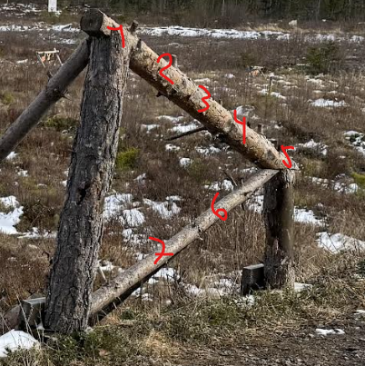
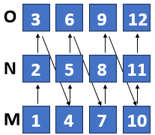
Station 2 – Stage 5: Timber
Number of rounds: 12
Time: 105 sek
Targets: 3 targets:
B: 248m: 15cm (0,59mil)
K: 355m: 20cm (0,55mil)
N: 420m: 25cm (59mil)
Course of fire:
Engage the targets with one round each from near to far from the position you choose on the timber. Move to the next position you choose and engage the targets with one round far to near. Move to the last position you choose and engage the targets near to far with two rounds each. Hit or miss
Station 2 – Stage 6: OALH Special REMOVED
Number of rounds: 10
Time: 105 sek
Targets: 1 target rack:
C: KYL-rack: 30cm-5cm – 324m (0,92-0,15mil)
Course of fire:
Engage the targets from big to small (left to right), hit to move. If you hit all 8 targets, re-engage the last target with your last rounds until 10 rounds has been shot.
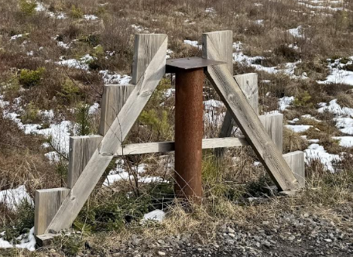

Station 3 – Stage 7: Biggie Smalls
Number of rounds: 12
Time: 105 sek
Targets: 6 targets:
J: 284m: ø18cm (0,63mil)
J: 284m: ø15cm (0,53mil)
G: 369m: ø20cm (0,54mil)
G: 369m: ø15cm (0,41mil)
H: 418m: 30cm (0,72mil)
H: 418m: 20cm (0,48mil)
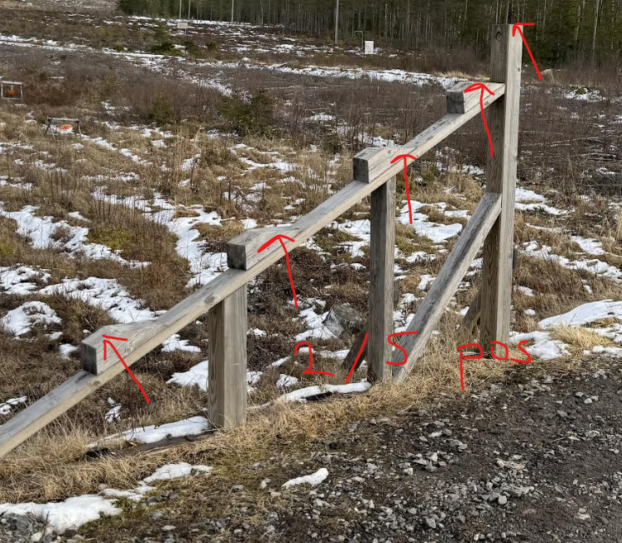
Course of fire:
Engage the targets near to far with two rounds on each target rack. Engage the big target and then the small target, hit to move for each target rack. Example: If you miss the first shot on the big plate on J, you re-engage this target and then you move to G. After 6 shots from the first position (J,G,H), move to the second position and repeat.

Station 3 – Stage 8: Skillstage
Number of rounds: 10
Time: 105 sek
Targets: 2 targets:
G: 369m: ø20cm (0,54mil)
G: 369m: ø15cm (0,41mil)
Course of fire:
Engage the big and then the small target with one round each from 5 positions on the barricade. Shooter must use all 4 positions before choosing a final position which is not the same as the one used on the 4th position. Hit or miss. This stage is a TIEBRAKE-stage.

Station 3 – Stage 9: Papa Doc
Number of rounds: 12
Time: 105 sek
Targets: 3 targets:
P: 342m: 25-10cm – (0,74-0,30mil) – the last target is a spare target
H: 419m: 30cm-20cm (0,72-0,48mil)
Course of fire:
Position one: Engage the left target on P and then the left target on H with one round each. Position two: Engage the second target on P and then the second target (right) on H with one round each. Position three: Engage the third target on P and then the left target on H with one round each. Position four: Engage the last target on target P and then the right target on H with one round each. From the last position, engage the targets on P from left to right. Hit or miss

