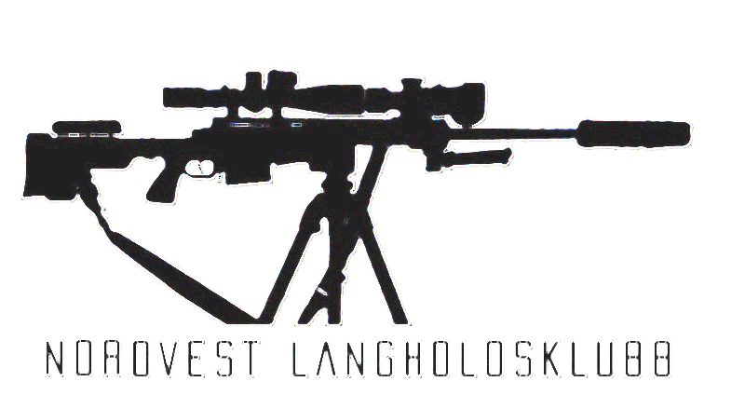
Nordvest Langholdsklubb.

Info:
Pin to the range: https://maps.app.goo.gl/z9AsmkDuaoWBcKXb6
To get there, you need to walk through the farm at the back and follow the road. The road is marked and clearly signposted.

Parking will be around the farm at this pin: https://maps.app.goo.gl/rnenGWQ4ktCyuUg48

The exercises are spread across five stations. The longest walking distance is 200 meters from the main shelter at the range.

We offer free coffee and cocoa at the range for those who want it. There will also be two fire pits burning. You’re welcome to grill your own food if you wish—just bring your own food.

Match brief at the shelter on the range 0900. If you need to zero you can do it from 0800. In case of problems with zero or rifle during the match its possible to recheck if needed.

Station 1

Stage 1 CAR WRECK
Start at given position with bolt back, mag in. Shooter will shoot from five marked positions on the car wreck. Position number one shoots target number one and so on. HIT OR MISS, shooter shoots two shoots from each position at the numbered target
Targets/Positions:
1: India 483M 30x30CM
2: Charlie 273M Ø25CM
3: Juliet 610M Ø35CM
4: Romeo 462M Ø35CM
5: Papa 426M 35x10/14CM

Number of rounds: 10
Time: 150 sec.

---------------------------------------------------------------------------------------------------------------
Personal notes: Stage score: ____ / 10

--------------------------------------------------------------------------------------------------------------

Stage 2 FLAT TIRE FRENZY
Start at given position with bolt back, mag in. Shoot target one from prone position on the left side of the tires with two shoots. Then move over to the tires. Shoot one shoot from each of the two left positions at target two Then two shoots from the center top position at target two . Then you shoot one shoot from each of the two positions on the right side on the tires at target two. Then you move over to the right side and shoot two shoots at target one from prone position.

Target:
1: Kilo 678M 40x40CM
2: India 479M 30x30CM
Number of rounds: 10
Time:150 sec.

---------------------------------------------------------------------------------------------------------------
Personal notes: Stage score: ____ / 10

--------------------------------------------------------------------------------------------------------------

Station 2:

Stage 3 HELICOPTER
Start at given position with bolt back, mag in. Shooter will shoot from five marked positions on the helicopter. Position one to four will shoot target number one. Position five will shoot target number two.

Targets:
1: Golf 376M 25x25CM
2: Golf 376M 40x40CM
Number of rounds: 10
Time: 150 sec

---------------------------------------------------------------------------------------------------------------
Personal notes: Stage score: ____ / 10

--------------------------------------------------------------------------------------------------------------

Stage 4 BLACK GOLD BARRICADE
Start at given position with bolt back, mag in. Shooter will shoot from four marked positions on oil barrels with two shoots from each position. Position one and two will shoot target one. Position three and four will shoot target two. HIT OR MISS shooter will change position after two shoots from each position.

Targets:
1: Echo 344M 20x20CM
2: Lima 424M Ø35CM
Number of rounds: 8
Time:120 sec.

---------------------------------------------------------------------------------------------------------------
Personal notes: Stage score: ____ / 8

--------------------------------------------------------------------------------------------------------------

Station 3:

Stage 5 THE BOULDER GAUNTLET
Start at given position with bolt back, mag in. Shoot the targets from the boulders and tanktraps marked with positions from one to five. Each position has its own target. Shoot two shoots at the target hit or miss.

Targets/Positions:
1: Delta 320M Ø23CM
2: Ærlig 927M 40x40CM
3: Whiskey 515M 48x30CM (Torso)
4: Yankee 654M 52x54CM
5: Xray 631M 30x36CM

Number of rounds: 10
Time:150 sec.

---------------------------------------------------------------------------------------------------------------
Personal notes: Stage score: ____ / 10

--------------------------------------------------------------------------------------------------------------

Stage 6 THE ROCK FACE RECKONING
Start at given position with bolt back, mag in. Shoot the target from the marked positions on the rock face. With two shoots from each position. HIT OR MISS, shooter will change position after two shoots.

Targets:
1: Delta 310M Ø23CM
2: Delta 310M Ø23CM
3: Whiskey 505M 48x30CM (Torso)
4: Yankee 646M 52x54CM
5: Mike 430M Ø23CM

Number of rounds: 10
Time:150 sec.

---------------------------------------------------------------------------------------------------------------
Personal notes: Stage score: ____ / 10

--------------------------------------------------------------------------------------------------------------

Station 4

Stage 7 KNOW YOUR LIMITS
Start at given position with bolt back, mag in. Shooter will shoot from one position, free of choice on the rock. Shooter will load two magazines with five shoots each. Start with one magazine in rifle, the other on designated spot. Shooter must hit the target to move on to the next one, HIT TO MOVE. After shooter has shoot all rounds in first magazine, shooter will pickup the second magazine and start again from the largest steel plate. All equipment allowed. All targets are on the same target rack.

Targets:
1: Sierra 420M 40x40CM
2: Sierra 420M Ø30CM
3: Sierra 420M Ø25CM
4: Sierra 420M Ø15CM
5: Sierra 420M Ø10CM
Number of rounds: 10
Time:120 sec.

---------------------------------------------------------------------------------------------------------------
Personal notes: Stage score: ____ / 10

--------------------------------------------------------------------------------------------------------------

Stage 8 TROOP LINE
Start at the given position with the bolt back and magazine inserted. Shooter will shoot from one position, free of choice on the rock. Shooter will shoot targets from near to far. HIT OR MISS, two shoots at each target.

Targets:
1: Oscar 385M 30x30CM
2: Papa 353M 10/14x35CM
3: Sierra 414M Ø30CM
4: Zulu 605M 40x40CM
5: Zulu 605M 30x35CM
Number of rounds: 10
Time:120 sec.

---------------------------------------------------------------------------------------------------------------
Personal notes: Stage score: ____ / 10

--------------------------------------------------------------------------------------------------------------

Station 5

Stage 9 TANK TRAP MADNESS
Start at given position with bolt back, mag in. Shoot from all four tank traps, shooter can choose any position on the tank traps. From each tank trap, shoot one shoot at target one, then two shoots at target two.

Targets:
1: Uniform 218M 10x10CM
2: TORSO (No ID) 511M 48x30CM
Number of rounds: 12
Time:150 sec.

---------------------------------------------------------------------------------------------------------------
Personal notes: Stage score: ____ / 12

--------------------------------------------------------------------------------------------------------------

Stage 10 SKILL STAGE 2
Start at given position with bolt back, mag in. Shoot two shoots from each of the four positions at target one. HIT OR MISS.

Targets:
1: Åse 418M Ø25CM
Number of rounds: 8
Time: 90 sec. This stage is a tie breaker stage.

---------------------------------------------------------------------------------------------------------------
Personal notes: Stage score: ____ / 8

--------------------------------------------------------------------------------------------------------------

Nordvest Langhold. Range Muldsvor

Stage | Hit count | Of possible points
1 |  | 10
2 |  | 10
3 |  | 10
4 |  | 8
5 |  | 10
6 |  | 10
7 |  | 10
8 |  | 10
9 |  | 12
10 |  | 8
SUM

