Matchbook
Moskus Steel 7

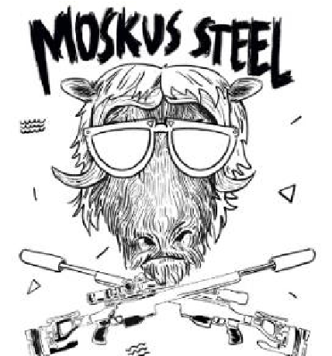

Safety and Rules:

Safety is paramount and everyone ́s responsibility. Anyone who observes an unsafe act or event, must/can call a “cease fire” (avbryt/stans skyting) at any time during the match.

- Treat all guns as if they are loaded
- Muzzle awareness is crucial. Keep the muzzle pointed in a safe direction at all times, either up, towards the firing line or in the safe zone on each station
- All movement with the rifle must be done with the bolt open
- Don ́t close the bolt until you ́re in position and have the rifle pointed towards the target
- If you are running a semi-auto, place the weapon on SAFE during transitions and say out loud “SAFE” before moving
- Keep your finger off the trigger and outside the trigger guard until you are ready to shoot
- The chamber flag is mandatory and must be in the camber until the RO tells you to remove it

Other:
All exercises starts with magazine in, bolt in rear position, at marked position. You can touch all props during stage brief, but you cannot position your rifle or equipment on the props before your turn to shoot.

Binoculars, spotting scopes and range finders can always be used. It ́s allowed to start a stage with tripods deployed. All target distances are laser ranged.

There are no limitations in gear you can use during stage, but you need to start with everything at hand and up from the ground.

For match flow: Be ready with the rifle and equipment on the starting line as soon as the shooter before you are finished shooting. Please help with picking brass unless the RO tells you otherwise on stage.

“Hit to move” means you must hit the first target before you move on to the next target. If you miss the first shot on the first target, you shall fire at the same target until you hit. “Hit or miss” means that you shoot at the target with rounds that you are supposed to and you move to next target or position.

All ranges is measured with rangefinder, after best effort.
All crew does the best job they can, we all want you to have a good time!

Moskus Steel 7 will be at Vinstra, Bleikmyra Shooting range.
You will be able to find Bleikmyra shooting range in Google.
(61°37'19.9"N 9°46'04.1"E)
When you start driving up it might seem long, but the range is there.

Match brief will start at 0900 at the parking!

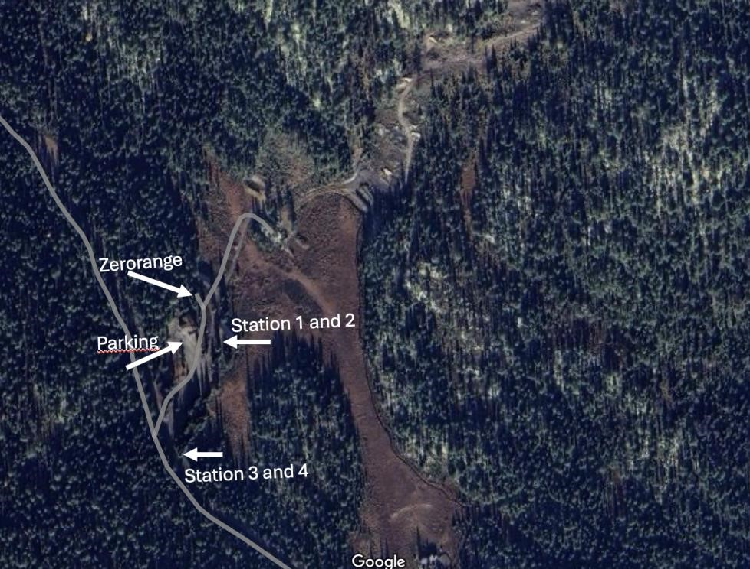

Some of the pictures of the props are not taken at Vinstra, due to the props is set up close to matchday. They will be similar!

Stage 1 Pipes
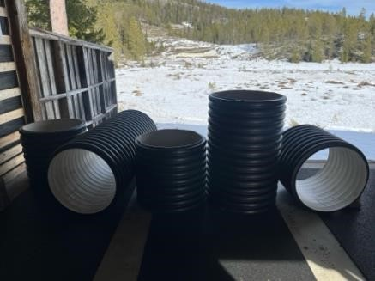
Start at given position with bolt back, mag in. Shoot the three targets from four different desired positions at the Pipes. Hit to move target in positions
Targets: T Ø20, Ø15, Ø10
Distance: 306m 334Y Number of rounds: 12 Time:120 sec.
--------------------------------------------------------------------------------------------------------------
Personal notes: Stage score: ____ / 12

--------------------------------------------------------------------------------------------------------------
Stage 2 Stairs

Start at given position with bolt back, mag in. Shoot from 10 different positions. On the “Stairs”. There will be flat surfaces on the stairs.
Target: O 30X30CM (extra target)
Distance:467m 510Y Number of rounds: 10 Time:120 sec.
--------------------------------------------------------------------------------------------------------------
Personal notes: Stage score: ____ / 10

--------------------------------------------------------------------------------------------------------------

Stage 3 Wall
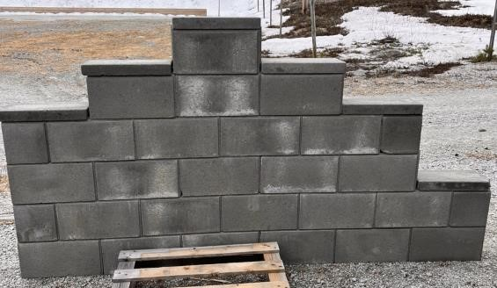
Start at given position with bolt back, mag in. Shoot the targets from the 5 different positions on the wall. Hit to move target in each position.
Target D 18X18 319m 348Y
Target E 25x25 388m 424Y

Number of rounds: 10
Time:120 sec.
--------------------------------------------------------------------------------------------------------------

Personal notes: Stage score: ____ /10

--------------------------------------------------------------------------------------------------------------

Stage 4 Skillstage - Tiebraker
Start at given position with bolt back, mag in. Shoot skillstage 4+1 positions
Targets S 20X20m, 15x15 Hit or Miss
Distance 359m 392Y Number of rounds: 10 Time:120 sec.
--------------------------------------------------------------------------------------------------------------
Personal notes: Stage score: ____ / 10

Stage 5 The hunter
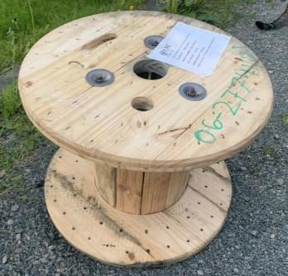
Start at given position with bolt back, mag in. Shoot the targets from the cable drum upper position and lower position, start at the position you would like. Shoot from every other position.
Targets F Hog 502m 548Y, Fox 491m 536Y, Wolf 493m 539Y Number of rounds: 12 Time:120sec.
--------------------------------------------------------------------------------------------------------------
Personal notes: Stage score: ____ / 12

--------------------------------------------------------------------------------------------------------------
Stage 6 Pallets
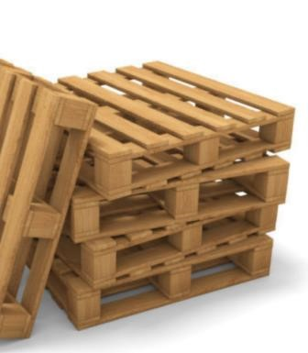
Start at given position with bolt back, mag in. Shoot the target from the pallets. Shoot targets G, then 1, G, then 2, G, then 3, G, then 4, then 1, 2, 3, and 4. (Botnia targets) Hit to move
Distances: M 381m 416Y, Botnia 1 – 405m 442Y, 2 – 421m 460Y, 3 – 499m 545Y, 4 – 559m 611Y.
Number of rounds: 12

Time:120 sec.
--------------------------------------------------------------------------------------------------------------
Personal notes: Stage score: ____ / 12
--------------------------------------------------------------------------------------------------------------

Station 4
Stage 7 Moskus Steel
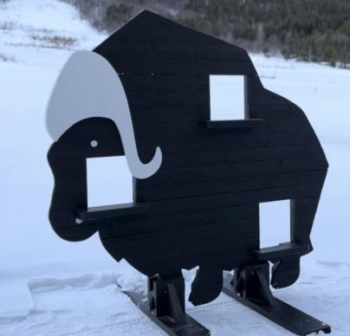
Start at given position with bolt back, mag in. Shoot two rounds from the three positions in the Muskox at the Muskox targets. Two of the positions can be used Twice, but the position needs to be changed.
Distance 634m 693Y Number of rounds: 10 Time:120sec.
--------------------------------------------------------------------------------------------------------------

Personal notes: Stage score: ____ /10

--------------------------------------------------------------------------------------------------------------
Stage 8 Tanktrap
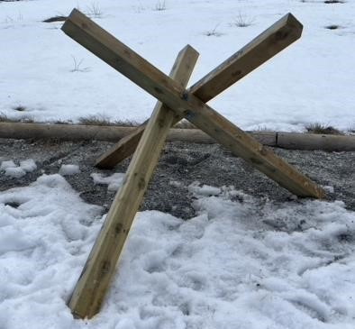
Start at given position with bolt back, mag in. Shoot from the positions at the tank trap, shoot both targets. Use four positions, one can be used twice. Shoot target J 20x40 and
Ø20 Hit to Move. 25x25
Distance 493m 539Y Number of rounds: 10 Time:120 sec.
--------------------------------------------------------------------------------------------------------------
Personal notes: Stage score: ____ / 10

--------------------------------------------------------------------------------------------------------------

Stage | Hit count | Of possible points
1 |  | 12
2 |  | 10
3 |  | 10
4 |  | 10
5 |  | 12
6 |  | 12
7 |  | 10
8 |  | 10
SUM |  | 86

