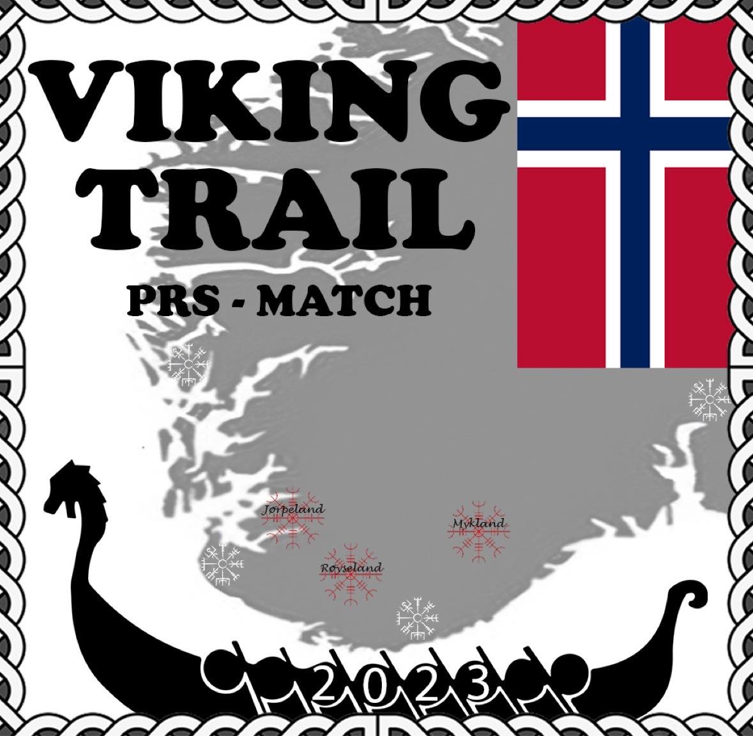
Runar Jonsson
Setesdalsvegen 4200, 4755 Hovden
+47 97404425

13.01.2026

The holder of this letter has accepted an invitation
to participate in this years Viking Trail match.

Invitation to participate in Viking Trail PRS Match (Long range shooting competition)

I hereby invite you to participate in Viking Trail PRS Match. The competition will take place on the 2-3 of May 2026 and will be shot in Jørpeland in Rogaland county and Røyseland in Kvinesdal in Southern Norway
The participant will need a total of 300 pcs of ammunition in a caliber of his/her own choosing to finish the competition.

Best regards,
Runar Jonsson
Match Director Viking Trail PRS Match

