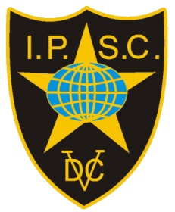

Invitation
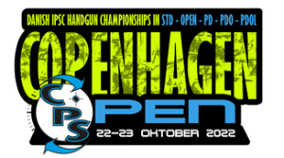

Copenhagen Open 2022
Copenhagen
20th – 21st – 22nd – 23rd October 2022
IPSC Denmark is happy to invite IPSC shooters from abroad to participate in our National Championships.
EU citizens with European Weapons Passport can enter w/o any gun registration.
Others pls. contact the organizers at markwise45@gmail.com

