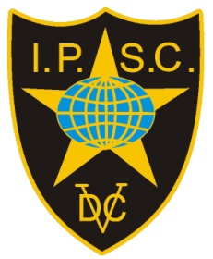

Invitation


Copenhagen Open 2023
Copenhagen
8th – 9th – 10th – 11th June 2023
IPSC Denmark is happy to invite IPSC shooters from abroad to participate in our National Championships.
EU citizens with European Weapons Passport can enter w/o any gun registration.
Others pls. contact the organizers at markwise45@gmail.com

