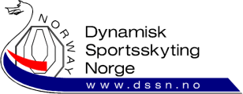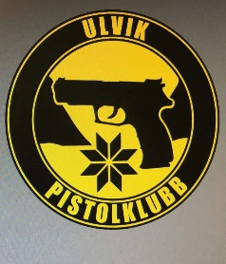
Invitation

Norwegian Championship Minirifle 2024
Ulvik, Norway
Pre match 30th-31st-jMay 2024
Main match 1st-2nd June 2024
DSSN and Ulvik PK are happy to invite IPSC shooters from abroad to participate in our National Championships.
EU citizens with European Weapons Passport can enter w/o any gun registration. Others pls. read. https://www.politiet.no/tjenester/vapen/reise-til-norge-med-vapen/
Contact information : Ulvik Pistolklubb, ulvik@dssn.no , Tlf: 91111376

