Krag Open 2024

Stage 1: Short Course (Hot Stage)
Targets | 4 IPSC targets, 3 no-shoots
Minimum rounds | 4
Firearm ready condition | Option 1
Start position | Behind the barricade B1
Time starts | On audible signal
Procedure | Engage all targets, each target must be engaged from a unique position on the barricade

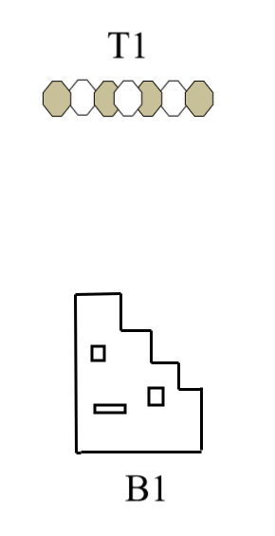

Stage 2: Short Course (Hot stage)
Targets | 2 IPSC targets, 2 plates
Minimum rounds | 4
Firearm ready condition | Option 3
Start position | Behind the barricade
Time starts | On audible signal
Procedure | Target array T1 must be engaged from behind the barricade, target array T2 must be engaged from designated box B1

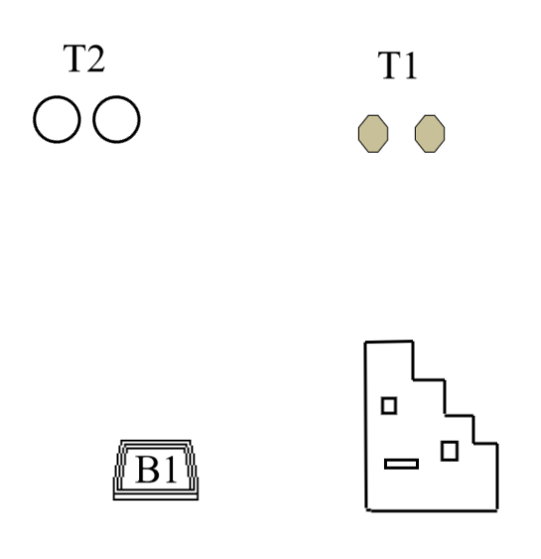

Stage 3: Long Course
Targets | 8 IPSC targets, 4 plates, 3 no-shoots
Minimum rounds | 10
Firearm ready condition | Option 1
Start position | Behind any barricade
Time starts | On audible signal
Procedure | Target array T1 must be engaged from behind the barricade B1, target array T2 must be engaged from behind the barricade B2, target array T3 and T4 must be engaged from the box B3

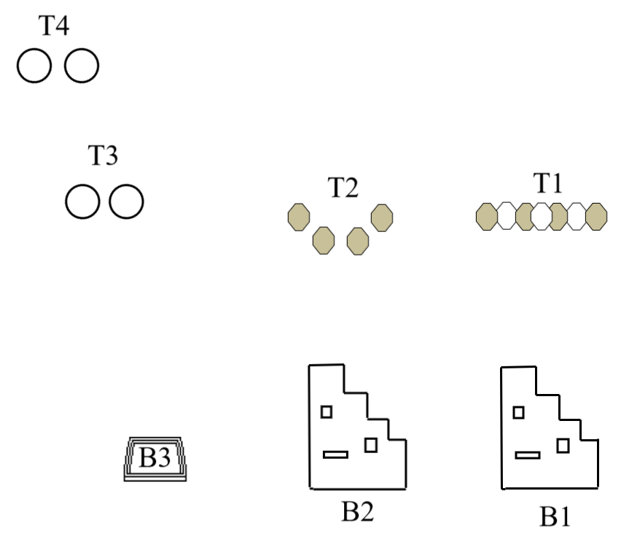

Stage 4: Short Course (Hot stage)
Targets | 5 IPSC paper targets
Minimum rounds | 5
Firearm ready condition | Option 1
Start position | Anywhere inside the demarcated area
Time starts | On audible signal
Procedure | Each target must be engaged while body touching prop obstacle. Each obstacle must be used at least once.
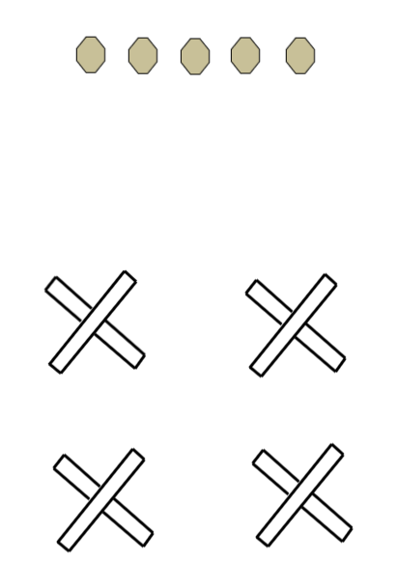

Stage 5: Medium Course (Hot stage)
Targets | 8 IPSC paper targets, 4 no-shoots
Minimum rounds | 8
Firearm ready condition | Option 2
Start position | Behind the barricade B1
Time starts | On audible signal
Procedure | Target array T1 and T2 must be engaged from the different sections of the barricade.
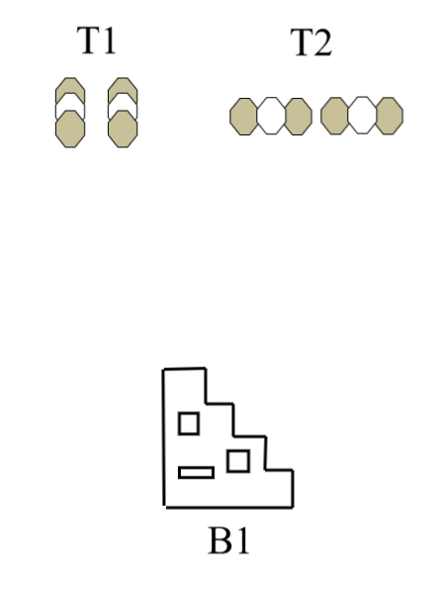

Stage 6: Medium Course
Targets | 8 IPSC paper targets, 3 no-shoots.
Minimum rounds | 8
Firearm ready condition | Option 1
Start position | Anywhere inside the demarcated area
Time starts | On audible signal
Procedure | Target array T1 must be engaged from prop obstacle.  Target array T2 must be engaged from barricade B1.  Target array T3 must be engaged from box B2.
