Document updated: 260907, all changes are in red text

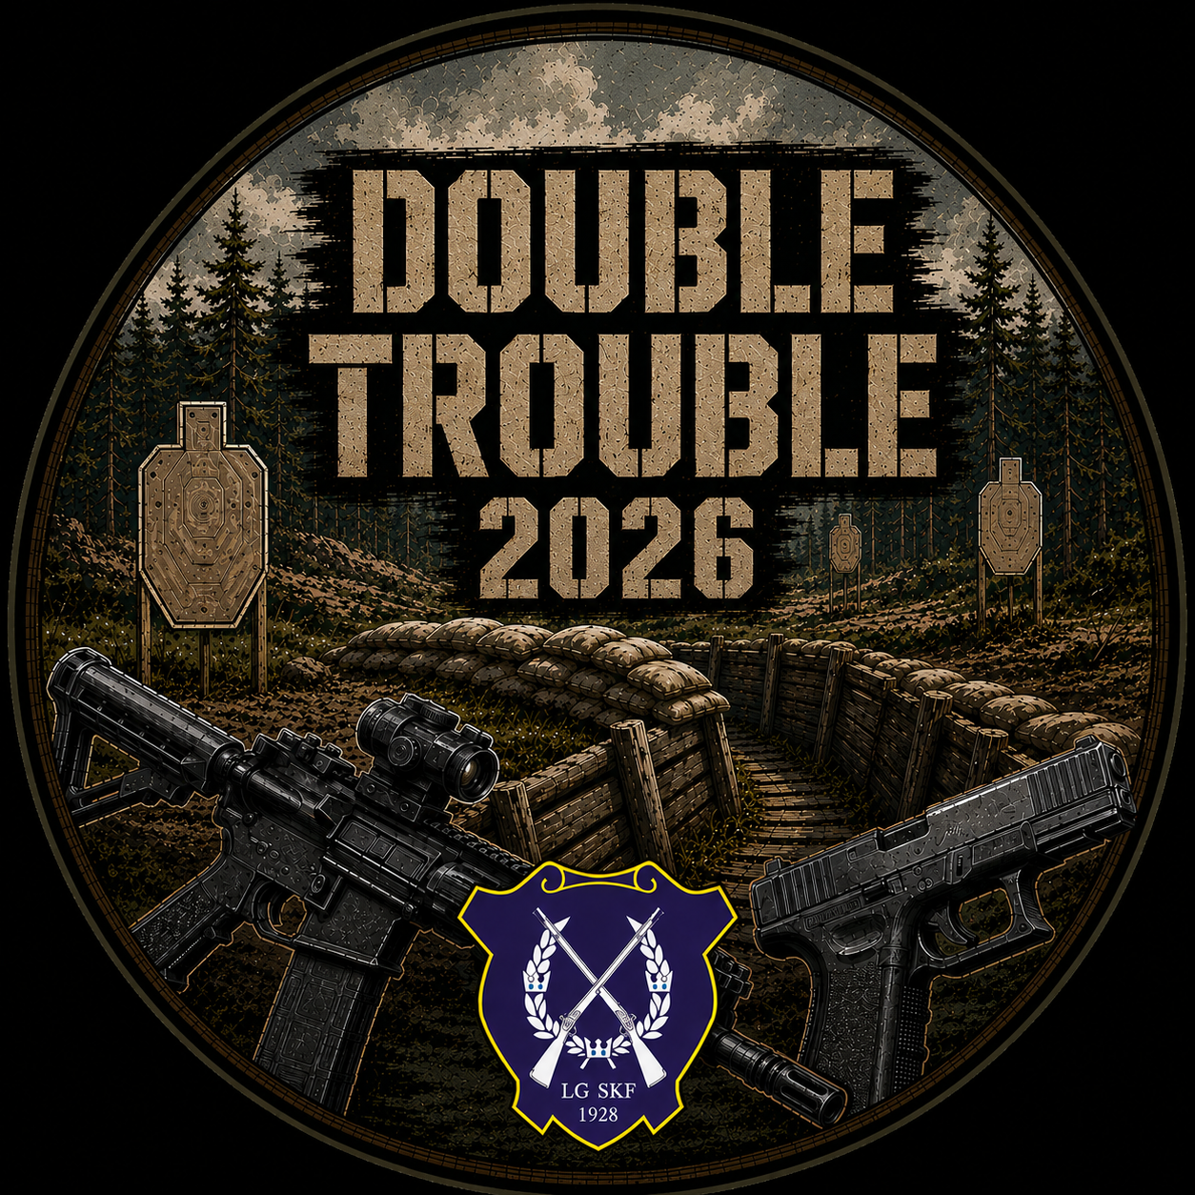DOUBLE TROUBLE
In the eastern field
October 4, 2026

General information and registration

Introduction
Double Trouble is a continuation of our shooting club’s match concept, following Little Trouble (IPSC Handgun) and Big Trouble (IPSC Rifle). This will be our first larger SRA competition, and we warmly welcome feedback both during the registration period and after the match.
Feedback can be sent to livgardet.skytteforening@gmail.com and will be reviewed during the match organization’s after-action review.

Match date
Prematch: October 3, 2026 (Saturday)
Main Match: October 4, 2026 (Sunday)

Match location
The match will take place at the Swedish Armed Forces Royal Guards Regiment training area in Kungsängen, Stockholm.

https://maps.app.goo.gl/EmqokERdMLhcru546

Match on SSI
The match is open to all competitors holding a valid SRA license.

SSI Double Trouble in the Eastern field, SRA
All official match information will be published on SSI.

Match Fee
The match fee is 500 SEK, payable via SSI.

Registration procedure and international participants
Main Match is limited to 80 competitors. New registrations will initially be placed on the waiting list and then manually moved to Pending. Once your status is Pending, you may proceed with payment.

- Phase 1 – July 1-31
  - Registration opens: July 1, 2026 at 18:00
  - Reserved slots
    - 10 slots each for shooters from Finland, Estonia, and Switzerland
    - 50 slots for shooters from Sweden
  - Payment deadline: July 31, 2026 at 23:59
- Phase 2 – August 1-31
  - Unpaid Pending registrations will be removed
  - Shooters on the waiting list will be moved to Pending in order of registration, regardless of nationality
  - Payment deadline: August 31, 2026 at 23:59
- Phase 3 – September
  - Unpaid pending registrations will be removed
  - Remaining waiting list entries will be processed in order of registration
  - Final payment deadline: September 15, 2026 at 23:59 (if a waiting list remains)

Campers & Caravans
It is not possible to park a camper or caravan on the parking the night before. However, there are plenty of nice spots outside of the military training area that you can use.

Prizes
The top three competitors in each division and category will receive placement awards (such as plaques).
Additional prizes, generously provided by our sponsor, will be raffled among all participants attending the prize ceremony.

Contact
For questions regarding the match, please use SSI’s messaging function.

Match Officials
- Match Director: Emil Jensen
- Range Masters: Christian Golshani, Henrik Tollmar

Sponsors

https://www.fmjskytte.se/
FMJ Shooting Range is a 4,000 m² indoor shooting and training facility located in Solna, just outside Stockholm. The facility features two independent ranges up to 50 meters, 360-degree shooting capability, tactical training areas, simulators, and classrooms.
FMJ offers a complete, environmentally friendly, and fully accessible environment for shooters of all experience levels. Operated by professional and elite-level shooters, FMJ is dedicated to developing the shooting sports community and supporting the next generation of competitors.

www.corax-store.se
CORAX is the result of two passionate sport shooters sharing a commitment to firearms and equipment of the highest quality.
We offer a wide range of products for hunting, professional use and sport shooting. Since 2018, we have supplied professional-grade equipment to Swedish sport shooters, the Swedish Police and the Swedish Armed Forces.
We understand the importance of equipment you can rely on. Our goal is to provide you with the products and expertise you need, so that the only limitation left is your own shooting ability.
With an extensive stock of high-quality products, fast delivery and exceptional customer service, we are here for those who want the best the market has to offer — at prices ranging from perfectly reasonable to completely unreasonable. (We also sell superpowers. Night vision, for example!)
So whether you have just received your first firearms licence or have years of professional experience within law enforcement or the military, you are welcome to CORAX to find everything you wantneed.

Match Design

Stages
The match consists of 8 stages across two shooting areas:
- One stage will be pistol only
- Two stages will require both rifle and pistol
Stage descriptions, target counts, and round counts on SSI are preliminary and expected to be finalized approximately 1–2 weeks prior to the match. Updates will be communicated via SSI.

Squads & logistics
- 16 squads of 5 shooters
- Half of the squads will start in each shooting area
- Private vehicles are required for transport between areas (gravel roads)
- Please limit the number of vehicles per squad

Schedule
- Shooting time: approximately 09:00–18:00
- A break will occur midway to switch shooting areas
Competitors are required to bring their own food.
Water will be available for refill at the stages.

Movement
Rucking between stages is required.
Distances between stages will vary from approximately 100 to 1.350 meters, with a median distance of around 400 meters.
Movement through wooded terrain will be required.

Access Restrictions
As the match takes place within a military training area, entry and exit is only permitted:
- At the start of the match
- During the scheduled break
- After finishing the match

Shooting Parameters
- Maximum distance: ~400 meters
- Maximum time per stage (par time): 180 seconds
- Stage briefing / walkthrough: 3 minutes

Targets
Paper targets are HF2020 targets. Steel targets are primarily IPSC Metric C- and D-plates.
Poppers and steel plates of other sizes and shapes may also occur on individual stages.
Steel targets at longer distances will be equipped with hit indicators.
See appendix 1 for details

Divisions
(A minimum of 5 competitors required per division)
- Open
- Standard
- Military

Recognized categories
(A minimum of 5 competitors required per category)
- Lady
- Senior
- Super Senior
- 7.62 (7.62×39 and 7.62×35 only)

Scoring method
Scoring will be conducted via SSI.
Competitors must verify and sign their scores electronically on the scorekeeper’s device after each stage.

Rules
Latest version of SRA rules applies (currently 8.1)

Arbitration
An arbitration committee will be appointed if required. It will consist of:
- The Match Director (chairman, non-voting)
- Three qualified SRA Range Officers not involved in match organization
Arbitration fee: 500 SEK, payable prior to the ruling.

Verifications
Once all squads have completed all stages, verification time will be announced at the stats office.
Verification time: 10 minutes

Gameday timetable

07:00–08:10 — Check-in and equipment/license control
(Valid SRA license required)
08:15 — Match briefing and safety briefing (at match center)
08:30 — Convoy departure to shooting areas
(Maximum two vehicles per squad)
08:55 — Stage briefing
(Two squads per stage — only the starting squad conducts walkthrough)
09:00 — First shot — match start
Midday: Break for transition between shooting areas
After completing four stages, squads must remain by their vehicles
17:59 — Last shot — match ends
18:30 — Prize ceremony
(Time is preliminary and will begin as soon as possible after match completion)

