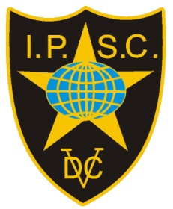

Invitation
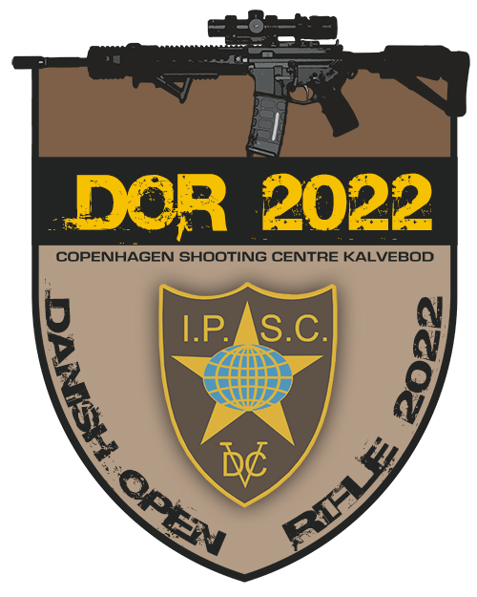

Danish Open IPSC Rifle Championships 2022
Copenhagen
13th – 14th – 15th – 16th July 2022
IPSC Denmark is happy to invite IPSC shooters from abroad to participate in our National Championships.
EU citizens with European Weapons Passport can enter w/o any gun registration.
Others pls. contact the organizers at markwise45@gmail.com

