Pain Assessment Guideline

Key Points
- It is the responsibility of every healthcare professional to assess a patient’s pain using a recognized pain assessment tool to provide effective and timely pain management
- Pain should be assessed on admission, during routine observations, before and after procedures, after analgesics, and with any changes in the patient’s condition.
- Careful consideration is required to ensure that the appropriate assessment tool is selected for each individual patient

Version: 1.0
Date Issued: | 23/09/26
Review Date: | 01/09/29
Key words: | Pain, assessment, function, distress

This is a controlled document. If you are using a printed copy, check it against the guidelines site to ensure you are using the latest edition.
Print copies must be destroyed after use

Summary
Pain measurement using the verbal descriptor scale:
0 = No pain 1 = Mild pain 2 = Moderate pain 3 = Severe pain

Functional activity score FAS (adapted from LTHT⁵)
A – No limitation of function: Can deep breath and clear secretions/cough. Mobility is at baseline.
B – Pain mildly limits function: Can deep breath but clearing secretions& coughing may be occasionally limited. Pain mildly limits mobility: Can sit/roll independently & may be able to transfer out of bed.
C – Pain moderately limits function: deep breathing is painful, clearing secretions and coughing is very limited. Pain moderately limits mobility : can roll and sit up with assistance, patient unable to mobilise from bed to chair.
D – Pain severely limits function: cannot deep breath, shallow breaths only, unable to cough. Pain severely limits mobility: can’t roll over or sit up in bed, even with assistance.

When to assess pain

On rest and movement

During routine observations and interactions
On admission - establish baseline pain level and history
Analgesia should be titrated to optimise function rather than reduce pain intensity
Patients with pain scores persistently 2 or 3 (moderate or severe) despite regular administration of analgesia are to be referred to Inpatient pain team:
WPH INPATIENT PAIN SERVICE
Monday – Saturday 08:30 – 16:30. Ext: 154435 - please leave a message
- New inpatient referral can be made via EPIC orders: Inpatient consult to pain management
- For enquiries in working hours please EPIC message: WPH Acute pain team
Out of hours medical staff could contact on-call anaesthetist mobile 07824012652 or referral by EPIC.

FPH INPATIENT PAIN SERVICE
Monday – Saturday 08:30 – 16:30 Ext: 132642 – please leave a message
- New inpatient referral can be made via EPIC orders: Inpatient consult to pain management
- For enquiries in working hours please EPIC message: FPH Acute pain team
Out of hours medical staff could contact on-call anaesthetist on bleep 5002

HWD INPATIENT PAIN SERVICE
Tuesday – Saturday 08:30 – 16:30 Please refer to the inpatient pain team via Epic or call mobile 07776633562.
HWH On call anaesthetic cover Monday-Saturday bleep 2501- or ring mobile 07787002726 - (10:00-22:00)
Out of hours medical staff could contact on-call anaesthetist at WPH on 07824012652.

Definition of terms
- “Pain is an unpleasant sensory and emotional experience, associated with, or resembling that associated with, actual or potential tissue damage” (1)
- Pain is always a personal experience that is influenced to varying degrees by biological, psychological, and social factors.
- Although pain usually serves an adaptive role, it may have adverse effects on function and social and psychological well-being.
- Verbal description is only one of several behaviours to express pain; inability to communicate does not negate the possibility that a human experiences pain” (1)

Pain assessment: is a multidimensional observational assessment of a patients’ experience of pain.
Pain measurement tools: instruments designed to measure pain

Assessment
Pain assessment is a broad concept involving clinical judgement based on observation of the type, significance and context of the individual’s pain experience.
It is the responsibility of every healthcare professional to assess a patient’s pain using a recognized pain assessment tool to provide effective and timely pain management. Administration of analgesia should facilitate function such as deep breathing, coughing or engaging in rehabilitation, not to completely alleviate pain (2).
Self-report is the gold standard for pain assessment.
Assessing pain may be challenging for patients with cognitive impairment, communication difficulties or language and cultural barriers. In these cases, age-specific and person-centred pain assessment should be used.
Benefits of pain assessment:
Consistent and accurate pain assessment provides the foundation for appropriate pain management and supports improved patient outcomes. Key benefits include:
- Improved patient comfort and wellbeing
- Informed clinical decision-making
- Evaluation of treatment effectiveness
- Prevention of clinical complications
- Enhanced patient safety
- Strengthen communication and continuity of holistic care
- Support for patient-centred care
When to assess pain:
- On admission - establish baseline pain level and history
- During routine observations and interactions
- On rest and movement
- During procedures or treatments
- After Analgesics are Administered
  - IV medications: Reassess pain in 15-30 minutes.
  - Oral medications: Reassess pain in 60-90 minutes.
  - Continue reassessment until pain is adequately managed.
- If pain is not controlled - increase the frequency of pain assessments
- With changes in condition - reassess pain when there are sudden changes in vital signs, agitation, confusion, or functional decline.
- Regularly assess pain to evaluate the effectiveness of analgesics. Proactively offer PRN analgesia before potentially painful experiences such as mobilization and physiotherapy.
- If the patient is using specific pain management methods like regional, epidural or patient-controlled analgesia, follow the specific Trust guideline for pain assessment

Assessment process
The aim of the assessment process is to identify all the factors, both physical and non-physical, that affect a patient’s perception of pain.
- Establish baseline pain level and history.
- Explore the history of the presenting complaint with the help of the SOCRATES structured framework:
S - Site
O - Onset
C - Characteristic
R - Radiation
A - Associated symptoms
T - Time/duration
E - Exacerbating/relieving factors
S - Severity
Discuss causes of pain, known expressions of pain (including behavioural changes), preferred and failed treatments.
Pain assessment tools:
At Frimley Health NHS Trust there are many pain assessment tools available which have been developed specifically for use in different patient groups (e.g. children/young people, adults, older people and people with cognitive impairment).
Careful consideration is required to ensure that the appropriate assessment tool is selected for each individual patient.

Use age-appropriate or condition-specific tools for:
  - Infants and children
  - Cognitively impaired patients
  - Non- verbal patients
  - Patients receiving palliative or end-of-life care
Children/young people
There are three main tools used for the neonate, infant and child 3-18 years - these tools reflect a combination of self- report and behavioural assessment:
Careful consideration needs to be given:
- cognitive ability
- environment (hospital)
- anxiety
- cause of pain (eg: post-operative)

1. FLACC –2 months- 7 years and used for up to 18 years for children with cognitive impairment and/or developmental disability. It is important to take behavioural cues identified by parents and caregivers to improve pain assessment in children.
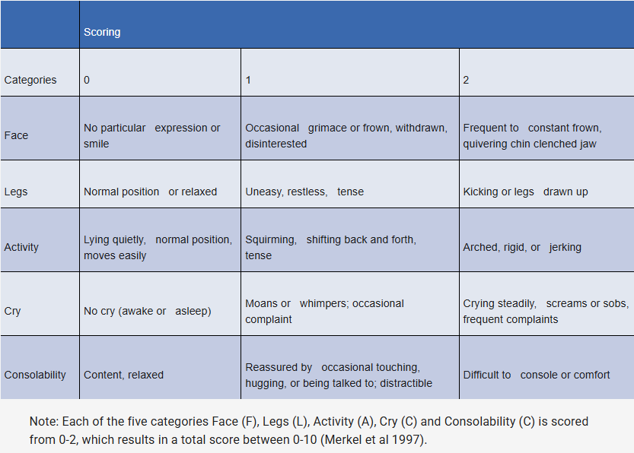

- Wong –Baker faces pain scales- 3-18 years old – Self report

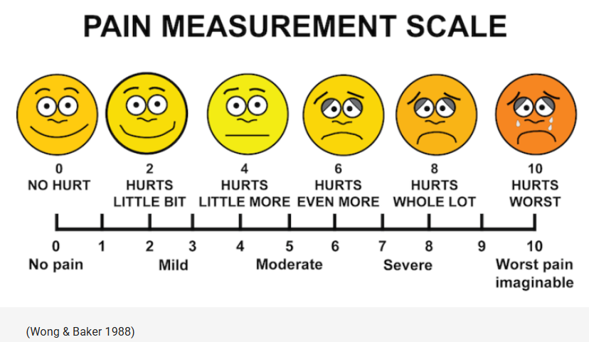

3.Visual analogue scale – 8 years and older- Self report
Ask the child using numbers from 0=no pain through to 10 being the worst pain

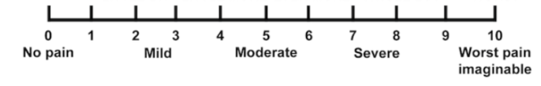
Adults
The verbal descriptor scale, also known as a verbal rating scale, is a commonly used method for assessing pain. This scale asks the patient to describe their pain intensity using words. It can range from a simple scale with few options (no pain, mild pain, moderate pain, severe pain) to a more detailed scale with additional word choices to express different levels of pain.
The patient chooses the word that best describes their level of pain. Using a verbal descriptor scale provides a more detailed understanding of the pain, allowing you to gain a better insight into the patient’s experience. Verbal descriptor scales can be helpful when patients find it challenging to use numerical scales.
Patients who are able to communicate, including those with mild cognitive impairment:

Verbal Descriptor Scale
0 = No pain
1 = Mild pain
2 = Moderate pain
3 = Severe pain

Numerical Rating Scale- 0-10
0 = no pain 10 = worst pain ever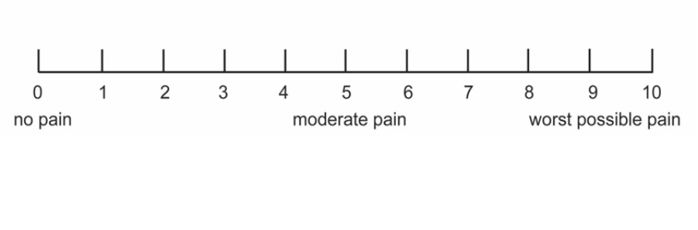
Patients who are non-speaking or language barriers:
Faces – patients can point to the faces to indicate what level of discomfort they are experiencing

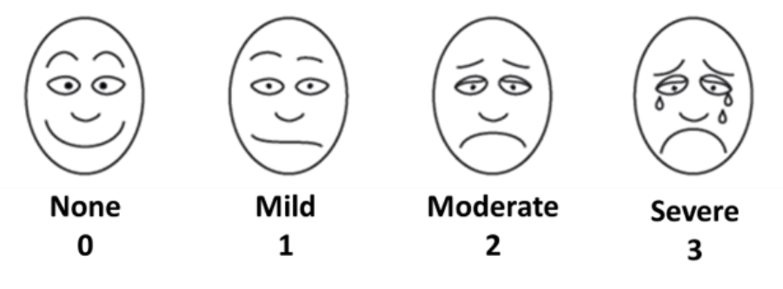

Bolton Pain Assessment Tool – observes patients' behaviours and physiological signs
- Establish baseline behaviour on admission, with input from family carers
- Utilise and refer to the ‘This is ME’ booklet containing personal information
- Consider factors including pain location, onset, triggers, characteristics, severity, relieving/exacerbating factors, and associated symptoms

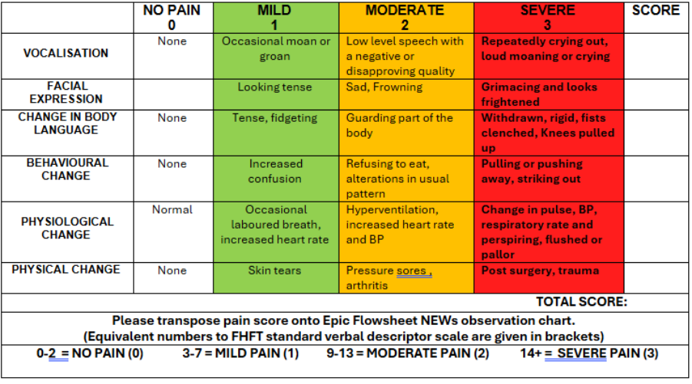

Functional Pain Assessment
It is now recognised that the sole use of the numerical pain score to guide analgesic interventions may lead to harm through overuse of opioids, leading to oversedation and increasing the risks of opioid use disorder. (3)
There is uncertainty regarding the comparative efficacy of unidimensional pain assessment tools, and it is increasingly recognised that pain assessment used to guide analgesic management should be based on function. (4)
Functional pain assessment focuses on how pain affects a patient’s ability to perform daily activities, participate in therapy, and maintain physical, emotional, and social functioning. It complements traditional pain scoring by offering a more holistic and clinically meaningful picture of the patient’s condition.
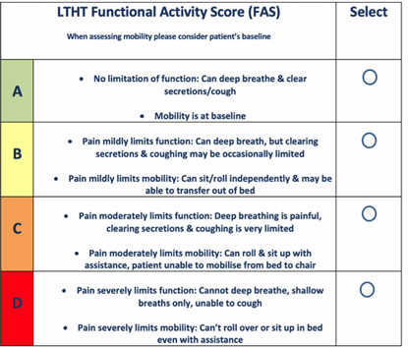 (5)

Why Functional Pain Assessment Matters
- Provides clinically relevant information beyond a numerical pain score.
- Better reflects real-world patient needs and rehabilitation progress.
- Improves interprofessional communication—especially between nursing, physiotherapy, and medical staff.
- Supports patient-centred care and measurable outcome tracking

References

1 . Raja SN, Carr DB, Cohen M, Finnerup NB, Flor H, Gibson S, Keefe FJ, Mogil JS, Ringkamp M, Sluka KA, Song XJ, Stevens B, Sullivan MD, Tutelman PR, Ushida T, Vader K. The revised International Association for the Study of Pain definition of pain: concepts, challenges, and compromises. Pain. 2020 Sep 1;161(9):1976-1982.doi: 10.1097/j.pain.0000000000001939. PMID: 32694387; PMCID: PMC7680716. (Accessed: 11 August 2026)

2. Faculty of Pain Medicine of the Royal College of Anaesthetists (2021) Core standards for pain management services in the UK. 2nd edn. London: Faculty of Pain Medicine of the Royal College of Anaesthetists. Available at: https://fpm.ac.uk/standards-guidelines/core-standards (Accessed: 11 August 2026)

3.Miguel, R., Strickland, J., Cantor, A., Ross, T., Soto, R., Nagi, P., Augustyniak, M., Smith, R., & Vila, H. (2005). The Efficacy and Safety of Pain Management Before and After Implementation of Hospital-Wide Pain Management Standards: Is Patient Safety Compromised by Treatment Based Solely on Numerical Pain Ratings?. Anesthesia & Analgesia, 101(2), 474–480. https://doi.org/10.1213/01.ANE.0000155970.45321.A8 (Accessed: 11 August 2026)

4. Baamer RM, Iqbal A, Lobo DN, Knaggs RD, Levy NA, Toh LS. Utility of unidimensional and functional pain assessment tools in adult postoperative patients: a systematic review. Br J Anaesth. 2022 May;128(5):874-888. doi: 10.1016/j.bja.2021.11.032. Epub 2022 Jan 5. PMID: 34996588; PMCID: PMC9074792. (Accessed: 11 August 2026)

5. Adcock C, McMahon R, Duffy K, Peters L, Drury N, Thomas C; Adult Acute Pain Team at Leeds Teaching Hospitals NHS Trust. Improving the assessment of acute pain in adult inpatients: a quality improvement project. Anaesth Rep. 2025 Dec 18;13(2):e70041. doi: 10.1002/anr3.70041. PMID: 41424920; PMCID: PMC12712392. (Accessed: 11 August 2026)

Full version control record
Version: | 1.0
Guidelines Lead(s): | Karin Cannons, Nurse Consultant Pain Management
Contributor(s): | Henrietta Bradbury, Pain Nurse Specialist HWPH  Joan Nengasca , Pain Specialist Nurse
Lead Director / Chief of Service: | Mr Luke Forster, Chief of Service
Library check completed: | March 2026
Ratified at: | Anaesthetic Clinical Governance
Date Issued: | [Will be filled in by Guidelines management team]
Review Date: | 01/09/26
Pharmaceutical dosing advice and formulary compliance checked by: | No medication content
Key words: | [for the search function on the guidelines site and app]

This guideline has been registered with the Trust. However, clinical guidelines are guidelines only. The interpretation and application of clinical guidelines will remain the responsibility of the individual clinician. If in doubt, contact a senior colleague or expert. Caution is advised when using guidelines after the review date.

This guideline is for use in Frimley Health NHS Foundation Trust hospitals only. Any use outside this location will not be supported by the Trust and will be at the risk of the individual using it.

Version History
Version | Date | Guideline Lead(s) | Status | Comment
1 | 23/09/26 | Henrieta Bradbury | Final | Ready for publication
Related Documents
Document Name | Document Name

