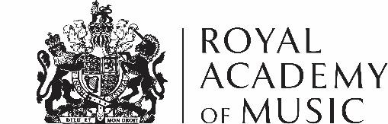
Prospective Offer Form
If you would like to offer an artefact to the Museum in accordance with our Collections Development Policy, please fill out this form. Please include copies of relevant documentation, images of the item(s) and as much detail as possible, including whether you are offering the item(s) as a gift or a loan.
Please return your form and any supporting documents and photographs to Royal Academy of Music Museum, Marylebone Road, London NW1 5HT or museum@ram.ac.uk

Item Information
Description of item(s)

Item history
Is there anything else you can tell us about where the item(s) came from?
Measurements & materials
Height x width x depth
Condition of item(s)
Current owner of object
I offer this object | As a Gift | As a Loan
Your Details
Name
Email Address
Telephone Number
Address
Postcode
Country
Date
I confirm I have read the ‘How to Offer’ section on the website and understand the Royal Academy of Music is under no obligation to accept any material offered. Should the Museum accept any item(s) as a donation to the collection, I understand this does not guarantee display of any item(s).
I confirm all the details on this form are true to the best of my knowledge.

By completing this form you agree to share your personal data with the Royal Academy of Music Museum. Your personal data will be stored and processed by the Royal Academy of Music in accordance with the provisions of the 2018 General Data Protection Regulation (GDPR). Please see www.ram.ac.uk/privacy for more information
If the donation is not accepted we will delete your personal information from our records after 2 years, in accordance with our data retention policy. If the donation is accepted we will keep your details (correct at the time of the donation) on file in perpetuity as a means of identification. This is so that, as an accredited museum, we can maintain provenance information about the donated item. We will not share your data with any third parties.

