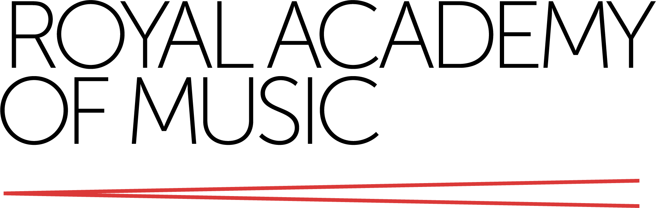

Modern Slavery and Human Trafficking Statement

1 Introduction

Modern slavery is a crime and a violation of fundamental human rights. It takes various forms, such as slavery, servitude, forced and bonded labour and human trafficking, all of which have in common the deprivation of a person’s liberty by another in order to exploit them for personal or commercial gain.

The Royal Academy of Music (the Academy) is committed to protecting and respecting human rights, understanding the risks around modern slavery and human trafficking related to its business, and ensuring that there is no modern slavery within any parts of its business or its supply chains.

2 Purpose

This statement is made pursuant to Section 54 of the Modern Slavery Act 2015 and is designed to satisfy the Act’s requirements by informing students, staff, and other stakeholders about the Academy and its policies with respect to modern slavery in its business and supply chains.

Although the Academy’s turnover (£26.2 million in 2019/20) is significantly less than the threshold for businesses required to publish a Modern Slavery Statement under the Act, the Governing Body is committed to do so, in the interests of transparency and accountability.

This Statement sets out the modern slavery and human trafficking risks inherent in the Academy’s business and supply chains, and the steps taken to address them. It applies to the Academy and its subsidiaries.

This statement is applicable to the financial year ending 31 July 2021.

3 About the Royal Academy of Music

The Academy is a music conservatoire of world renown. Our mission is to provide pre-professional, undergraduate and postgraduate musical training of the highest standards and to enrich musical culture by educating the world’s most talented musicians. Quality and equality are at the core of our values, underpinning all of our activities. The Academy operates in a spirit of professionalism, collaboration and openness, and promotes an inclusive learning and working environment in which all students, staff and visitors are welcomed. We support students and staff in challenging and removing any form of prejudice or discrimination, and in promoting equality and diversity, which in turn enriches the teaching, learning, artistic and social environment.

We train around 860 students from over 50 countries in a variety of musical disciplines, and employ approximately 600 members of staff. We operate out of premises in central London. We spend approximately £6 million each year on goods and services, through a variety of supply chain arrangements.

The Governing Body is responsible for overseeing and managing the business of the Academy, setting its strategic direction and determining its character and mission. The Governing Body has delegated responsibility for the oversight of its responsibilities in respect of Modern Slavery to the Audit Committee.

The Academy has a wholly-owned subsidiary, the RAM Collections Trust.

4 Our policy

The Academy acknowledges the provisions of the Modern Slavery Act 2015 and is committed to ensuring transparency within its organisation and with suppliers of goods and services.

The Academy will not knowingly support or deal with any business involved in slavery or human trafficking and we have a formal policy on Modern Slavery and Human Trafficking.

5 Risks identified and actions being taken - staff

The Academy mitigates the risk of the occurrence of modern slavery in its permanent staff through adherence to its HR recruitment and candidate selection policies.

Checks are carried out to ensure that staff recruited are legally able to work in the UK. The Academy’s pay rates are determined in line with Universities & Colleges Employers Association national awards. The Academy pays its employees, including interns, a minimum of the London Living Wage and is committed to extending this to all workers supplied through agencies. Academy students who are remunerated for work performed are paid at least the National Living Wage, or the National Minimum Wage, depending on their age.

Awareness training will be provided for staff to highlight policies and processes in relation to modern slavery and human trafficking, and to ensure that staff remain vigilant and report any concerns. Our Whistleblowing policy has been updated with regard to concerns around modern slavery and human trafficking, in our activities or supply chains.

6 Risks identified and actions being taken - temporary staff

Temporary staff and other staff recruited indirectly by the Academy are recruited through established and accredited sources who can provide assurance that they fully comply with the legislative requirements relating to the rights and welfare of their candidates and employees.

Agencies provide assurance that the appropriate checks have been made on the temporary staff being supplied to the Academy.

7 Risks identified and actions being taken - students

Although the risk of students experiencing occurrences of modern slavery or human trafficking through direct contact with the Academy is considered very low, it is appreciated that whilst living in London, they may become aware of such instances.

In order to mitigate such circumstances, the Academy has in place easily accessible and well publicised safeguarding channels through which students can obtain assistance, support and advice on their wellbeing.

8 Risks identified and actions being taken - supply chains

The Academy purchases goods and services across a wide range of suppliers, and its purchasing procedures and documentation are aligned with the principles in the Modern Slavery Act 2015. Our standard terms and conditions of business include clauses covering modern slavery and human trafficking. Training is provided to those responsible for procurement at the Academy to raise awareness and ensure an understanding of the risks of modern slavery and trafficking in our supply chains.

The Academy participates in a cost-sharing group, Ensemble Purchasing, through which we gain access to dedicated procurement expertise and advice. The Academy is also a member of the London Universities Procurement Consortium (‘LUPC’), a professional collaborative buying organisation.

Both Ensemble Purchasing and LUPC are committed to acquiring goods and services without causing harm to others and are committed to supporting the UK Government’s National Action Plan to implement the UN Guiding Principles on Business and Human Rights.

LUPC has a Responsible Procurement Policy and Strategy, which is at the forefront of the business and sets out a programme of projects and actions aiming to address risks of human rights abuses. It also has a Responsible Procurement Officer who provides expertise in the area of modern slavery and human rights abuses, and who ensures responsible procurement is practised across all LUPC’s operations and relationships with suppliers. Each contract let by the LUPC has responsible procurement principles embedded in the tender process.

LUPC framework agreements are used for goods and services wherever viable; suppliers on these frameworks have been subject to extensive due diligence, including ensuring that there is no evidence of any act of modern slavery or human trafficking, forced or bonded labour, or labour violations. The Academy has just utilised the LUPC’s framework agreement for its cleaning services, which requires suppliers to demonstrate their ongoing commitment to ensuring that they take steps to guard against modern slavery in all its forms.

The Academy’s supply chains mainly fall under ‘super-categories’ which are:

* Professional Services eg recruitment agency staff
* ICT Equipment and Services
* Facilities Management Services

Supplies considered to carry higher risks of human rights abuse are ICT equipment and some professional services and facilities management services, such as cleaning, catering and security services. The corresponding source countries are deemed to be as follows:

|  |  |
| --- | --- |
| **Category** | **Country** |
| ICT equipment | East Asia, China, India, Eastern Europe, Mexico |
| Cleaning services | United Kingdom |
| Catering | United Kingdom |
| Security services | United Kingdom |
| Recruitment agencies | United Kingdom |

LUPC focusses its resources on these high-risk categories. The risk assessment was based on a consideration of the risks associated with the production countries, their own research on products and production methods, including working conditions and supply chain structures, and their continuous engagement with their partners and suppliers.

In the ICT equipment category, LUPC leads in the procurement of desktop and notebook personal computers for UK higher education institutions. Through LUPC, the Academy is an affiliated member of and works closely with the NGO Electronics Watch, the collaborative organisation monitoring global electronics supply chains.

9 Risks identified and actions being taken – donations and investments

Philanthropic donations over £100,000 are scrutinised by the Academy’s Gift Acceptance Committee, whose principal purpose is to consider and advise the Governing Body on whether the sources and purposes of prospective donations, fundraising and other funded activities are ethically acceptable.

The Terms of Reference of both the Gift Acceptance Committee and the Museum and Library Committee make specific reference to the Academy’s obligations regarding Modern Slavery. Due diligence performed on proposed donations includes searching for any connection to modern slavery or human trafficking.

In relation to investments, the Academy has an Ethical Investment Policy. This states that, wherever possible, investments will be made in ways which are consistent with its mission and values; quality and equality are at the core of our values, underpinning all of our activities. In making investment decisions, environmental, social and governance (ESG) issues are considered, including the Academy’s obligations regarding Modern Slavery. The Academy’s funds are managed by professional fund managers, who are signatories to the United Nations Principles of Responsible Investment (PRI), and who share a commitment to assess ESG concerns (including human rights issues such as modern slavery) in its investments.

**10 Approval of Statement**

This statement is reviewed and published annually.

This statement is made pursuant to section 54(1) of the Modern Slavery Act 2015 and constitutes the Academy’s slavery and human trafficking statement for the financial year ending 31 July 2021.

Approved by the Audit Committee (on behalf of the Governing Body)

8 March 2021